**Estilos de Dashboards para escolha do cliente**

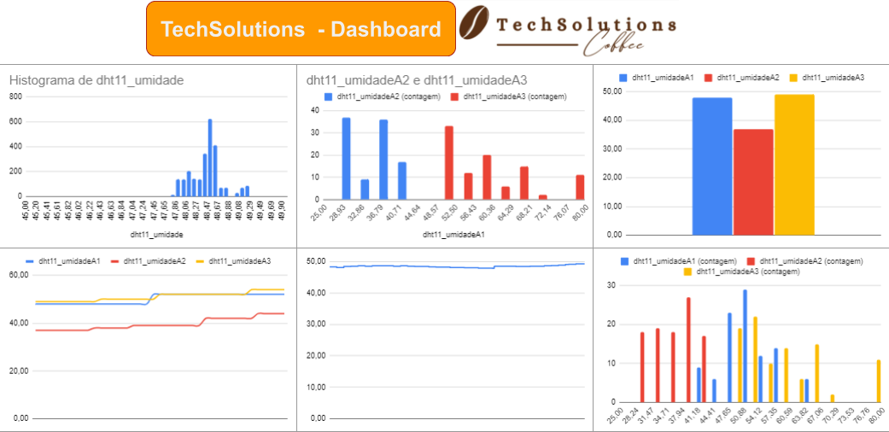

https://docs.google.com/spreadsheets/d/1Wo5FQXn3AK5LeUvEHgtALD9E00q89YPCucAAl7ROyYw/edit#gid=2027329278