**Projeto Final Das**

**Desenvimento de Software**

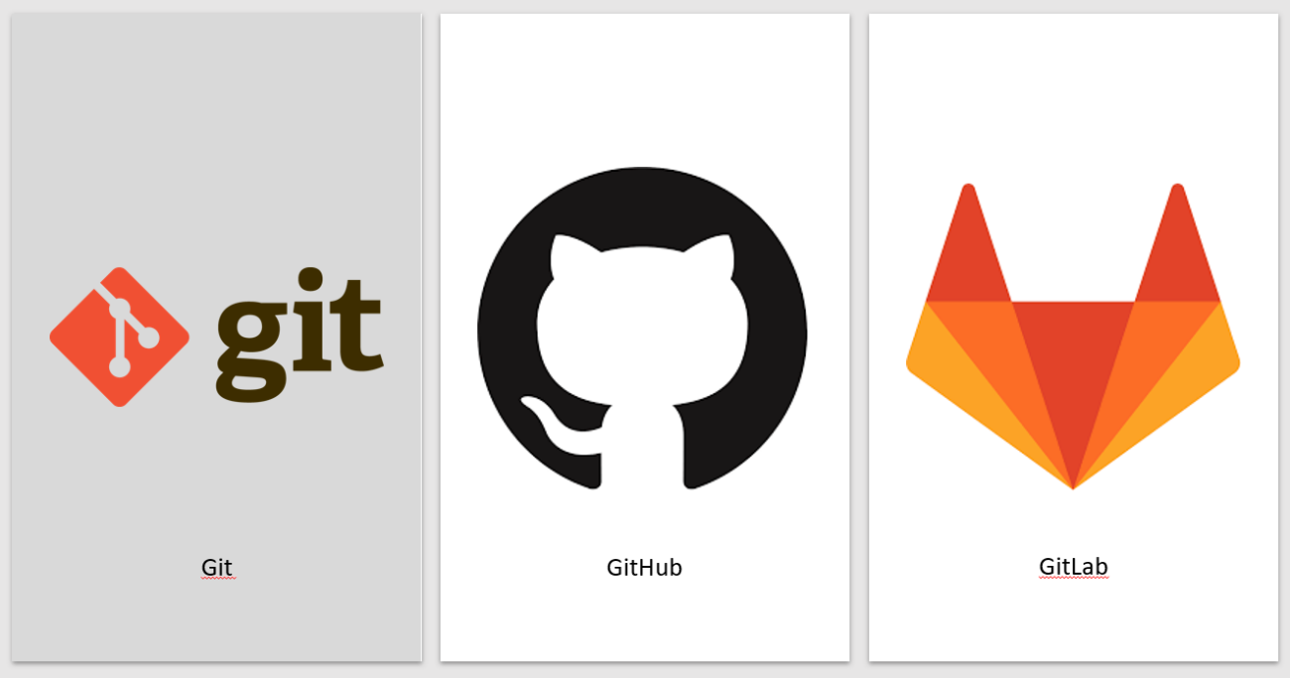

Bruno Magalhães nº2022035

Desenvolvimento Ágil de software

**Criar o repositório**

- Comecei este projeto criando a pasta “C:\Users\35196\Desktop\Istectrabalhos\Das-ProjetoFinal”.

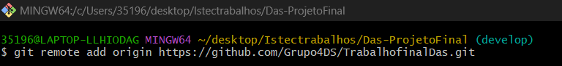

**Carregamento inicial do ficheiro no branch develop:**

**5 alterações no próprio branch develop com os devidos comentários:**

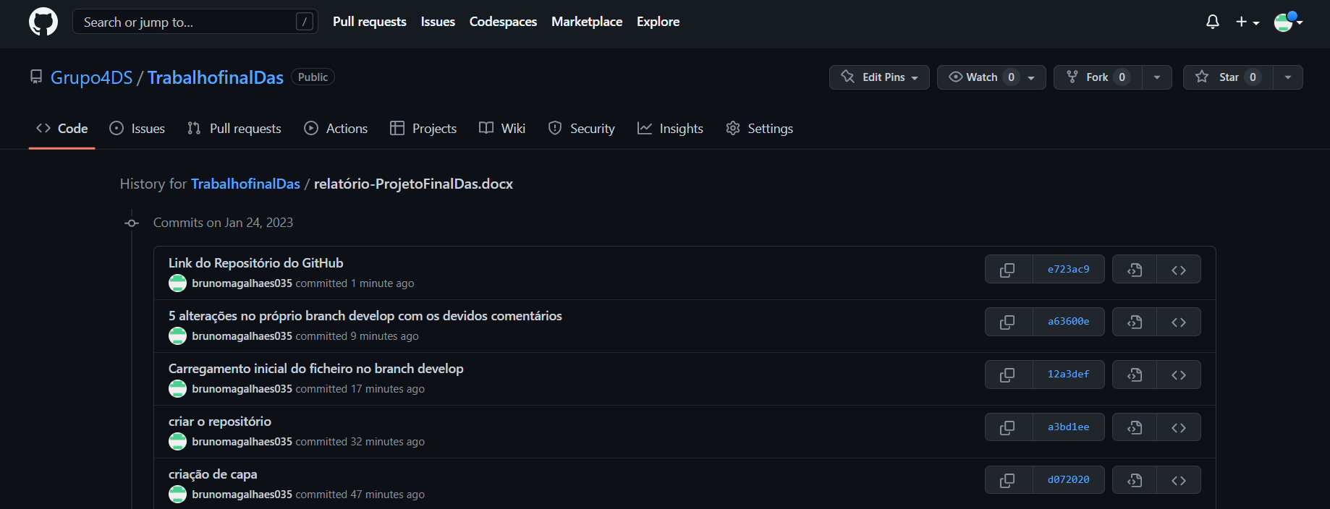

**1 release que contribua para o branch master:**

**Link do Repositório do GitHub:**

<https://github.com/Grupo4DS/TrabalhofinalDas.git>