**TITULAR INSTALACIÓN:** Vigilant S.A.

**DIRECCIÓN:** Paraguay, Parc. 8/9

**EMPLAZAMIENTO:**Alcantarilla (Murcia)

# DETALLE DE LOS ELEMENTOS DE PROTECCION CONTRA INCENDIOS

### Revisión de: Extintor

|  |  |  |  |  |  |  |  |
| --- | --- | --- | --- | --- | --- | --- | --- |
| **Nº** | **EQUIPO  REVISADO** | **Nº Timbre** | **F.Fabricacion** | **Retimbrado** | **Ubicación** | **Intervención** | **Estado** |
| 1 | PG6-ABC | 524187 | 19/04/2015 |  | Pasillo | Revisión | OK |
| 2 | PG6-ABC | 14258 | 13/11/2007 | 19/07/2018 | Entrada | Retimbrado+Recarga | RTRC |
| 3 | PG6-ABC | 54654 | 21/08/2012 | 20/07/2018 | Caseta | Revisión | OK |
|  |  |  |  |  |  |  |  |
|  |  |  |  |  |  |  |  |
|  |  |  |  |  |  |  |  |
|  |  |  |  |  |  |  |  |
|  |  |  |  |  |  |  |  |
|  |  |  |  |  |  |  |  |
|  |  |  |  |  |  |  |  |
|  |  |  |  |  |  |  |  |
|  |  |  |  |  |  |  |  |
|  |  |  |  |  |  |  |  |
|  |  |  |  |  |  |  |  |
|  |  |  |  |  |  |  |  |
|  |  |  |  |  |  |  |  |
|  |  |  |  |  |  |  |  |
|  |  |  |  |  |  |  |  |
|  |  |  |  |  |  |  |  |

**Observaciones:** preuba

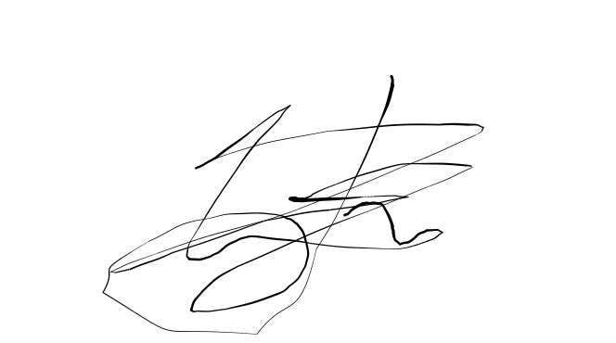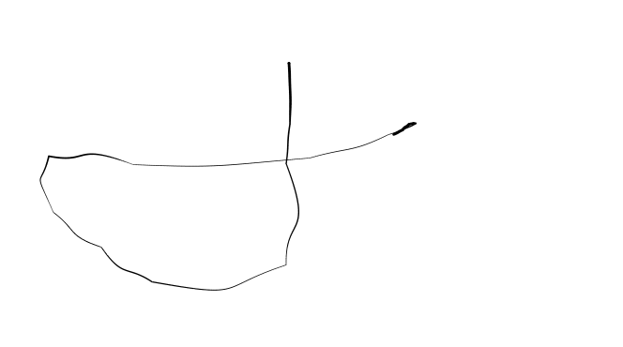Conforme Cliente Técnico

20/07/18 303

Juan Pedro

HOJA Nº: 1