**TITULAR INSTALACIÓN:** GABIA METAL S.L.

**DIRECCIÓN:** C/ LOS RUBIALES, 20-22, PARQUE METROPOLITANO, 18130, ESCUZAR, GRANADA

**EMPLAZAMIENTO:**UNICA

# DETALLE DE LOS ELEMENTOS DE PROTECCION CONTRA INCENDIOS

### Revisión de: BIE

|  |  |  |  |  |  |  |  |
| --- | --- | --- | --- | --- | --- | --- | --- |
| **Nº** | **EQUIPO  REVISADO** | **Nº Timbre** | **F.Fabricacion** | **Retimbrado** | **Ubicación** | **Intervención** | **Estado** |
| 1 | BIE 25/20 |  | 01/01/2007 | 01/12/2014 | ENTRADA NAVE | Revisión | OK |
| 2 | BIE 25/20 |  | 01/01/2007 | 01/12/2014 | NAVE | Revisión | OK |
| 3 | BIE 25/20 |  | 01/01/2007 | 01/12/2014 | NAVE | Revisión | OK |
| 4 | BIE 25/20 |  | 01/01/2007 | 01/12/2014 | NAVE | Revisión | OK |
| 5 | BIE 25/20 |  | 01/01/2007 | 01/12/2014 | NAVE | Revisión | OK |
| 6 | BIE 25/20 |  | 01/01/2007 | 01/12/2014 | NAVE | Revisión | OK |
|  |  |  |  |  |  |  |  |
|  |  |  |  |  |  |  |  |
|  |  |  |  |  |  |  |  |
|  |  |  |  |  |  |  |  |
|  |  |  |  |  |  |  |  |
|  |  |  |  |  |  |  |  |
|  |  |  |  |  |  |  |  |
|  |  |  |  |  |  |  |  |
|  |  |  |  |  |  |  |  |
|  |  |  |  |  |  |  |  |
|  |  |  |  |  |  |  |  |
|  |  |  |  |  |  |  |  |
|  |  |  |  |  |  |  |  |

**Observaciones:**

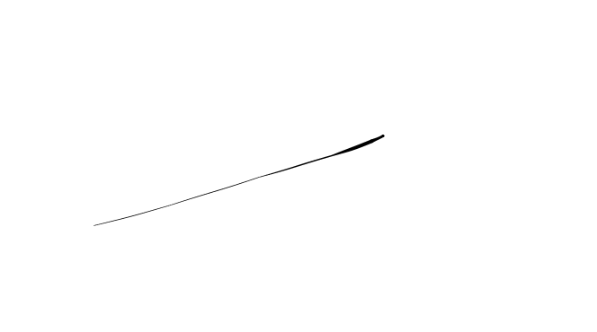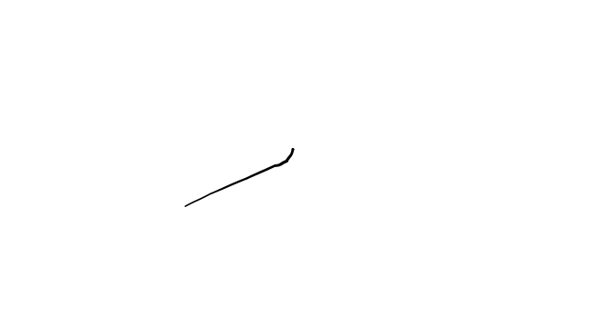Conforme Cliente Técnico

08/08/18

HOJA Nº: 1