**TITULAR INSTALACIÓN:** GRUAS GRANADA 2000 S.L.

**DIRECCIÓN:** C/ POLIGONO TECNOLOGICO DE OGIJARES, NAVE 32-A, 18151, OGIJARES, GRANADA

**EMPLAZAMIENTO:**UNICA

# DETALLE DE LOS ELEMENTOS DE PROTECCION CONTRA INCENDIOS

### Revisión de: Extintor

|  |  |  |  |  |  |  |  |
| --- | --- | --- | --- | --- | --- | --- | --- |
| **Nº** | **EQUIPO  REVISADO** | **Nº Timbre** | **F.Fabricacion** | **Retimbrado** | **Ubicación** | **Intervención** | **Estado** |
| 20 | PG-6 ABC | 116 | 01/01/2014 | 01/01/2014 | .. | Revisión | OK |
| 21 | PG-3 ABC | 2822 | 01/01/2007 | 01/01/2017 | GR-14 | Revisión | OK |
| 22 | PG-6 ABC | 22619 | 01/01/2007 | 01/01/2012 | NAVE 3 CHURRIANA | Revisión | OK |
| 23 | PG-6 ABC | 132983 | 01/01/2006 | 01/01/2014 | GR-17 | Revisión | OK |
| 24 | PG-3 ABC | 569 | 01/01/2014 | 01/01/2014 | GR-15 | Revisión | OK |
| 25 | PG-6 ABC | 1409 | 01/01/2002 | 01/01/2015 | GR-30 | Revisión | OK |
| 26 | PG-9 ABC | 8313037 | 01/01/2001 | 01/01/2014 | GR-02 | Revisión | OK |
| 27 | PG-9 ABC | 8313046 | 01/01/2001 | 01/01/2014 | GR-02 | Revisión | OK |
| 28 | PG-6 ABC | 441006 | 01/01/2004 | 01/01/2014 | GR-17 | Revisión | OK |
| 29 | PG-6 ABC | 441096 | 01/01/2004 | 01/01/2014 | GR-17 | Revisión | OK |
| 30 | PG-6 ABC | 538795 | 01/01/2000 | 01/01/2015 | NAVE 2 | Revisión | OK |
|  |  |  |  |  |  |  |  |
|  |  |  |  |  |  |  |  |
|  |  |  |  |  |  |  |  |
|  |  |  |  |  |  |  |  |
|  |  |  |  |  |  |  |  |
|  |  |  |  |  |  |  |  |
|  |  |  |  |  |  |  |  |
|  |  |  |  |  |  |  |  |

**Observaciones:**

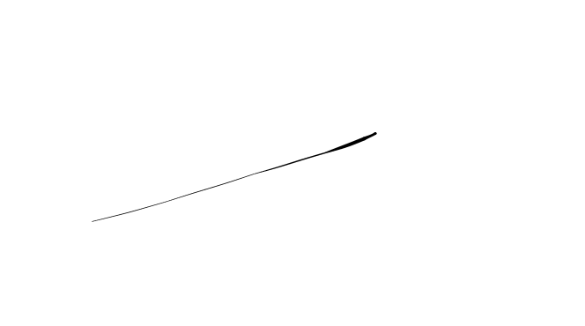Conforme Cliente Técnico

09/08/18

HOJA Nº: 2