**TITULAR INSTALACIÓN:** GESTION Y EXPLOTACION DE RESTAURANTES S.L.

**DIRECCIÓN:** AUTOVIA A-92, KM. 192, 18300, LOJA, GRANADA

**EMPLAZAMIENTO:**AREA DE SERVICIO Y HOTEL LOS ABADES

# DETALLE DE LOS ELEMENTOS DE PROTECCION CONTRA INCENDIOS

### Revisión de: BIE

|  |  |  |  |  |  |  |  |
| --- | --- | --- | --- | --- | --- | --- | --- |
| **Nº** | **EQUIPO  REVISADO** | **Nº Timbre** | **F.Fabricacion** | **Retimbrado** | **Ubicación** | **Intervención** | **Estado** |
| 20 | BIE 25/20 |  | 01/01/1970 | 01/01/2016 | SALON CRISTALES | Revisión | OK |
| 21 | BIE 45/20 |  | 01/01/1970 | 01/01/2016 | JUNTO LAVANDERIA | Revisión | OK |
| 22 | BIE 45/20 |  | 01/01/1970 | 01/01/2016 | MUELLE CARGA | Revisión | MAL |
|  |  |  |  |  |  |  |  |
|  |  |  |  |  |  |  |  |
|  |  |  |  |  |  |  |  |
|  |  |  |  |  |  |  |  |
|  |  |  |  |  |  |  |  |
|  |  |  |  |  |  |  |  |
|  |  |  |  |  |  |  |  |
|  |  |  |  |  |  |  |  |
|  |  |  |  |  |  |  |  |
|  |  |  |  |  |  |  |  |
|  |  |  |  |  |  |  |  |
|  |  |  |  |  |  |  |  |
|  |  |  |  |  |  |  |  |
|  |  |  |  |  |  |  |  |
|  |  |  |  |  |  |  |  |
|  |  |  |  |  |  |  |  |

**Observaciones:**

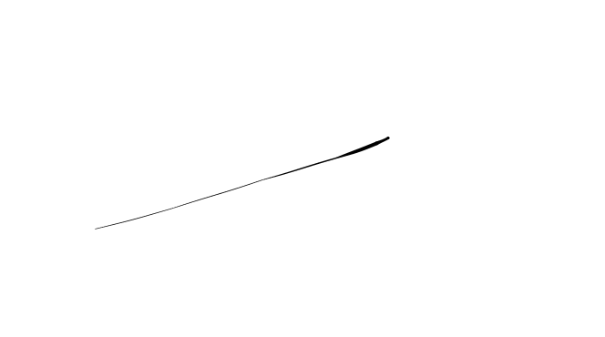Conforme Cliente Técnico

08/08/18

HOJA Nº: 2