**TITULAR INSTALACIÓN:** FABIAN ARENAS E HIJOS S.L.

**DIRECCIÓN:** AUTOVIA DE MALAGA, KM. 442, 18320, SANTA FE, GRANADA

**EMPLAZAMIENTO:**CONCESIONARIO RENAULT

# DETALLE DE LOS ELEMENTOS DE PROTECCION CONTRA INCENDIOS

### Revisión de: Extintor

|  |  |  |  |  |  |  |  |
| --- | --- | --- | --- | --- | --- | --- | --- |
| **Nº** | **EQUIPO  REVISADO** | **Nº Timbre** | **F.Fabricacion** | **Retimbrado** | **Ubicación** | **Intervención** | **Estado** |
| 20 | NC5-CO2 | 1009540 | 01/01/2004 | 01/10/2014 | CUADRO ELECTRICO | Revisión | OK |
|  |  |  |  |  |  |  |  |
|  |  |  |  |  |  |  |  |
|  |  |  |  |  |  |  |  |
|  |  |  |  |  |  |  |  |
|  |  |  |  |  |  |  |  |
|  |  |  |  |  |  |  |  |
|  |  |  |  |  |  |  |  |
|  |  |  |  |  |  |  |  |
|  |  |  |  |  |  |  |  |
|  |  |  |  |  |  |  |  |
|  |  |  |  |  |  |  |  |
|  |  |  |  |  |  |  |  |
|  |  |  |  |  |  |  |  |
|  |  |  |  |  |  |  |  |
|  |  |  |  |  |  |  |  |
|  |  |  |  |  |  |  |  |
|  |  |  |  |  |  |  |  |
|  |  |  |  |  |  |  |  |

**Observaciones:**

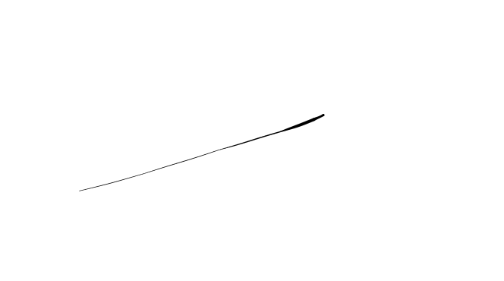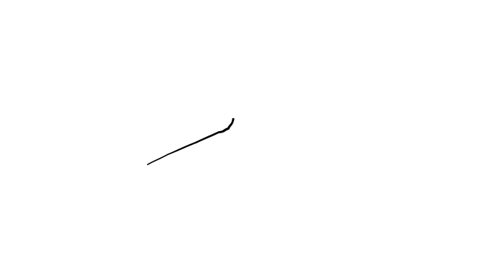Conforme Cliente Técnico

07/08/18

HOJA Nº: 2