**TITULAR INSTALACIÓN:** GESTION DE ESTACIONAMIENTOS S.L.

**DIRECCIÓN:** C/ RECOGIDAS, S/N, 18004, GRANADA

**EMPLAZAMIENTO:**TORRES NEPTUNO

# DETALLE DE LOS ELEMENTOS DE PROTECCION CONTRA INCENDIOS

### Revisión de: BIE

|  |  |  |  |  |  |  |  |
| --- | --- | --- | --- | --- | --- | --- | --- |
| **Nº** | **EQUIPO  REVISADO** | **Nº Timbre** | **F.Fabricacion** | **Retimbrado** | **Ubicación** | **Intervención** | **Estado** |
| 40 | BIE 25/20 |  | 01/01/2003 | 01/01/2016 | ZONA C | Revisión | OK |
| 41 | BIE 25/20 |  | 01/01/2003 | 01/01/2016 | ZONA C | Revisión | OK |
| 42 | BIE 25/20 |  | 01/01/2003 | 01/01/2016 | ZONA C | Revisión | OK |
| 43 | BIE 25/20 |  | 01/01/2003 | 01/01/2016 | ZONA C | Revisión | OK |
| 44 | BIE 25/20 |  | 01/01/2003 | 01/01/2016 | ZONA C | Revisión | OK |
|  |  |  |  |  |  |  |  |
|  |  |  |  |  |  |  |  |
|  |  |  |  |  |  |  |  |
|  |  |  |  |  |  |  |  |
|  |  |  |  |  |  |  |  |
|  |  |  |  |  |  |  |  |
|  |  |  |  |  |  |  |  |
|  |  |  |  |  |  |  |  |
|  |  |  |  |  |  |  |  |
|  |  |  |  |  |  |  |  |
|  |  |  |  |  |  |  |  |
|  |  |  |  |  |  |  |  |
|  |  |  |  |  |  |  |  |
|  |  |  |  |  |  |  |  |

**Observaciones:**

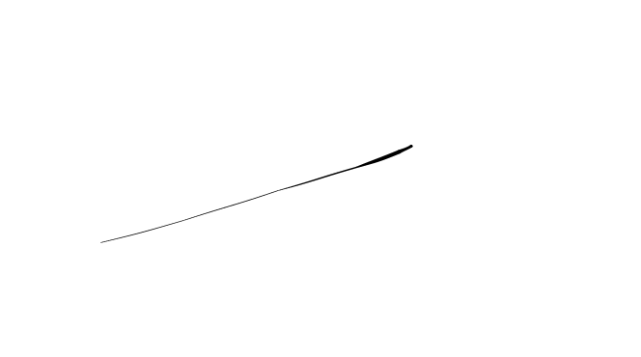Conforme Cliente Técnico

10/08/18

HOJA Nº: 4