**TITULAR INSTALACIÓN:** RESIDENCIA UNIVERSITARIA CORRALA DE SANTIAGO

**DIRECCIÓN:** C/ SANTIAGO, 5, 18071, GRANADA

**EMPLAZAMIENTO:**UNICA

# DETALLE DE LOS ELEMENTOS DE PROTECCION CONTRA INCENDIOS

### Revisión de: BIE

|  |  |  |  |  |  |  |  |
| --- | --- | --- | --- | --- | --- | --- | --- |
| **Nº** | **EQUIPO  REVISADO** | **Nº Timbre** | **F.Fabricacion** | **Retimbrado** | **Ubicación** | **Intervención** | **Estado** |
| 1 | BIE |  | 01/01/2000 | 01/01/2014 | PLANTA BAJA | Revisión | OK |
| 2 | BIE |  | 01/01/2000 | 01/01/2014 | PLANTA 1 | Revisión | OK |
| 3 | BIE |  | 01/01/2000 | 01/01/2013 | PLANTA 2 | Revisión | OK |
| 4 | BIE |  | 01/01/2000 | 01/01/2014 | PLANTA 3 | Revisión | OK |
|  |  |  |  |  |  |  |  |
|  |  |  |  |  |  |  |  |
|  |  |  |  |  |  |  |  |
|  |  |  |  |  |  |  |  |
|  |  |  |  |  |  |  |  |
|  |  |  |  |  |  |  |  |
|  |  |  |  |  |  |  |  |
|  |  |  |  |  |  |  |  |
|  |  |  |  |  |  |  |  |
|  |  |  |  |  |  |  |  |
|  |  |  |  |  |  |  |  |
|  |  |  |  |  |  |  |  |
|  |  |  |  |  |  |  |  |
|  |  |  |  |  |  |  |  |
|  |  |  |  |  |  |  |  |

**Observaciones:**

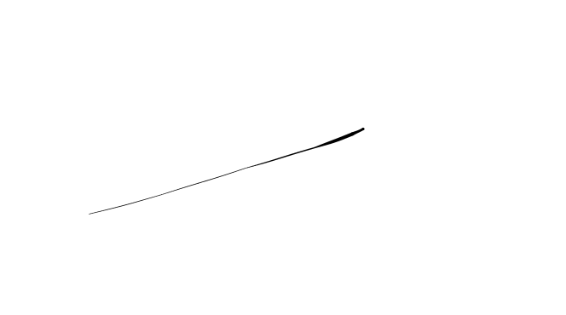Conforme Cliente Técnico

06/08/18

HOJA Nº: 1