**TITULAR INSTALACIÓN:** CONSERVATORIO PROFESIONAL DE DANZA REINA SOFIA

**DIRECCIÓN:** C/ TORRE MACHUCA, S/N, 18008, GRANADA

**EMPLAZAMIENTO:**UNICA

# DETALLE DE LOS ELEMENTOS DE PROTECCION CONTRA INCENDIOS

### Revisión de: Extintor

|  |  |  |  |  |  |  |  |
| --- | --- | --- | --- | --- | --- | --- | --- |
| **Nº** | **EQUIPO  REVISADO** | **Nº Timbre** | **F.Fabricacion** | **Retimbrado** | **Ubicación** | **Intervención** | **Estado** |
| 20 | PG6-ABC | 1985 | 01/01/2003 | 13/07/2017 | BIBLIOTECA | Revisión | OK |
| 21 | PG6-ABC | 1564 | 01/01/2003 | 13/07/2017 | ALMACEN 1 | Revisión | OK |
| 22 | PG6-ABC | 1963 | 01/01/2003 | 13/07/2017 | ESCENARIO | Revisión | OK |
| 23 | PG6-ABC | 1928 | 01/01/2003 | 13/07/2017 | CALDERAS | Revisión | OK |
|  |  |  |  |  |  |  |  |
|  |  |  |  |  |  |  |  |
|  |  |  |  |  |  |  |  |
|  |  |  |  |  |  |  |  |
|  |  |  |  |  |  |  |  |
|  |  |  |  |  |  |  |  |
|  |  |  |  |  |  |  |  |
|  |  |  |  |  |  |  |  |
|  |  |  |  |  |  |  |  |
|  |  |  |  |  |  |  |  |
|  |  |  |  |  |  |  |  |
|  |  |  |  |  |  |  |  |
|  |  |  |  |  |  |  |  |
|  |  |  |  |  |  |  |  |
|  |  |  |  |  |  |  |  |

**Observaciones:**

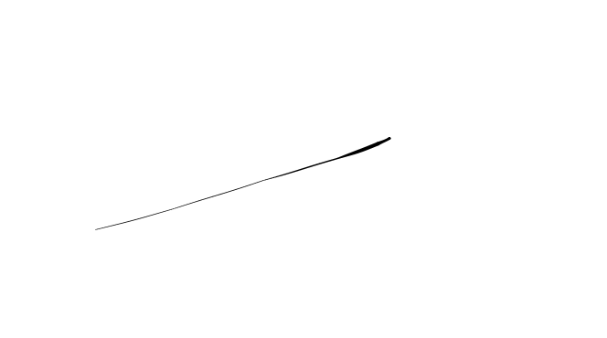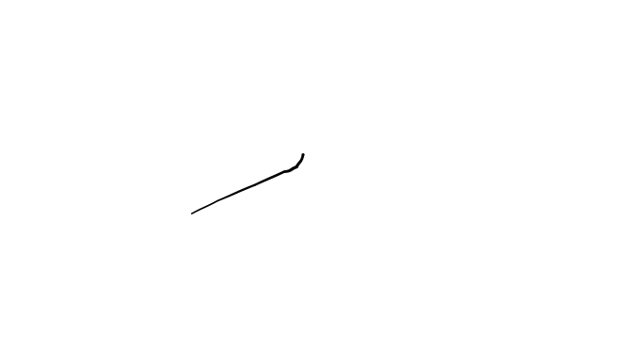Conforme Cliente Técnico

06/08/18

HOJA Nº: 2