**TITULAR INSTALACIÓN:** CP LAS NIEVES

**DIRECCIÓN:** C/ REAL DE MALAGA, 136-138, 18110, LAS GABIAS, GRANADA

**EMPLAZAMIENTO:**PISCINA

# DETALLE DE LOS ELEMENTOS DE PROTECCION CONTRA INCENDIOS

### Revisión de: BIE

|  |  |  |  |  |  |  |  |
| --- | --- | --- | --- | --- | --- | --- | --- |
| **Nº** | **EQUIPO  REVISADO** | **Nº Timbre** | **F.Fabricacion** | **Retimbrado** | **Ubicación** | **Intervención** | **Estado** |
| 1 | BIE 25/20 |  | 01/01/2018 |  | PLANTA ALTA | Retimbrado+Recarga | RTRC |
| 2 | BIE 25/20 |  | 01/01/2008 | 07/03/2018 | PLANTA BAJA | Retimbrado+Recarga | RTRC |
|  |  |  |  |  |  |  |  |
|  |  |  |  |  |  |  |  |
|  |  |  |  |  |  |  |  |
|  |  |  |  |  |  |  |  |
|  |  |  |  |  |  |  |  |
|  |  |  |  |  |  |  |  |
|  |  |  |  |  |  |  |  |
|  |  |  |  |  |  |  |  |
|  |  |  |  |  |  |  |  |
|  |  |  |  |  |  |  |  |
|  |  |  |  |  |  |  |  |
|  |  |  |  |  |  |  |  |
|  |  |  |  |  |  |  |  |
|  |  |  |  |  |  |  |  |
|  |  |  |  |  |  |  |  |
|  |  |  |  |  |  |  |  |
|  |  |  |  |  |  |  |  |

**Observaciones:**

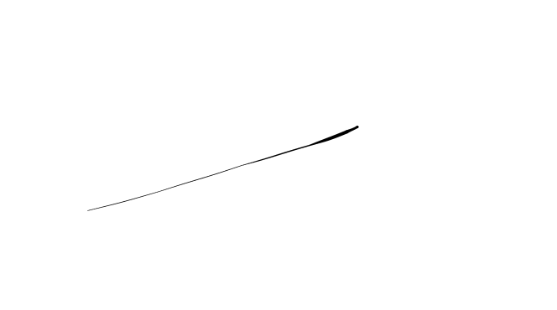Conforme Cliente Técnico

06/08/18

HOJA Nº: 1