**TITULAR INSTALACIÓN:** GIMNASIO TRIUNFO S.A.

**DIRECCIÓN:** C/ ANCHA DE CAPUCHINOS, 7-9, 18012, GRANADA

**EMPLAZAMIENTO:**UNICA

# DETALLE DE LOS ELEMENTOS DE PROTECCION CONTRA INCENDIOS

### Revisión de: BIE

|  |  |  |  |  |  |  |  |
| --- | --- | --- | --- | --- | --- | --- | --- |
| **Nº** | **EQUIPO  REVISADO** | **Nº Timbre** | **F.Fabricacion** | **Retimbrado** | **Ubicación** | **Intervención** | **Estado** |
| 1 | BIE 25/20 |  | 01/01/2002 | 01/06/2013 | ENTRADA | Revisión | OK |
| 2 | BIE 45/20 |  | 01/01/1970 | 01/06/2013 | PASILLO | Revisión | OK |
|  |  |  |  |  |  |  |  |
|  |  |  |  |  |  |  |  |
|  |  |  |  |  |  |  |  |
|  |  |  |  |  |  |  |  |
|  |  |  |  |  |  |  |  |
|  |  |  |  |  |  |  |  |
|  |  |  |  |  |  |  |  |
|  |  |  |  |  |  |  |  |
|  |  |  |  |  |  |  |  |
|  |  |  |  |  |  |  |  |
|  |  |  |  |  |  |  |  |
|  |  |  |  |  |  |  |  |
|  |  |  |  |  |  |  |  |
|  |  |  |  |  |  |  |  |
|  |  |  |  |  |  |  |  |
|  |  |  |  |  |  |  |  |
|  |  |  |  |  |  |  |  |

**Observaciones:**

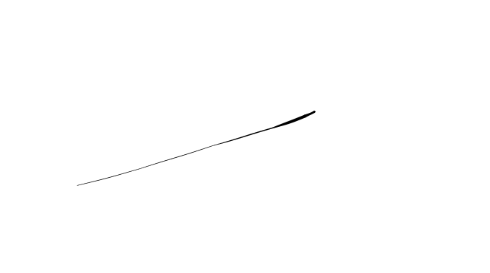Conforme Cliente Técnico

08/08/18

HOJA Nº: 1