**TITULAR INSTALACIÓN:** JUNCTION PARQUE GRANADA S.L.U.

**DIRECCIÓN:** CORTIJO DE PIEDRAHITA BOULEVARD BILLY WILDER, S/N, 18197, PULIANAS, GRANADA

**EMPLAZAMIENTO:**EDIFICIO

# DETALLE DE LOS ELEMENTOS DE PROTECCION CONTRA INCENDIOS

### Revisión de: Extintor

|  |  |  |  |  |  |  |  |
| --- | --- | --- | --- | --- | --- | --- | --- |
| **Nº** | **EQUIPO  REVISADO** | **Nº Timbre** | **F.Fabricacion** | **Retimbrado** | **Ubicación** | **Intervención** | **Estado** |
| 20 | PG 6 - ABC | 243890 | 01/01/2004 | 01/01/2014 | PASILLO ENTRADA | Revisión | OK |
|  |  |  |  |  |  |  |  |
|  |  |  |  |  |  |  |  |
|  |  |  |  |  |  |  |  |
|  |  |  |  |  |  |  |  |
|  |  |  |  |  |  |  |  |
|  |  |  |  |  |  |  |  |
|  |  |  |  |  |  |  |  |
|  |  |  |  |  |  |  |  |
|  |  |  |  |  |  |  |  |
|  |  |  |  |  |  |  |  |
|  |  |  |  |  |  |  |  |
|  |  |  |  |  |  |  |  |
|  |  |  |  |  |  |  |  |
|  |  |  |  |  |  |  |  |
|  |  |  |  |  |  |  |  |
|  |  |  |  |  |  |  |  |
|  |  |  |  |  |  |  |  |
|  |  |  |  |  |  |  |  |

**Observaciones:**

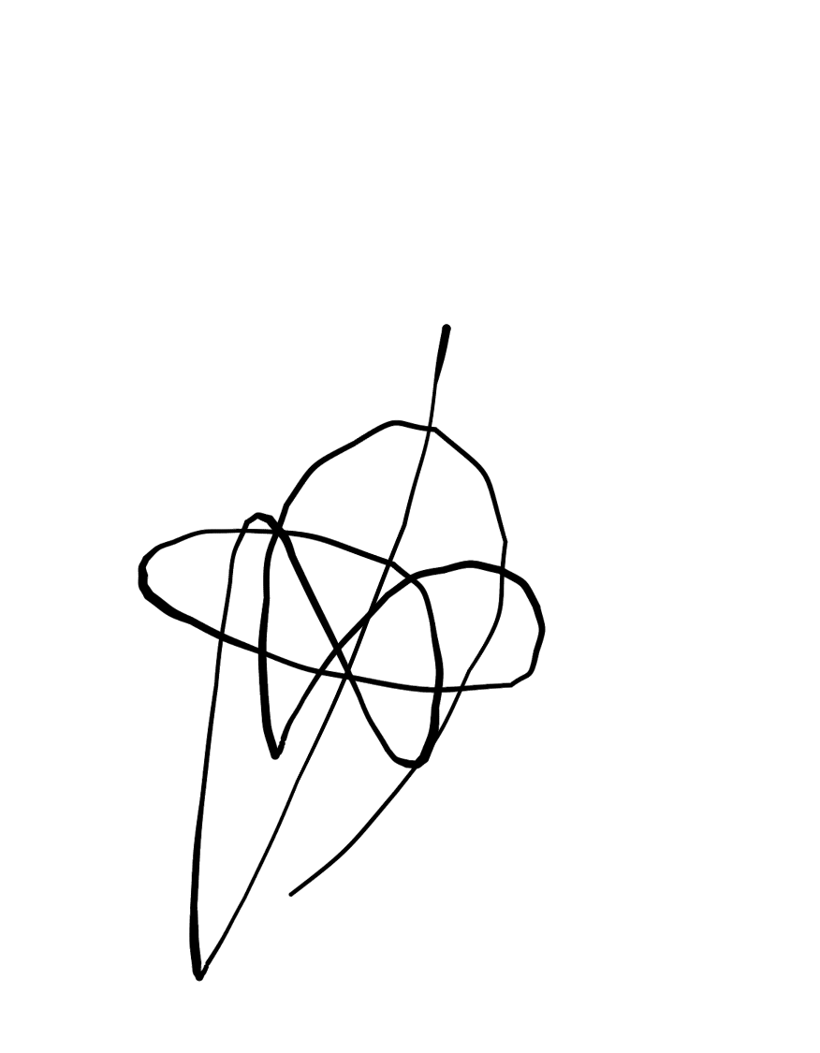Conforme Cliente Técnico

13/08/18

HOJA Nº: 2