**TITULAR INSTALACIÓN:** JUNCTION PARQUE GRANADA S.L.U.

**DIRECCIÓN:** CORTIJO DE PIEDRAHITA BOULEVARD BILLY WILDER, S/N, 18197, PULIANAS, GRANADA

**EMPLAZAMIENTO:**APARCAMIENTO SUBTERRANEO

# DETALLE DE LOS ELEMENTOS DE PROTECCION CONTRA INCENDIOS

### Revisión de: BIE

|  |  |  |  |  |  |  |  |
| --- | --- | --- | --- | --- | --- | --- | --- |
| **Nº** | **EQUIPO  REVISADO** | **Nº Timbre** | **F.Fabricacion** | **Retimbrado** | **Ubicación** | **Intervención** | **Estado** |
| 1 | BIE 25/20 |  | 01/01/2005 | 12/03/2018 | PARKING | Revisión | OK |
| 2 | BIE 25/20 |  | 01/01/2005 | 12/03/2018 | PARKING | Revisión | OK |
| 3 | BIE 25/20 |  | 01/01/2005 | 12/03/2018 | PARKING | Revisión | OK |
| 4 | BIE 25/20 |  | 01/01/2005 | 12/03/2018 | PARKING | Revisión | OK |
| 5 | BIE 25/20 |  | 01/01/2005 | 12/03/2018 | PARKING | Revisión | OK |
| 6 | BIE 25/20 |  | 01/01/2005 | 12/03/2018 | PARKING | Revisión | OK |
| 7 | BIE 25/20 |  | 01/01/2005 | 12/03/2018 | PARKING | Revisión | OK |
| 8 | BIE 25/20 |  | 01/01/2005 | 12/03/2018 | PARKING | Revisión | OK |
| 9 | BIE 25/20 |  | 01/01/2005 | 12/03/2018 | PARKING | Revisión | OK |
| 10 | BIE 25/20 |  | 01/01/2005 | 12/03/2018 | PARKING | Revisión | OK |
| 11 | BIE 25/20 |  | 01/01/2005 | 12/03/2018 | PARKING | Revisión | OK |
| 12 | BIE 25/20 |  | 01/01/2005 | 12/03/2018 | PARKING | Revisión | OK |
| 13 | BIE 25/20 |  | 01/01/2005 | 12/03/2018 | PARKING | Revisión | OK |
| 14 | BIE 25/20 |  | 01/01/2005 | 12/03/2018 | PARKING | Revisión | OK |
| 15 | BIE 25/20 |  | 01/01/2005 | 12/03/2018 | PARKING | Revisión | OK |
| 16 | BIE 25/20 |  | 01/01/2005 | 12/03/2018 | PARKING | Revisión | OK |
| 17 | BIE 25/20 |  | 01/01/2005 | 12/03/2018 | PARKING | Revisión | OK |
|  |  |  |  |  |  |  |  |
|  |  |  |  |  |  |  |  |

**Observaciones:**

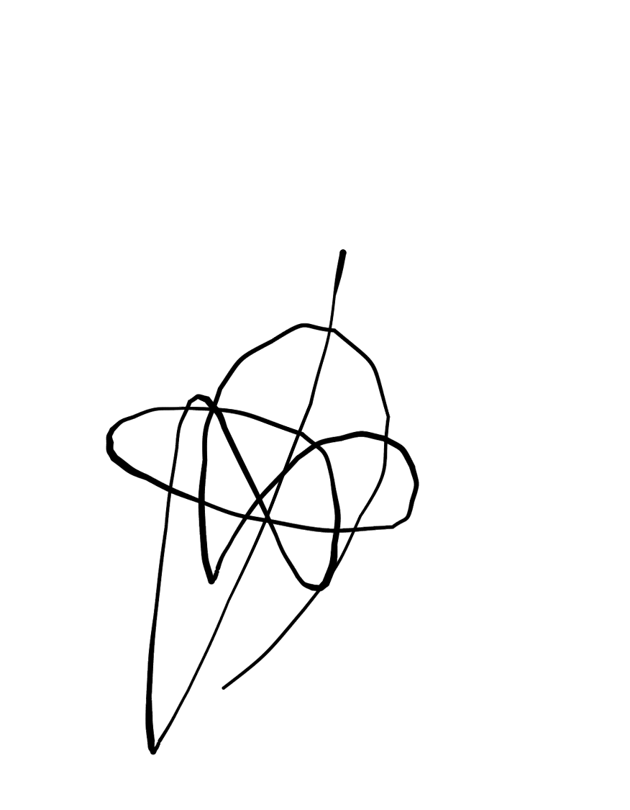Conforme Cliente Técnico

13/08/18

HOJA Nº: 1