**TITULAR INSTALACIÓN:** JUNCTION PARQUE GRANADA S.L.U.

**DIRECCIÓN:** CORTIJO DE PIEDRAHITA BOULEVARD BILLY WILDER, S/N, 18197, PULIANAS, GRANADA

**EMPLAZAMIENTO:**APARCAMIENTO SUBTERRANEO

# DETALLE DE LOS ELEMENTOS DE PROTECCION CONTRA INCENDIOS

### Revisión de: Extintor

|  |  |  |  |  |  |  |  |
| --- | --- | --- | --- | --- | --- | --- | --- |
| **Nº** | **EQUIPO  REVISADO** | **Nº Timbre** | **F.Fabricacion** | **Retimbrado** | **Ubicación** | **Intervención** | **Estado** |
| 1 | PG 6 - ABC | 669743 | 01/01/2017 |  | PARKING | Revisión | OK |
| 2 | PG 6 - ABC | 327408 | 01/01/2004 | 01/01/2015 | PARKING | Revisión | OK |
| 3 | PG 6 - ABC | 1142 | 01/01/2011 | 01/01/2016 | PARKING | Revisión | OK |
| 4 | PG 6 - ABC | 183897 | 01/01/2005 | 01/01/2015 | PARKING | Revisión | OK |
| 5 | PG 6 - ABC | 183971 | 01/01/2004 | 01/01/2015 | PARKING | Revisión | OK |
| 6 | PG 6 - ABC | 1509 | 01/01/2010 | 01/01/2015 | PARKING | Recarga | RC |
| 7 | PG 6 - ABC | 181243 | 01/01/2005 | 01/01/2015 | PARKING | Revisión | OK |
| 8 | PG 6 - ABC | 198048 | 01/01/2006 | 01/01/2015 | PARKING | Revisión | OK |
| 9 | PG 6 - ABC | 181257 | 01/01/2005 | 01/01/2015 | PARKING | Revisión | OK |
| 10 | PG 6 - ABC | 724 | 01/01/2005 | 01/01/2015 | PARKING | Revisión | OK |
| 11 | PG 6 - ABC | 891 | 01/01/2005 | 01/01/2015 | PARKING | Revisión | OK |
| 12 | PG 6 - ABC | 198041 | 01/01/2006 | 01/01/2015 | PARKING | Revisión | OK |
| 13 | PG 6 - ABC | 562 | 01/01/2005 | 01/01/2015 | PARKING | Revisión | OK |
| 14 | PG 6 - ABC | 152982 | 01/01/2005 | 01/01/2015 | PARKING | Revisión | OK |
| 15 | PG 6 - ABC | 745 | 01/01/2005 | 01/01/2015 | PARKING | Revisión | OK |
| 16 | PG 6 - ABC | 748 | 01/01/2005 | 01/01/2015 | PARKING | Revisión | OK |
| 17 | PG 6 - ABC | 828 | 01/01/2005 | 01/01/2015 | PARKING | Revisión | OK |
| 18 | PG 6 - ABC | 616 | 01/01/2005 | 01/01/2015 | PARKING | Revisión | OK |
| 19 | PG 6 - ABC | 10032 | 01/01/2005 | 01/01/2015 | PARKING | Revisión | OK |

**Observaciones:**

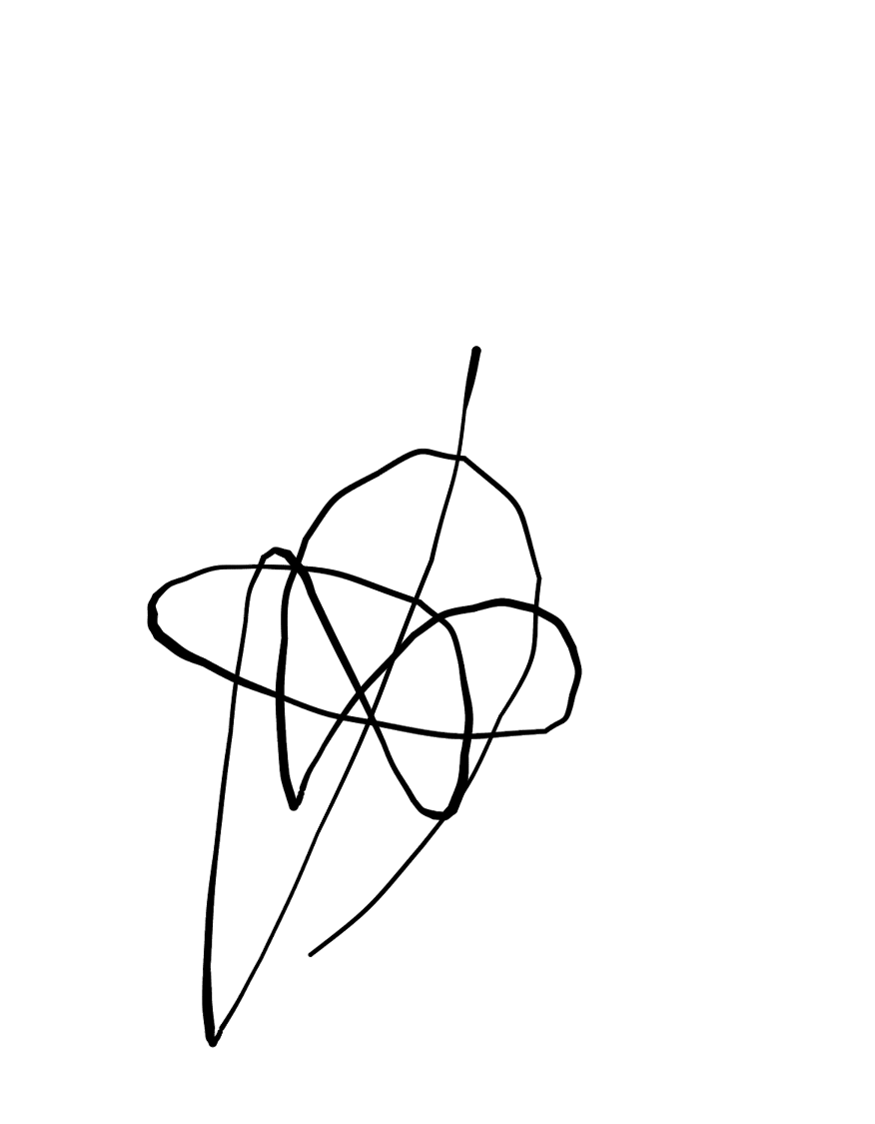Conforme Cliente Técnico

13/08/18

HOJA Nº: 1