**TITULAR INSTALACIÓN:** FUNERARIA ARMILLA FERMIN CRIADO S.L.

**DIRECCIÓN:** CAMINO CEMENTERIO MUNICIPAL, S/N, 18195, CULLAR VEGA, GRANADA

**EMPLAZAMIENTO:**CULLAR VEGA

# DETALLE DE LOS ELEMENTOS DE PROTECCION CONTRA INCENDIOS

### Revisión de: Extintor

|  |  |  |  |  |  |  |  |
| --- | --- | --- | --- | --- | --- | --- | --- |
| **Nº** | **EQUIPO  REVISADO** | **Nº Timbre** | **F.Fabricacion** | **Retimbrado** | **Ubicación** | **Intervención** | **Estado** |
| 1 | PG6-ABC | 255664 | 01/01/2006 | 01/01/2016 | PASILLO | Revisión | OK |
| 2 | NC5-CO2 | 5047 | 01/01/2006 | 01/01/2016 | PASILLO | Revisión | OK |
| 3 | PG6-ABC | 593 | 01/01/2011 | 01/01/2016 | ENTRADA | Revisión | OK |
|  |  |  |  |  |  |  |  |
|  |  |  |  |  |  |  |  |
|  |  |  |  |  |  |  |  |
|  |  |  |  |  |  |  |  |
|  |  |  |  |  |  |  |  |
|  |  |  |  |  |  |  |  |
|  |  |  |  |  |  |  |  |
|  |  |  |  |  |  |  |  |
|  |  |  |  |  |  |  |  |
|  |  |  |  |  |  |  |  |
|  |  |  |  |  |  |  |  |
|  |  |  |  |  |  |  |  |
|  |  |  |  |  |  |  |  |
|  |  |  |  |  |  |  |  |
|  |  |  |  |  |  |  |  |
|  |  |  |  |  |  |  |  |

**Observaciones:**

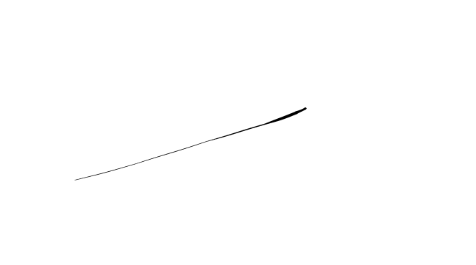Conforme Cliente Técnico

08/08/18

HOJA Nº: 1