**TITULAR INSTALACIÓN:** I.E.S. BULYANA

**DIRECCIÓN:** AVD ANDALUCIA, 15 , 18197 PULIANAS (GRANADA)

**EMPLAZAMIENTO:**I.E.S. BULYANA

# DETALLE DE LOS ELEMENTOS DE PROTECCION CONTRA INCENDIOS

### Revisión de: Extintor

|  |  |  |  |  |  |  |  |
| --- | --- | --- | --- | --- | --- | --- | --- |
| **Nº** | **EQUIPO  REVISADO** | **Nº Timbre** | **F.Fabricacion** | **Retimbrado** | **Ubicación** | **Intervención** | **Estado** |
| 21 | Pg6- ABC | 001728 | 01/01/2013 | 10/09/2018 | Gimnasio | Retimbrado+Recarga | RTRC |
| 21 | Pg6- ABC | 00540 | 01/01/2013 | 10/09/2018 | Gimnasio | Retimbrado+Recarga | RTRC |
| 22 | Pg6- ABC | 00957 | 01/01/2013 | 10/09/2018 | Gimnasio | Retimbrado+Recarga | RTRC |
| 22 | Pg6- ABC | 00957 | 01/01/2013 | 10/09/2018 | Gimnasio | Retimbrado+Recarga | RTRC |
|  |  |  |  |  |  |  |  |
|  |  |  |  |  |  |  |  |
|  |  |  |  |  |  |  |  |
|  |  |  |  |  |  |  |  |
|  |  |  |  |  |  |  |  |
|  |  |  |  |  |  |  |  |
|  |  |  |  |  |  |  |  |
|  |  |  |  |  |  |  |  |
|  |  |  |  |  |  |  |  |
|  |  |  |  |  |  |  |  |
|  |  |  |  |  |  |  |  |
|  |  |  |  |  |  |  |  |
|  |  |  |  |  |  |  |  |
|  |  |  |  |  |  |  |  |
|  |  |  |  |  |  |  |  |

**Observaciones:**

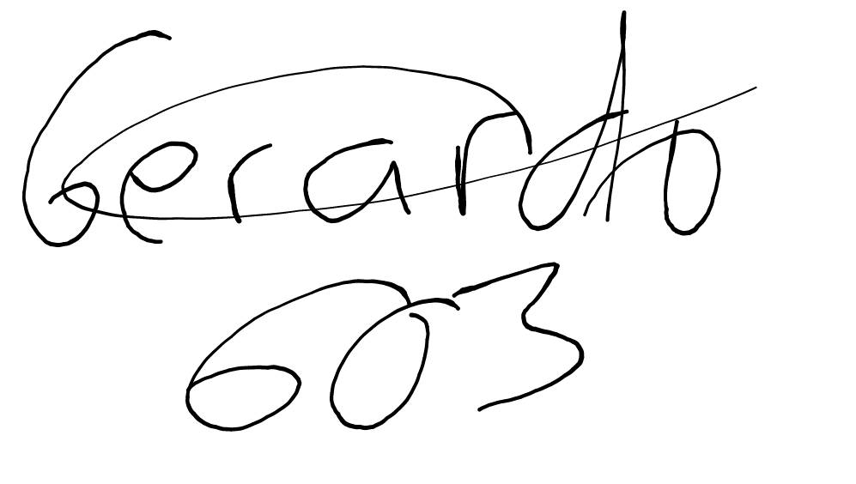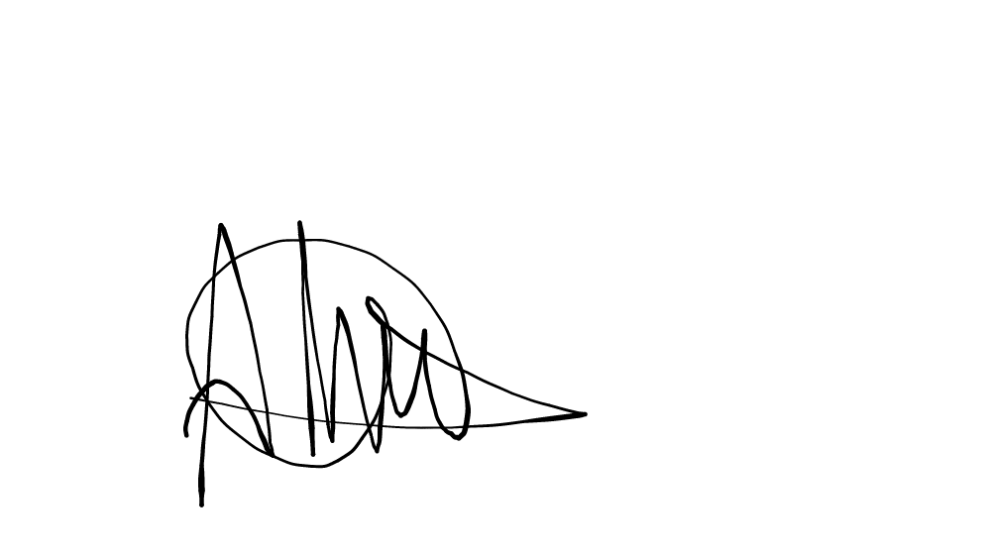Conforme Cliente Técnico

10/09/18 603

HOJA Nº: 2