**TITULAR INSTALACIÓN:** Vigilant S.A.

**DIRECCIÓN:** Paraguay, Parc. 8/9

**EMPLAZAMIENTO:**Alcantarilla (Murcia)

# DETALLE DE LOS ELEMENTOS DE PROTECCION CONTRA INCENDIOS

### Revisión de: BIE

|  |  |  |  |  |  |  |  |
| --- | --- | --- | --- | --- | --- | --- | --- |
| **Nº** | **EQUIPO  REVISADO** | **Nº Timbre** | **F.Fabricacion** | **Retimbrado** | **Ubicación** | **Intervención** | **Estado** |
| 1 | 20x15 | 447852 | 18/07/2018 |  | Pasillo | Revisión | OK |
|  |  |  |  |  |  |  |  |
|  |  |  |  |  |  |  |  |
|  |  |  |  |  |  |  |  |
|  |  |  |  |  |  |  |  |
|  |  |  |  |  |  |  |  |
|  |  |  |  |  |  |  |  |
|  |  |  |  |  |  |  |  |
|  |  |  |  |  |  |  |  |
|  |  |  |  |  |  |  |  |
|  |  |  |  |  |  |  |  |
|  |  |  |  |  |  |  |  |
|  |  |  |  |  |  |  |  |
|  |  |  |  |  |  |  |  |
|  |  |  |  |  |  |  |  |
|  |  |  |  |  |  |  |  |
|  |  |  |  |  |  |  |  |
|  |  |  |  |  |  |  |  |
|  |  |  |  |  |  |  |  |

**Observaciones:**

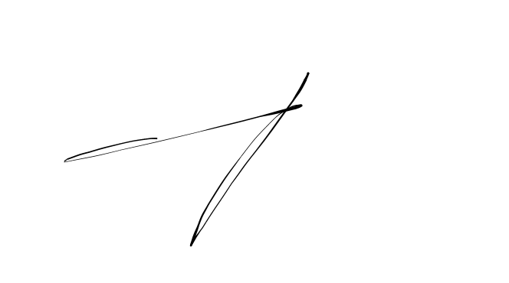Conforme Cliente Técnico

19/07/18 303

5646

HOJA Nº: 1