**TITULAR INSTALACIÓN:** VIGILANT S.A.

**DIRECCIÓN:** C/ PARAGUAY, PARC. 8/9, 30820, ALCANTARILLA, MURCIA

**EMPLAZAMIENTO:**EMPRESA

# DETALLE DE LOS ELEMENTOS DE PROTECCION CONTRA INCENDIOS

### Revisión de: Extintor

|  |  |  |  |  |  |  |  |
| --- | --- | --- | --- | --- | --- | --- | --- |
| **Nº** | **EQUIPO  REVISADO** | **Nº Timbre** | **F.Fabricacion** | **Retimbrado** | **Ubicación** | **Intervención** | **Estado** |
| 1 | PG6-ABC | 123456 | 13/09/2018 |  | CRA | Revisión | OK |
|  |  |  |  |  |  |  |  |
|  |  |  |  |  |  |  |  |
|  |  |  |  |  |  |  |  |
|  |  |  |  |  |  |  |  |
|  |  |  |  |  |  |  |  |
|  |  |  |  |  |  |  |  |
|  |  |  |  |  |  |  |  |
|  |  |  |  |  |  |  |  |
|  |  |  |  |  |  |  |  |
|  |  |  |  |  |  |  |  |
|  |  |  |  |  |  |  |  |
|  |  |  |  |  |  |  |  |
|  |  |  |  |  |  |  |  |
|  |  |  |  |  |  |  |  |
|  |  |  |  |  |  |  |  |
|  |  |  |  |  |  |  |  |
|  |  |  |  |  |  |  |  |
|  |  |  |  |  |  |  |  |

**Observaciones:**

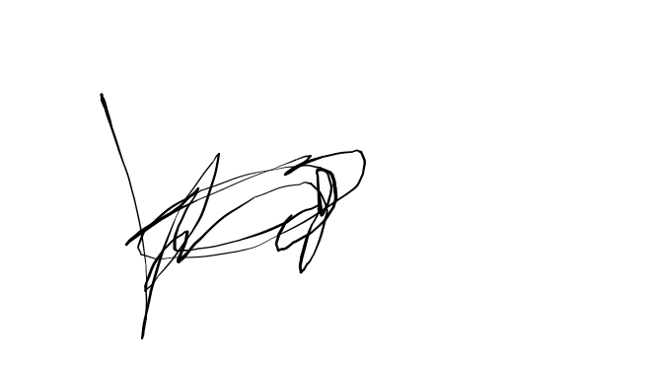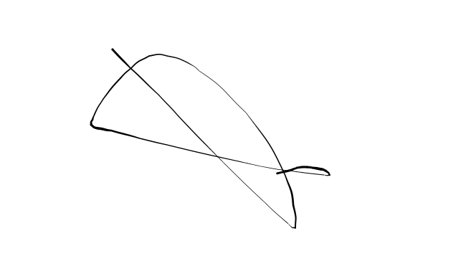Conforme Cliente Técnico

14/09/18

HOJA Nº: 1