**TITULAR INSTALACIÓN:** preubas

**DIRECCIÓN:** a?lkdsalkdsa?dslkjf

**EMPLAZAMIENTO:**adsf

# DETALLE DE LOS ELEMENTOS DE PROTECCION CONTRA INCENDIOS

### Revisión de: Extintor

|  |  |  |  |  |  |  |  |
| --- | --- | --- | --- | --- | --- | --- | --- |
| **Nº** | **EQUIPO  REVISADO** | **Nº Timbre** | **F.Fabricacion** | **Retimbrado** | **Ubicación** | **Intervención** | **Estado** |
| 12 | asdf | asdf | 01/01/2012 | 13/08/2018 | asdfa | Retimbrado+Recarga | RTRC |
|  |  |  |  |  |  |  |  |
|  |  |  |  |  |  |  |  |
|  |  |  |  |  |  |  |  |
|  |  |  |  |  |  |  |  |
|  |  |  |  |  |  |  |  |
|  |  |  |  |  |  |  |  |
|  |  |  |  |  |  |  |  |
|  |  |  |  |  |  |  |  |
|  |  |  |  |  |  |  |  |
|  |  |  |  |  |  |  |  |
|  |  |  |  |  |  |  |  |
|  |  |  |  |  |  |  |  |
|  |  |  |  |  |  |  |  |
|  |  |  |  |  |  |  |  |
|  |  |  |  |  |  |  |  |
|  |  |  |  |  |  |  |  |
|  |  |  |  |  |  |  |  |
|  |  |  |  |  |  |  |  |

**Observaciones:**

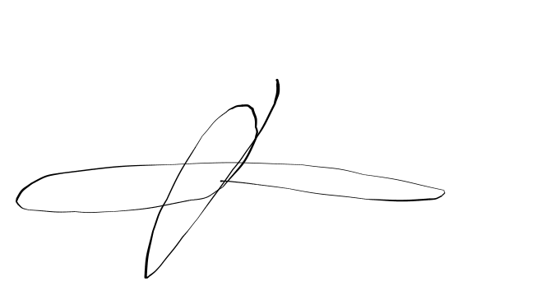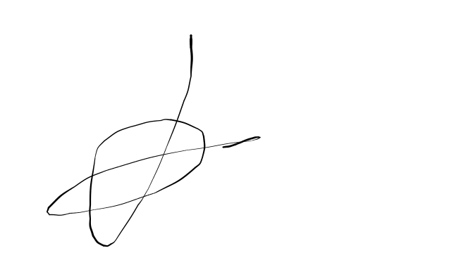Conforme Cliente Técnico

13/08/18

HOJA Nº: 1