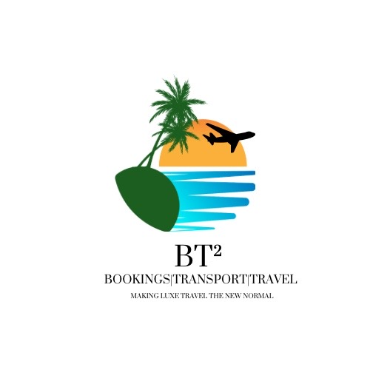
BT² Canada Visitor Visa – Full Client Intake Form
BT² – Bookings | Transport | Travel
Email: bookings.bt2@gmail.com | WhatsApp: 876-484-7802
Making Luxe Travel the New Normal
-----------------------------------------
Personal & Family
Full name: ________________________________
Citizenship(s): ________________________________
Marital status: ________________________________
Spouse & children details: ________________________________

Travel History
Countries visited last 10 years: ________________________________
Previous Canadian visa or refusal: ________________________________

Employment & Ties
Current employer: ________________________________
Length of employment: ________________________________
Approved leave dates: ________________________________
Property or business owned: ________________________________

Financial Information
Bank name: ________________________________
Account type: ________________________________
Average balance (6 months): ________________________________
Other assets: ________________________________

IMPORTANT DECLARATION & AUTHORISATION:
I confirm that all information provided is true, complete, and accurate. I understand that false, misleading, or incomplete information may result in refusal, delays, or bans. I acknowledge that BT² provides application assistance only and does not guarantee approval. I authorise BT² – Bookings | Transport | Travel to prepare and submit applications on my behalf.
Client Signature: __________________________ Date: ______________

