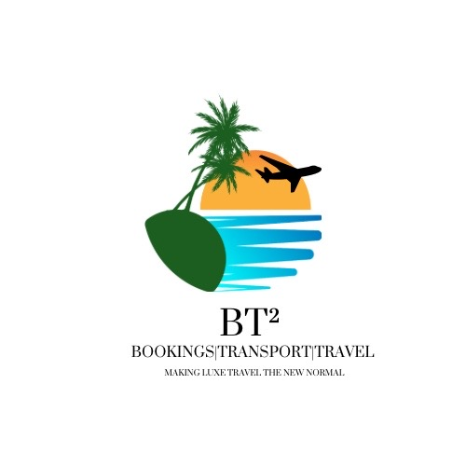
BT² Passport Application Information Form
BT² – Bookings | Transport | Travel
Email: bookings.bt2@gmail.com | WhatsApp: 876-484-7802
Making Luxe Travel the New Normal
-----------------------------------
Full Name (as per passport/birth certificate):

Other names used (maiden/previous):

Date of Birth:

Place of Birth:

Nationality:

Marital Status:

Residential Address:

Phone / WhatsApp Number:

Email Address:

Passport Number (if renewal):

Date of Issue & Expiry:

Parents’ Full Names:

Emergency Contact:

DISCLAIMER:
BT² provides visa and passport application assistance only and does not guarantee approval. All decisions are made solely by the relevant issuing authority.
DECLARATION & AUTHORISATION:
I confirm that the information provided is true and complete. I authorise BT² – Bookings | Transport | Travel to prepare and submit applications on my behalf based on the information supplied.
Client Signature: __________________________ Date: ______________

