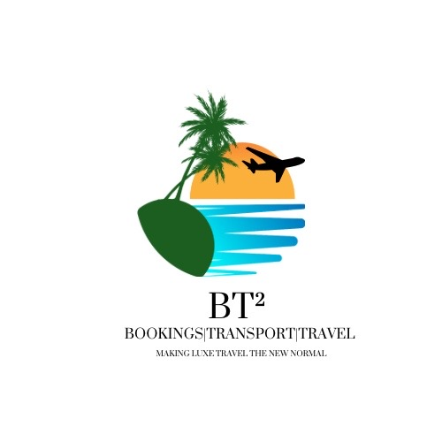
BT² Passport Application – Full Client Information Form
BT² – Bookings | Transport | Travel
Email: bookings.bt2@gmail.com | WhatsApp: 876-484-7802
Making Luxe Travel the New Normal
-----------------------------------------
Personal Information
Full name (as per birth certificate/passport): ________________________________
All other names used: ________________________________
Date of birth: ________________________________
Place of birth: ________________________________
Gender: ________________________________
Nationality: ________________________________
TRN / National ID number: ________________________________

Passport History
Passport number (if renewal): ________________________________
Date of issue: ________________________________
Date of expiry: ________________________________
Issuing country: ________________________________
Lost or stolen passport (details): ________________________________

Family Information
Mother’s full name and nationality: ________________________________
Father’s full name and nationality: ________________________________

Legal / Background
Criminal convictions (Yes/No – details): ________________________________
Court matters pending (Yes/No – details): ________________________________

IMPORTANT DECLARATION & AUTHORISATION:
I confirm that all information provided is true, complete, and accurate. I understand that false, misleading, or incomplete information may result in refusal, delays, or bans. I acknowledge that BT² provides application assistance only and does not guarantee approval. I authorise BT² – Bookings | Transport | Travel to prepare and submit applications on my behalf.
Client Signature: __________________________ Date: ______________

