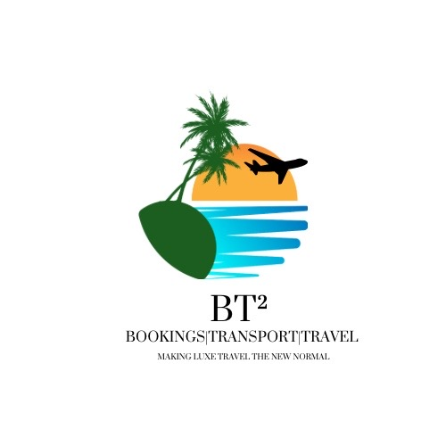
BT² UK Standard Visitor Visa – Full Client Intake Form
BT² – Bookings | Transport | Travel
Email: bookings.bt2@gmail.com | WhatsApp: 876-484-7802
Making Luxe Travel the New Normal
-----------------------------------------
Personal Information
Full name: ________________________________
Nationality: ________________________________
Passport number & expiry: ________________________________

Travel Details
Purpose of visit: ________________________________
Travel dates: ________________________________
UK address / accommodation: ________________________________

Employment & Income
Employer name & address: ________________________________
Job title: ________________________________
Monthly income: ________________________________
Additional income sources: ________________________________

Immigration History
UK or other visa refusals: ________________________________
Overstays or removals: ________________________________

IMPORTANT DECLARATION & AUTHORISATION:
I confirm that all information provided is true, complete, and accurate. I understand that false, misleading, or incomplete information may result in refusal, delays, or bans. I acknowledge that BT² provides application assistance only and does not guarantee approval. I authorise BT² – Bookings | Transport | Travel to prepare and submit applications on my behalf.
Client Signature: __________________________ Date: ______________

