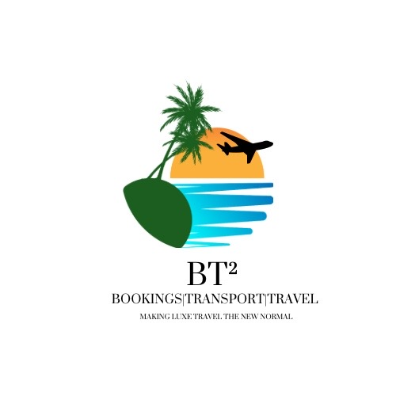
BT² USA Visa (DS‑160) – Full Client Intake Form
BT² – Bookings | Transport | Travel
Email: bookings.bt2@gmail.com | WhatsApp: 876-484-7802
Making Luxe Travel the New Normal
-----------------------------------------
Personal History
Full name (passport): ________________________________
All names ever used: ________________________________
Date & place of birth: ________________________________
Other citizenships: ________________________________
National ID number: ________________________________
Social media handles (last 5 years): ________________________________

Travel History
Previous travel to USA (dates & visa type): ________________________________
US refusals or overstays (details): ________________________________
Countries visited last 5 years: ________________________________

Employment History (5 years)
Current employer name & address: ________________________________
Job title and duties: ________________________________
Monthly income: ________________________________
Previous employers (details): ________________________________

Security & Background
Arrests or convictions: ________________________________
Immigration violations: ________________________________
Military / law enforcement service: ________________________________

IMPORTANT DECLARATION & AUTHORISATION:
I confirm that all information provided is true, complete, and accurate. I understand that false, misleading, or incomplete information may result in refusal, delays, or bans. I acknowledge that BT² provides application assistance only and does not guarantee approval. I authorise BT² – Bookings | Transport | Travel to prepare and submit applications on my behalf.
Client Signature: __________________________ Date: ______________

