Name : **Gaurav Kumar Singh**

Email : bm22mtech11002@iith.ac.in

LinkedIn : https://www.linkedin.com/in/gaurav-kumar-singh-72b8921b7/

PSYLIQ

**DIABETES PREDICTION ASSESSMENT**

1. **Retrieve the Patient_id and ages of all patients.**

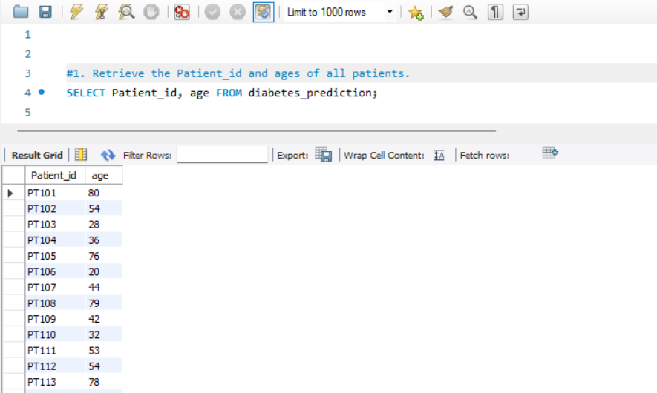

1. **Select all female patients who are older than 40.**

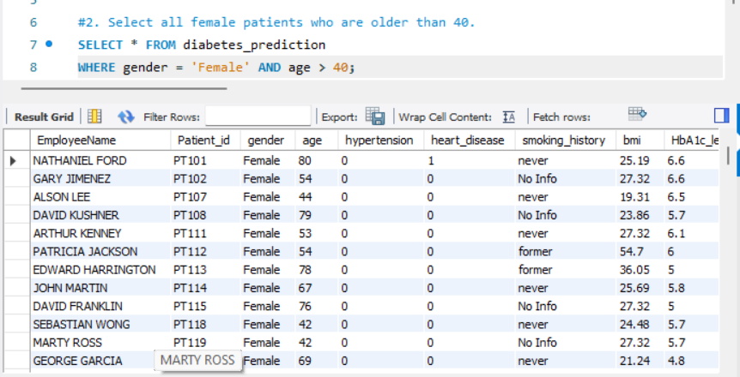

1. **Calculate the average BMI of patients.**

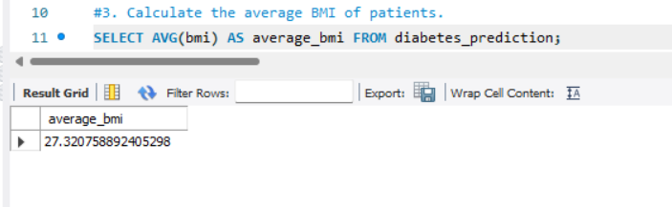

1. **List patients in descending order of blood glucose levels.**

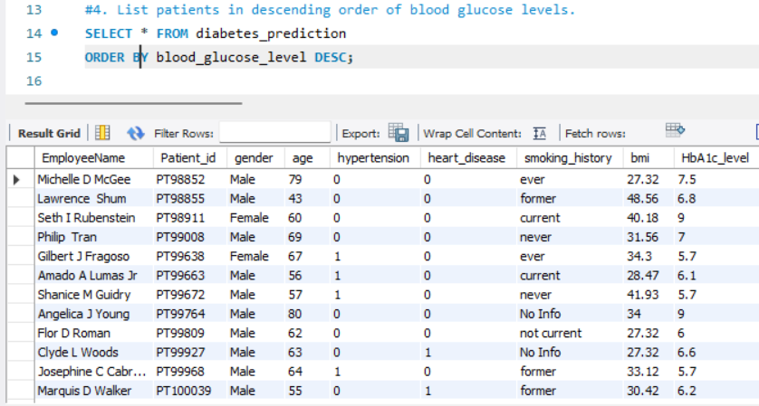

1. **Find patients who have hypertension and diabetes.**

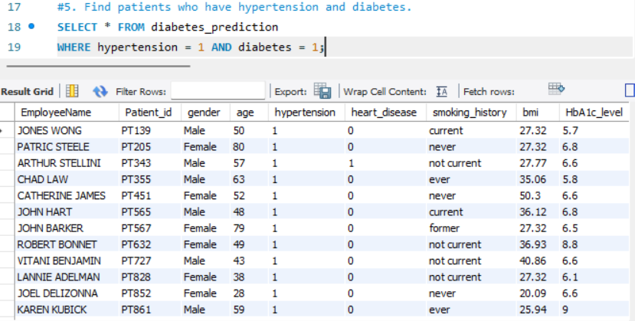

1. **Determine the number of patients with heart disease.**

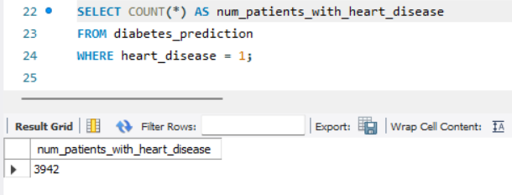

1. **Group patients by smoking history and count how many smokers and nonsmokers there are.**

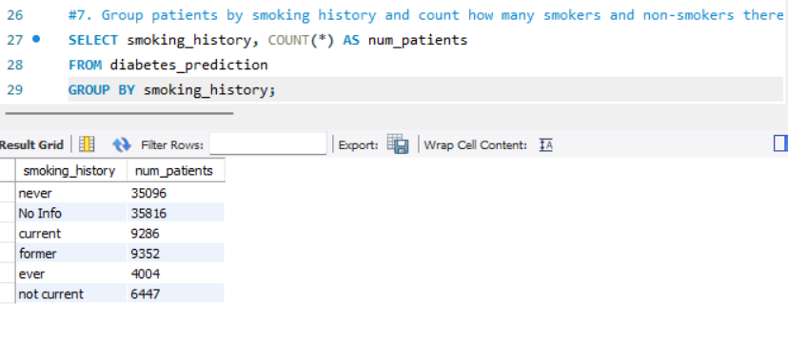

1. **Retrieve the Patient_ids of patients who have a BMI greater than the average BMI.**

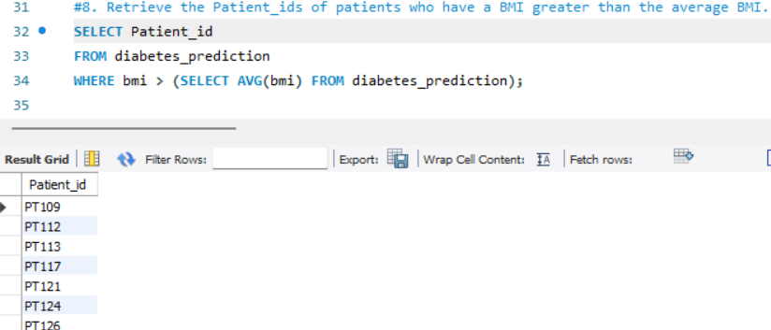

**9. Find the patient with the highest HbA1c level and the patient with the lowest**

**HbA1clevel.**

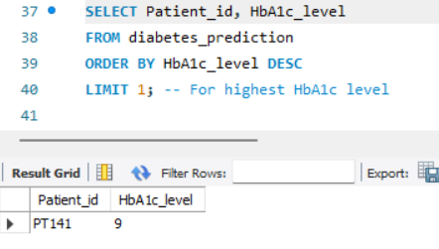

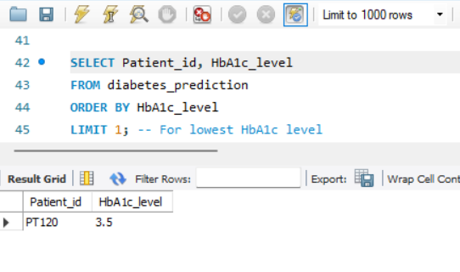

1. **Calculate the age of patients in years (assuming the current date as of now).**

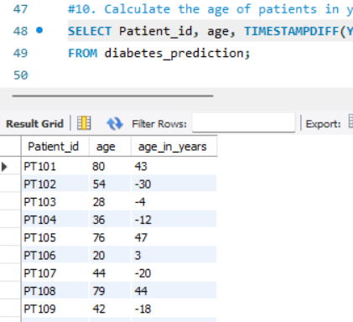

1. **Rank patients by blood glucose level within each gender group.**

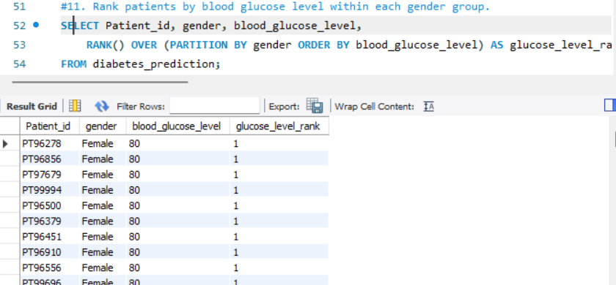

1. **Update the smoking history of patients who are older than 50 to "Ex-smoker."**

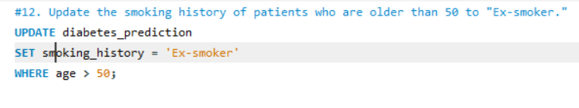

1. **Insert a new patient into the database with sample data.**

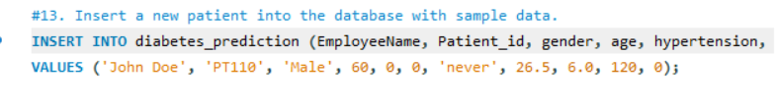

1. **Delete all patients with heart disease from the database.**

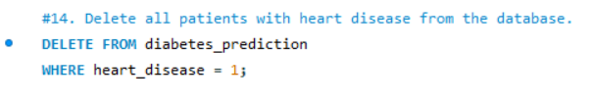

1. **Find patients who have hypertension but not diabetes using the EXCEPT operator.**

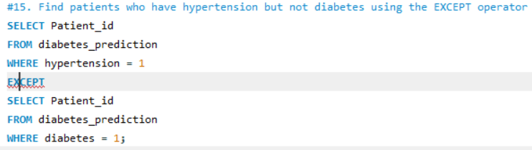

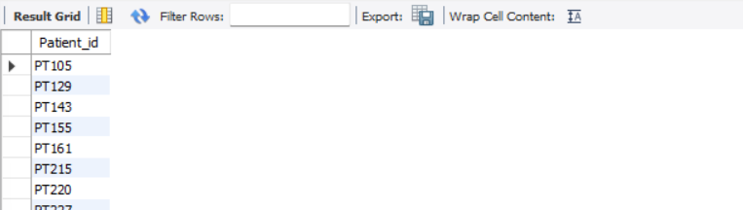

1. **Define a unique constraint on the "patient_id" column to ensure its values are unique.**

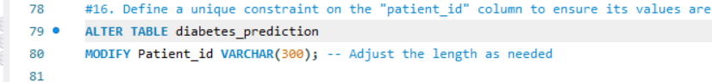

**17. Create a view that displays the Patient_ids, ages, and BMI of patients.**

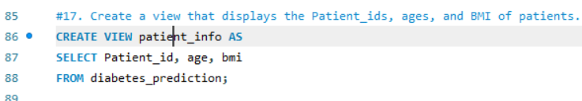

**18. Suggest improvements in the database schema to reduce data redundancy and**

**improve data integrity.**

* Normalization: Ensure the database is normalized to reduce redundancy. For example, you might have a separate table for patient demographics (e.g., name, gender), and the main table would reference the demographics using a foreign key.
* Foreign Keys: Use foreign keys to establish relationships between tables. For instance, you could have a separate table for smoking history with a foreign key in the main table.
* Data Types: Use appropriate data types for each column to minimize storage and enhance data integrity.
* Indexes: Add indexes on columns frequently used in search conditions to improve query performance.

**19. Explain how you can optimize the performance of SQL queries on this dataset**

**Indexes: Properly index columns used in WHERE clauses and JOIN conditions.**

* Avoid SELECT : Only select the columns you need instead of using SELECT .
* Use Joins Efficiently: Optimize JOIN operations, and use INNER JOIN, LEFT JOIN, etc., as needed.
* Partitioning: If the dataset is large, consider partitioning the table based on certain criteria.
* Update Statistics: Keep statistics up-to-date to help the query optimizer make better decisions.
* Limit Results: Use LIMIT or TOP to restrict the number of rows returned, especially when displaying data in applications.
* Review Execution Plans: Analyze the query execution plans to identify areas for improvement.
* Caching: Utilize caching mechanisms where appropriate to avoid redundant queries.