SOFTWARE REQUIREMENT SPECIFICATION

ERP System

# Table of Contents

Table of Contents 2

1. INTRODUCTION 4
   1. PURPOSE 4
   2. DOCUMENT CONVENTION 4
   3. SCOPE 5

Phase - I 5

Phase-II 5

Phase-III 5

* 1. RESOURCES 5
     1. People 5
     2. Hardware Requirements 6
     3. Software Requirements 6

1. OVERALL DESCRIPTION 8
   1. PRODUCT PERSPECTIVE 9
      1. User Interfaces 9
      2. Hardware Interfaces 10
         1. Server Side 10
         2. Client Side 10
         3. Software Interfaces 10
         4. Communication Interfaces 10
   2. Product Functions 11
      1. Biometric Based Attendance System 11

Requirement Analysis 11

Requirement Specification 12

Raspberry Pi 3 13

R305 Fingerprint Sensor 13

* + 1. ERP Requirements 14
       1. Login and Logout 14
       2. Attendance Management 14
       3. Leave Application 14
       4. Salary Management System 14
       5. Employee Management System 15
       6. Invoice Generation 15
  1. Constraints and Dependencies 15

1. DATA MODEL 16
   1. Data Objects 16
      1. User Object 16
      2. Attendance Object 16
      3. Salary Object 16
   2. Relationships 16
2. PROPOSED MILESTONES 17
3. CONCLUSION 18

List of Tables List of Figures section #To complete after E-R Diagrams

# INTRODUCTION

### PURPOSE

This Software Requirement Specification (SRS) document covers the Extern Labs Enterprise Resource Management System’s software requirements, quality and design description. It will illustrate the purpose and complete declaration for the development of the system. It will also explain system constraints, interface and its basic modules interaction.

Intended Audience:

1. Software Developer
2. Software Tester

### DOCUMENT CONVENTION

|  |  |
| --- | --- |
| **Term** | **Definition** |
| ERP | Enterprise Resource Management |
| SRS | Software Requirement Specification |
| DB | Database |
| VCS | Version Control System |
| BAS | Biometric Attendance System |

|  |  |
| --- | --- |
| ER | Entity Relationship |

### SCOPE

The scope of the project has been defined in the following three phases. The underlying applications are required to be produced for the same.

### Phase - I

* + - Biometric Attendance System
    - User Login/ Signup system
    - Attendance Management
    - Leave Application

### Phase-II

* + - Salary Management System
    - Employee Dashboard
    - Admin Management Tool ( Access Control System)

### Phase-III

* + - Invoice Management
    - Integration of all the platform
  1. **RESOURCES**

### People

* + - * Development Team
        + Biometric Development
        + Web Application - Frontend
        + Web Application - Backend
        + Testing Team

### HardwareRequirements

* + - * Biometric Attendance System
        + Raspberry Pi 3B/B+
        + FingerPrint Sensor (suggested models: R305/R307/ZFM20)
        + USB to TTL/serial converter (suggested models: PL2303)
        + Bread Board
        + Jumper Wires
        + LCD display
        + Buzzer / Speaker
      * Web Application
        + Server Machine for hosting :
        + Development Machine : Min req: i7, 8Gb Ram, 200 GB Storage

### SoftwareRequirements

* + - * Biometric Attendance System
        + Any lightweight debian based distro/Raspbian OS
        + Python
        + Python Fingerprint Library
      * Web Application
        + Ubuntu 18.04/20.04 LTS
        + Python
        + Django Rest Framework
        + Postgresql
        + Git (VCS)
        + #Front-end technologies ( TO BE FILLED)

# OVERALL DESCRIPTION

The ERP project is developed in order to provide an integrated software suite for Extern Labs. It will offer functionality in many areas including HR, Employee Management and Resource Management services. The overall goal of the ERP is to implement an administrative software that can be used to improve services to the employees and the management team and can help make the organization to be more technologically competitive and efficient.

## PRODUCTPERSPECTIVE

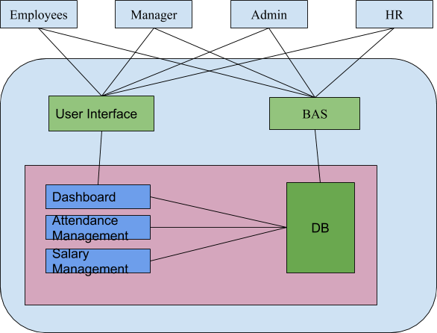

### User Interfaces

The user interfaces of the ERP System are to be achieved through a web application. Thus, it will use web technologies such as HTML, CSS, AJAX, JavaScript etc. There will be forms, buttons, select boxes, text boxes to interact with the user. There is a main login interface of the system. Each level of user will login to the system by this login page. In the login page, there is an authentication system to verify that the user is an employee of Extern Labs. There is also an authorization system for each user to access his or her own pages and access rights (Employee, Team Lead, Administrator, HR). Each module has its own user interface. Every user type can only access its own interface.

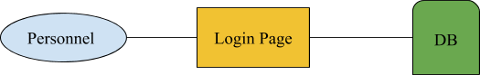

### Hardware Interfaces

#### Server Side

The web application will be hosted on one of the servers of the company and connected to Postgresql Database.

#### Client Side

The system is a web-based application that is only to be used by the employees of the company. The user must have an internet connection in order to access the system and to use the application. Users are required to have a modern web browser such as Mozilla Firefox, or Google Chrome etc.

#### Software Interfaces

In this system, Django Rest Framework would be used to provide the backend along with modern frameworks like Reactjs to provide the front-end interface.

#### Communication Interfaces

The HTTP protocol will be used to facilitate communications between the client and server. Also, SMTP protocol will be used to manage mail notification systems.

## Product Functions

### Biometric Based Attendance System

The Biometric based Attendance System is to be developed on Raspberry Pi 3b+ board using Python along with Py-Fingerprint Library. The purpose of developing this system is to computerize the

current scenario deployed in order to take attendance of the employees of Extern Labs.

The project would later be integrated with the Erp System providing an easier way of managing

attendance and tracking entry and exit time of employees. THe automated system shall be developed in the following phases with the help of Waterfall model (One phase at a time).

#### Requirement Analysis

The following table defines the requirements for the Biometric Attendance System

|  |  |  |  |
| --- | --- | --- | --- |
| Serial Number | Requirement | Description | Remarks |
| BAS 1 | Adding New Employees in t database. | Only authorized personnel canadnew employee | Can be done On integrated with t ERP. |

|  |  |  |  |
| --- | --- | --- | --- |
| BAS 2 | Enrolling a new fingerprint | The FPS would be used to enroll new user | Only authorized people should b able to perform action. |
| BAS 3 | Taking Attendance | RPi connected with the fingerprin scanner would analyze fingerprin and save the attendance | Should send and retrieve data fro the database (Ps |
| BAS 4 | In/Out time during the day | The system should be able totracthe user’s in and out time during work hours and generate automat reports regarding that |  |

#### Requirement Specification

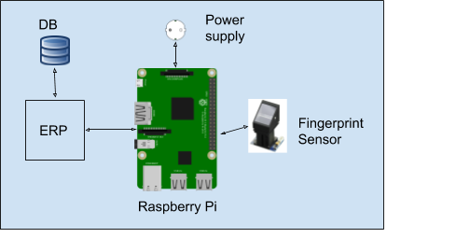

Fig 2.1.1 Proposed structure of the biometric attendance system

#### Raspberry Pi 3

Raspberry Pi is a tiny computer board that comes with CPU, GPU, USB ports, I/O pins, WiFi, Bluetooth, USB and network boot and is capable of doing some functions like a regular computer.

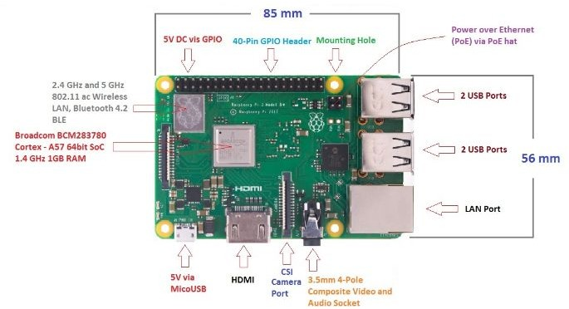

Fig 2.1.2 Components of Raspberry Pi 3B +

#### R305 Fingerprint Sensor

The R305 module is a suitable fingerprint module for the project. It has an inbuilt storage capability of 256 fingerprints and it can also work well and under varying physical conditions such as temperature. It is fast and compatible with multiple Operating Systems.

### ERPRequirements

#### Login and Logout

The employee should be defined in the DB of the application in order to Login and Logout of the system. The login and logout system would be the same for all user levels.

#### Attendance Management

The Attendance Management would be done with the help of BAS. The in and out time would be maintained in the database for all employees, which would help in calculating the working days and the working hours of the employees.

#### Leave Application

The Software intends to provide a leave application section where employees can apply for leaves. This would notify their team leader and the Hr and they can approve it or disapprove it with a click.

#### Salary Management System

The salary management system would provide with Salary details of the employees based on the

working hours and leaves taken. This would be calculated with the help of the entries in the database.

#### Employee Management System

The Employee Management System would only be accessible to the HR and the admin, where they can manage, add, remove, employees, and enroll their fingerprints into the database. The HR roles

also include the ability to add special days such as national holidays, etc to the system and approving and disapproving leave applications.

#### Invoice Generation

The HR could generate invoice and salary slips for the employees which can be accessed and downloaded through the application interface.

## Constraints and Dependencies

* Working internet connection is required to access the application.
* The application should be available to serve 24*7 over the internet while the BAS should only be a part of the company’s intranet.
* The application is dependent on Postgres database which should serve the application 24x7.

# DATA MODEL

This section consists of the data models which will be used in the ERP system. It also includes the description of the data and relationships between them and the Entity Relationship Diagrams for the project.

## DataObjects

### UserObject

This object will be used to keep the complete name of employee, User Id, Age, Gender and roles along with the fingerprint data of the employee.

### AttendanceObject

This would maintain the regular in and out time. Total working days, Total working hours based on the entry and exit time and leaves taken.

### SalaryObject

This would be used to calculate the Salary of the users based on the attendance generated in the attendance model.

## Relationships

This section contains the E-R Diagrams for the project.

#############THIS SECTION IS INCOMPLETE

# PROPOSED MILESTONES

### Total estimation of hours:

|  |  |  |  |
| --- | --- | --- | --- |
| **Milestone** | **Tasks** | **Hrs** | **Date(DD/MM/Y** |
| 1 - Analysis and Documentation | | | |
| 1.1 | SRS Documentation | 0 | 11/05/20 |
| 1.2 | Architecture and Design | 0 | 11/05/20 |
| 1.3 | Distribution of Tasks | 0 | 11/05/20 |
| 2 - Development | | | |
| 2.1 | Biometric Attendance System | 0 | 11/05/20 |
| 2.2 | Django Backend | 0 | 11/05/20 |
| 2.3 | Frontend Development | 0 | 11/05/20 |
| 3 - Testing | | | |
| 3.1 | Attendance System Testing | 0 | 11/05/20 |
| 3.2 | Application Testing phase -1 | 0 | 11/05/20 |
| 4 - Deployment | | | |

|  |  |  |  |
| --- | --- | --- | --- |
| 4.1 | Deployment on Server | 0 | 11/05/20 |
| 4.2 |  | 0 | 11/05/20 |
| 5 - Training | | | |
| 5.1 | HR Training | 0 | 11/05/20 |
| 5.2 | Employee Training | 0 | 11/05/20 |

# CONCLUSION

In this SRS document, a complete description of the Extern Labs ERP System along with the features. Data flow and other requirements were stated.

These requirements will help to proceed the project in other stages. However, all of these are subject to change as per the requirement in further development stages.