Comprehensive Project Report: Onboarding Portal

Submitted By: Ayush Gupta, Application Development Intern

Project Purpose: The Onboarding Portal is a comprehensive, full-stack employee onboarding and provisioning system designed to seamlessly coordinate the onboarding process across multiple departments including HR, Line Managers, Heads of Department (HODs), Infrastructure Teams, and System Administrators.
Overall Architecture: Decoupled Client-Server SPA. React 19 Frontend communicating via RESTful JSON APIs to a Django 5.2 backend. Uses JWT for authentication.
Major Modules:
- Request Management (HR, Manager, HOD, Infra)
- Catalog & Asset Management (Software, Hardware inventory)
- User Management & Self-Service - Role-based Dashboards
Strengths:
- Strict role-based access control with detailed audit logs (ChangeLog).
- Robust input validation against gibberish and invalid formatting.
- Clear separation of concerns between frontend routing/state and backend validation.
Weaknesses:
- Default use of SQLite might lack concurrency scale if not explicitly deployed with MS SQL Server.
- Frontend uses localStorage without encryption, relying heavily on JSON.parse which could break if manually tampered with.
Technical Debt:
- Native fetch wrapper in api.js relies on modifying the global window.fetch object, which is an anti-pattern compared to Axios interceptors.
- Some complex views (like save-request) appear to handle a lot of state machine logic that could be extracted into a dedicated service layer.
Security Posture:
- JWT validation is strictly enforced.
- Action roles are validated server-side.
- OTP protects profile updates and password resets.
- Input is sanitized and validated.
- Scalability Assessment: Moderate.
- Django is scalable, but the SQLite fallback isn't.
- Needs proper WSGI/ASGI and robust DB for scale.
- Maintainability Assessment: High. Clear folder structure, modularized Django views, React components are separated.

Project Overview

Project Name: Onboarding Portal
Purpose: Automate and track the employee onboarding workflow across departments.
Problem it solves: Eliminates paper and mail trails and disjointed communications during the onboarding phase by providing a centralized system for tracking requests, assigning hardware, and managing required software.
Target users: HR personnel, Line Managers, Heads of Department, Infrastructure Admins & Executives, and newly onboarded Employees.
Major features: Role-based dashboards, OTP-based profile updates, workflow management, software/hardware inventory tracking, automated employee code generation, and audit logging.
Technology stack: React 19, Vite, Django 5.2, MS SQL Server / SQLite.

Repository Structure

Onboarding-App/
├── client/
│ ├── src/
│ │ ├── components/ # Reusable UI components
│ │ ├── services/ # API fetch wrappers (api.js)
│ │ ├── AdminDashboard.jsx
│ │ ├── App.jsx # App entry, routing, state
│ │ ├── HRDashboard.jsx
│ │ ├── HRForm.jsx
│ │ ├── Login.jsx
│ │ ├── constants.js # Workflow stages, roles
│ │ └── utils.js # Helpers, validations
│ ├── package.json
│ └── vite.config.js
├── server/
│ ├── onboarding/ # Django App
│ │ ├── views/ # Modular views (auth, common, requests, etc.)
│ │ ├── models.py # DB models
│ │ ├── urls.py # API routing
│ │ └── tests.py
│ ├── onboarding_backend/ # Django Settings
│ ├── manage.py
│ └── requirements.txt
├── README.md
└── TECHNICAL_DOCS.md

Important files:
- server/onboarding/models.py (Database schema)
- client/src/App.jsx (Frontend routing)
- server/onboarding/views/ (API Logic).

Technology Stack

Frontend:
- Framework: React 19 via Vite
- State management: React Hooks (useState, useEffect)
- Routing: Client-side hash-based routing built manually in App.jsx - Styling: Vanilla CSS
Backend:
- Framework: Django 5.2
- Language: Python 3.10+
- ORM: Django ORM
- Authentication: Custom JWT via simplejwt
- Database engine: MS SQL Server (via mssql-django) or SQLite as fallback.
Developer Tools:
- Package managers: npm, pip
- Linter: ESLint

Architecture

High-level architecture is a decoupled Single Page Application (SPA). The client uses Hash Routing to determine views. When making requests, services/api.js intercepts global fetch to append JWT tokens from localStorage. The server is a REST JSON API. It uses @require_jwt to validate tokens statelessly and inject the request.user into views.

Complete Feature Inventory

Feature Name | Description | Roles | Files Involved
Role-based Auth | JWT login and protected routes | All | auth.py , App.jsx , api.js
Request Submission | Submitting a new onboarding case | HR | HRForm.jsx , onboarding.py
Workflow State Machine | Transitions from Manager -> HOD -> Infra -> Approved | Manager, HOD, Infra | RequestDetailPanel.jsx , requests.py
Software Catalog | Managing pre-installed/employee software | Admin | AdminDashboard.jsx , common.py
Asset Management | Tracking Laptops (RAM, Storage, GPU) | Admin, Infra | AdminDashboard.jsx , requests.py
OTP Self-Service | Update profile via OTP verification | Employee | users.py , App.jsx
Change Logs | Audit trails for all request actions | All | requests.py , models.py
Archive/Restore | Soft delete of requests | Admin | requests.py

Authentication & Authorization

- Login Flow: User posts email/password to /api/login. Backend verifies against Django User model and generates a JWT. Token is stored in localStorage.
- Password Reset: OTP is generated and emailed. Checked via /api/verify-otp.
- JWT: Used for all protected routes via @require_jwt decorator.
- RBAC: Roles are Admin, Manager, HOD, Employee. Frontend blocks views based on role (getAllowedPagesForUser). Backend explicitly checks roles in views before performing actions.

Database Documentation

Tables:
1. Department: id, name (unique).
2. UserProfile: One-to-one with User. role, department_id, phone_number, employee_code.
3. SoftwareCatalogItem: name, category, department_id, is_active.
4. AssetInventory: asset_code, laptop_model, laptop_processor, laptop_ram, laptop_storage, laptop_gpu, is_assigned.
5. OnboardingRequest: Tracks full workflow. Dozens of fields including request_code, stage, employee_name, pre_installed_software, manager_software, asset_code.
6. ChangeLog: Audit trail. actor, action_type, description, timestamp.
7. PasswordResetOTP: email, otp, is_verified.
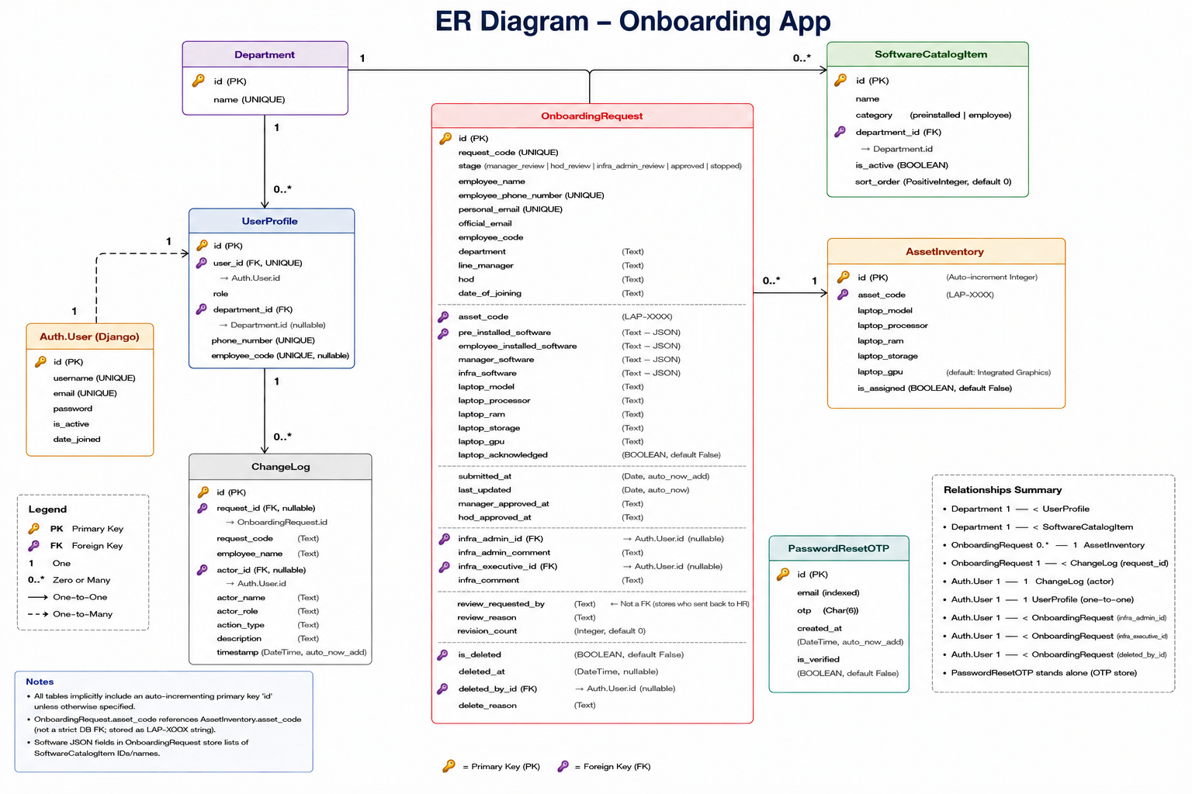

API Documentation

Partial Endpoint List (Refer to TECHNICAL_DOCS.md for full list):
- POST /api/login: Accepts email, password. Returns {token, user}.
- POST /api/onboarding-email: HR creates request. Accepts employee_name, personal_email, department, etc.
- POST /api/save-request: Updates state machine. Accepts request_code, action (approve, send_back, stop), comments.
- GET /api/requests: Returns filtered list of requests.
- GET /api/changelogs: Returns audit trail logs.
- POST /api/finalize-onboarding: Allocates final employee code and creates Employee user.

Frontend Documentation

- Routing: Handled manually in App.jsx checking window.location.hash.
- State: React Context / useState for global user, token, requests.
- API calls: Centralized in services/api.js. Overrides global fetch to add Authorization: Bearer <token>.
- Components: AdminDashboard, HRDashboard, HRForm, RequestDetailPanel.

Backend Documentation

- Controllers/Views: Modularized in server/onboarding/views/. Separated into auth.py, users.py, requests.py, common.py, onboarding.py.
- Models: Defined in models.py. Extensive use of custom validators (validate_gibberish, validate_phone_number) triggered in .clean() methods.

Data Flow
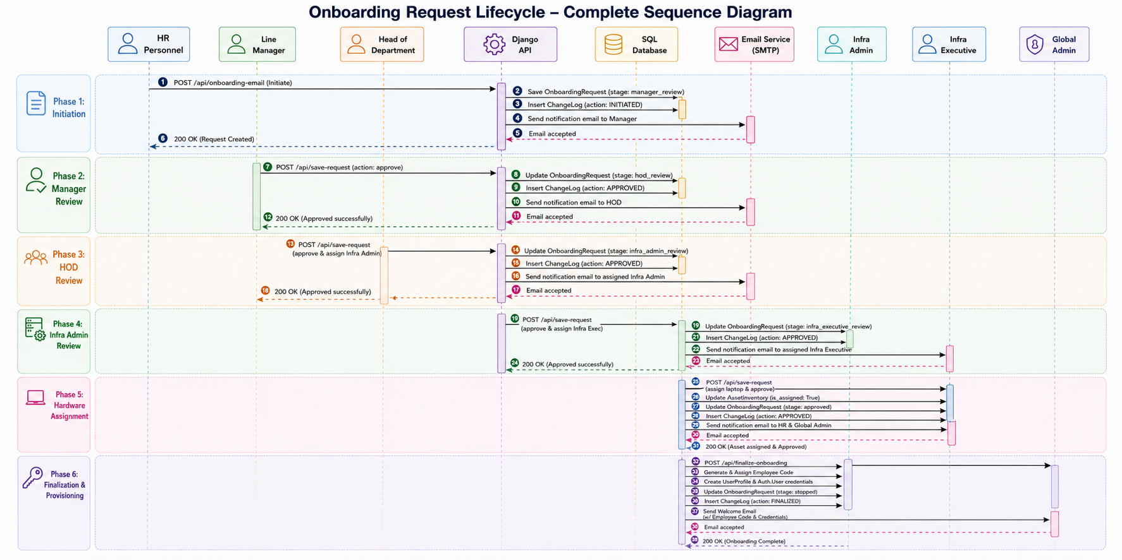

Security Analysis

- Authentication: Custom JWT generation and verification.
- Authorization: Handled per-view based on injected request.user.
- Input Validation: Strict gibberish detection algorithm in Django models.
- Vulnerabilities: localStorage is vulnerable to XSS if malicious scripts are injected (though React escapes variables). Use of global fetch override is risky if other third-party libraries use fetch.

Configuration

- DJANGO_SECRET_KEY: Used for JWT and sessions.
- GMAIL_SENDER / GMAIL_APP_PASSWORD: SMTP integration for OTP.
- VITE_API_URL: Frontend pointer to backend API.
- DB_NAME, DB_HOST: For MS SQL configuration.

External Integrations

- Email Provider: SMTP via Gmail (django.core.mail). Used for OTP delivery and notification workflows.

Build & Deployment

- Development: npm run dev (Vite) and python manage.py runserver (Django).
- Deployment: Needs standard Django production setup (Gunicorn) and static file serving for React bundle.
- Migrations: python manage.py migrate populates schema and seeds initial data.

Testing

- Unit tests exist (tests.py)
- Framework: Django TestCase.

Logging & Monitoring

- Error handling: Django default error handling.
- Auditing: ChangeLog table logs all business logic state transitions.
- Alerts: None currently implemented.

Performance

- Database: Standard indexing applied (db_index=True on frequently queried fields).
- Code splitting: Vite handles this inherently, though SPA is monolithic.
- Improvement: Implement pagination for /api/requests as data grows.

Known Issues

- Technical Debt: localStorage direct parsing without try/catch fallback could crash the frontend if tampered with.
- Using SQLite in production environments will bottleneck quickly.

Improvement Opportunities

- Security: Move JWT storage from localStorage to HttpOnly secure cookies.
- Performance: Implement pagination on the requests and changelogs API endpoints.
- Refactoring: Remove the global window.fetch override in favor of a dedicated Axios instance.

Developer Guide

- Local Setup: Requires Node 18+ and Python 3.10+.
- Backend Setup:
- python -m venv venv, pip install -r requirements.txt, python manage.py migrate, python manage.py runserver.
- Frontend Setup: npm install, npm run dev.
- Branching Strategy: Not determinable from the available codebase. Use standard GitFlow.
- Environment: Use .env in both client/ and server/.

