<https://kubernetes.io/docs/tutorials/kubernetes-basics/create-cluster/cluster-interactive/>

1. Create Ubuntu EC2 instance

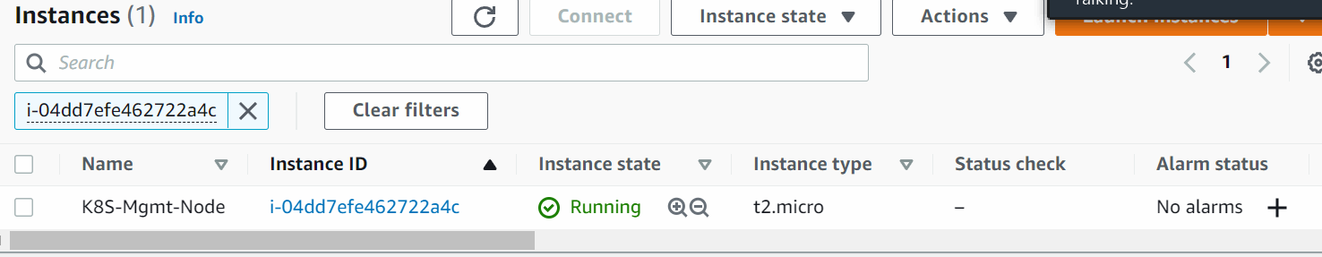

* apt-get update -y
* apt-get install awscli -y
* Install kubectl on ubuntu instance
  + curl -LO https://storage.googleapis.com/kubernetes-release/release/$(curl -s https://storage.googleapis.com/kubernetes-release/release/stable.txt)/bin/linux/amd64/kubectl
  + chmod +x ./kubectl
  + sudo mv ./kubectl /usr/local/bin/kubectl
  + kubectl version
* Install kops on ubuntu instance
  + curl -LO https://github.com/kubernetes/kops/releases/download/1.15.0/kops-linux-amd64
  + chmod +x kops-linux-amd64
  + sudo mv kops-linux-amd64 /usr/local/bin/kops

1. Create an IAM user/role with Route53, EC2, IAM, and S3 full access and Attach the IAM role to the ubuntu instance
2. Create an S3 bucket with a unique name <[demo.k8s.edureka.net](https://s3.console.aws.amazon.com/s3/buckets/demo.k8s.edureka.net?region=us-east-1)>
3. Create a Route53 private hosted zone (you can create a Public hosted zone if you have a domain).
4. Expose environment variable:

export KOPS_STATE_STORE=s3://demo.k8s.vikas.net

1. Create ssh keys before creating a cluster:

ssh-keygen

1. Create Kubernetes cluster definitions on the S3 bucket

kops create cluster --cloud=aws --zones=us-east-1c --name=demo.k8s.edureka.net --dns-zone=edureka.net --dns private

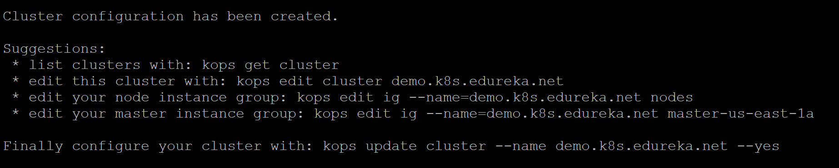

1. Create Kubernetes cluster

kops update cluster demo.k8s.vikas.net --yes

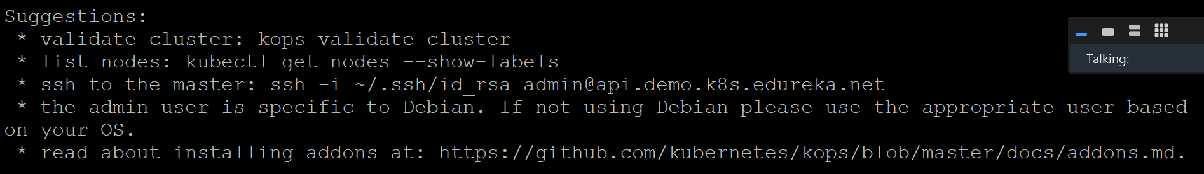

1. Validate your cluster:

kops validate cluster

1. To delete cluster:

kops delete cluster demo.k8s.vikas.net –yes

#### Deploying Nginx pods on Kubernetes

1. Deploying Nginx Container

kubectl run sample-nginx --image=nginx --replicas=2 --port=80

kubectl get pods

kubectl get deployments

2. Expose the deployment as a service.

kubectl expose deployment sample-nginx --port=80 --type=LoadBalancer

kubectl get services -o wide