COSC 412

Induvial Project

Gurmilan Singh Sangha

Meeting 3/31/2021

**1.1 Project Introduction**

So, my project idea for this class was to build website for my Gurdwara(Sikh church), I have seen so many other Gurdwara’s in other larger cities have websites where the administrative staff can share information about events, pictures, calendar events and other information that would be important to the public (Gurdwara’s are open to all) I plan on naming the website after the Gurdwara, Singh Sabha MD.com

**1.2 Project Deliverables**

* Individual Project Proposal
* Permission from Admin Staff (@Gurdwara)
* Design Review Mtg meeting
* List of requirements
* Use Case Diagram
* SPMP
* Proposed Design
* List of Tools
* Functioning Website
* Presentation

**1.3 Evolution of the SPMP**

* Corrections Made to the Individual Project Proposal
* Corrections might need to be made the SPMP after meeting with Professor Broadwater.

**1.4 Reference Materials**

* Slides Provided by Professor Broadwater

**1.5 Definitions and Acronyms**

**Gurdwara** - the holy temple for people in the Sikh religion and it translates to the Guru’s Door.

**SPMP**- Software Project Management Plan

**2.1 Project Organization**

This is an individual project so; I will be the only working on all elements of this project. I will be everything from the Client liaison to the development team for this project. All management will be reliant on myself; all deadlines are provided to me by Professor Broadwater. I will be paying for whatever resources are needed in the process of completing this website. I will try to limit spending due to budget constraints.

**2.2 Assumptions, Dependencies and Constraints**

* Users will want to use the website based on the design and are happy with all religious material uploaded.
* I large constraints is the limited amount of money that can be used during the creation of this website.
* I am assuming a large portion of the products like API’s Plugin and other services like hosting and purchasing the domain name will be relatively in expensive or free.

**2.3 Risks**

This Project has several large risks, User adoption, Inappropriate usage, limitation of time, and size of project. I am worried that a large portion of the Gurdwara community might not adopt to using a different website then Facebook. I also worry about the people finding this website and commenting or interfering with other users, to limit this risk factor I created a new user for the public. There is a limitation in this whole project because this ultimately has a deadline, where other websites like Facebook, Google and YouTube have gone through many iterations to test what best fits the community. The last risk factor is the size of the website, I must make sure all functions are working correctly, while I am a capable programmer this is my first time creating a website.

**3.0 Technical**

**Tools to be Used.**

* WordPress
* NameCheap ( not 100%)
* GitHub
* Draw.io

**3.1 Explanation of the tools**

I have used Name Cheap and WordPress to create a website in the past for a Neighbors website(Therapist), the I learned a lot from the experience, so I think creating a website on my own will be a good test of my skills and allow me to show my skillset.

**3.2 Technical User Requirements for Each User**

**Admin User**

* The admin will be the only user allowed to verify General public users to transition them into Verified users.
* The admin will be the only user allowed to add calendar events.
* Will be able login and logout.
* The General Public users will be able to upload a bio with personal info.

**Verified Users**

* Will be able login and logout
* The General Public users will be able to upload a bio with personal info.
* The Verified users will be able to upload Blog posts.
* The Verified users will be able to Read blog posts.
* The Verified users will be able to upload pictures.
* The Verified users will be able to comment on pictures.
* The Verified users will be able to view pictures.
* The Verified users will be able to upload a bio with personal info.

**General Public Users**

* The General Public users will be able to view pictures.
* The General Public users will be able to read blog posts.
* The General Public users will be able to upload a bio with personal info.

**3.3 User Diagram**

I think it will be practical to have 3 types of users, General Public, Verified Users and Admin Staff. Obviously, General public users will have super limited abilities to limit unwanted comment from anonymous users. Verified users will just have to speak in person with the Admin staff in person to be verified. The functions on the website are fairly mundane.

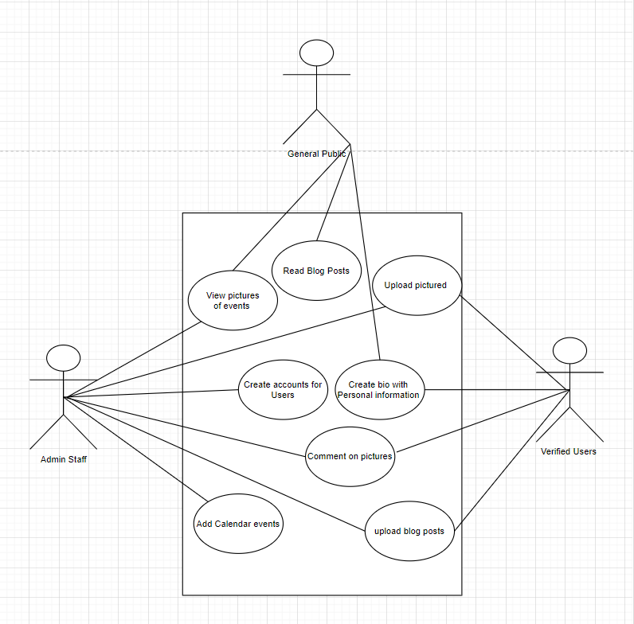

**3.4 Gantt Chart** 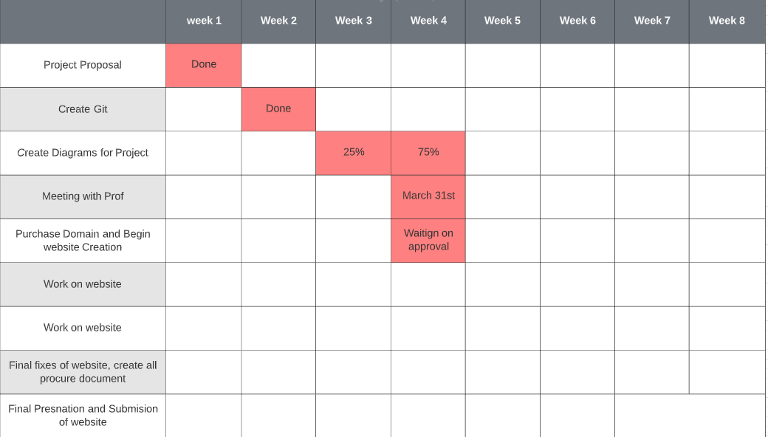

**3.5 WBS Chart**

