18.06.2018
Wildgruber Markus (Markus@wildgruber.org)

Biological Trashbin

Hardware:
Laird Sentrius RG1xx LoraWan Gateway
Lora Mote RN2483
MSP430FR6989

1. Gateway:

1.1. Access the Laird Gateway:

Open a browser and acces the Gateway via its IP-Address https://172.20.34.111
Login with Username and Password.
Under LoRa chance select preset to The Things Network – EU and apply.
On the left side you can see the Gateways EUI - C0EE40FFFF29386F

1.2. Register Laird LoraWan Gateway :

Go to https://www.thethingsnetwork.org/ and great a account.
On https://console.thethingsnetwork.org/gateways you add your Gateway.
Gateway ID: Use your decice EUI and select I‘m using the legacy packet forwarder
Description: Anything
Frequency Plan: Europe 868MHz
Router: ttn-router-eu
Location: Can be added but not needed

1.3. Add Application:

On https://console.thethingsnetwork.org/applications/add
Application ID: Anything
Description: Anything

1.4. Add Devices:

On https://console.thethingsnetwork.org/applications/othrgbtestapp/devices/register
Device ID: Anything
Device EUI: read from Lora Chip with „sys get hweui“

2. Lora Mote RN2483

2.1 Connect to RN2483 via console:
unsigned char commRx[20];

Install minicom, „sudo apt-get install minicom“
open minicom, „sudo minicom -s“

configure serial:
shift + a, change to /dev/tty.. (ttyUSBx or ttyACMx), enter
shift + e, change baudrate to 57600 with shift + b, enter
shift + f, chage Hardwareflow to no, enter
exit, enter

ctrl + a, shift + z, shift + e,

enter commads, to send commands always enter and shift + j

unsigned char commRx[20];

2.2 Communication between two Lora Motes:

Commandlist: RN2483 LoRaTM Technology ModuleCommand Reference User’s Guide

For Sender and Receiver: (Values can be different)

mac pause
radio set mod lora
radio set freq 868100000
radio set pwr 14
radio set sf sf7
radio set afcbw 41.7
radio set rxbw 125
unsigned char commRx[20];
radio set crc on
radio set iqi off
radio set prlen 8
radio set cr 4/5
radio set wdt 60000
radio set sync 12
radio set bw 125

Sender: radio tx <hex message>
Receiver: radio rx 0 //Reenter after receiving a message

2.3 Communication between two Lora Mote and Gateway OTAA:

mac pause
mac set appeui <insert appeui aus thingsnetwork>
mac set appkey <instert appkey>
mac set dr 5 //Value must be greater than 3
mac set sf7
mac set freq <insert frequence that is available>
mac set bw 125
mac resume
mac join otaa

Send:
mac tx <uncnf/cnf> <port> <value>

unsigned char commRx[20];

3. Software Flow:

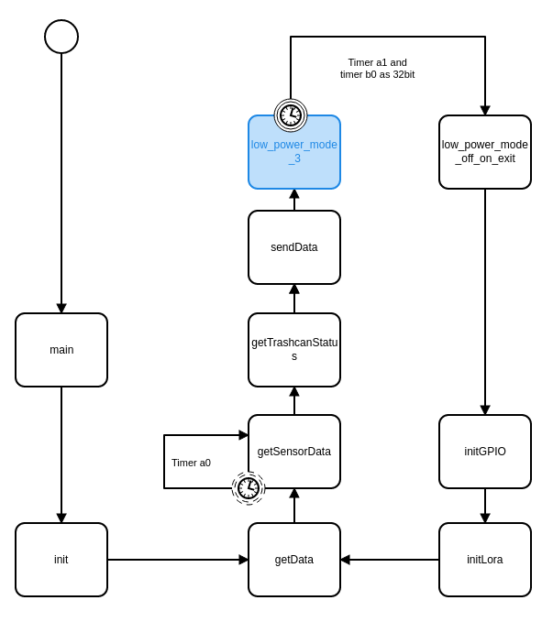

4. Trashcan Status:

1 – ¼ filled
2 – ½ filled
3 – ¾ filled
4 – full
F - Error

5. Read data from thethingsnetwork:

sudo apt-get install mosquitto mosquitto-clients
mosquitto_sub -h eu.thethings.network -t '+/devices/+/up' -u 'appid' -P 'appkey' -v -p 1883 >> test.log

f.e. : mosquitto_sub -h eu.thethings.network -t '+/devices/+/up' -u 'othrgbtestapp' -P 'ttn-account-v2.afsagfsfdfdafXKvcBfasdasgasdgWhtiR5bBOPm-OU' -v -p 1883

