# DMS

A Sample Partnership Roadmap

Graphic showing sample data management partnership

Strategy

Perform an inventory of your information systems and document the sources of your data; assess data management processes, tools, and vendors.

Identify which systems are the primary source of specific data, such as customer information, and which should be used by or feed other systems or reports.

Work with you to create the data architecture to best collect, cleanse, transform, and store your data to easily access and perform analysis and reporting; chart a data management roadmap.

Implementation

Combine data from disparate sources; validate and cleanse if necessary.

Create and implement policies and procedures to ensure data is collected accurately.

Implement change management process with your teams to ensure changes are clearly communicated and managed properly so that data integrity is maintained.

Create documentation such as data dictionaries, which clearly identify the sources of each data element, any cleansing, transformation or enhancements that have occurred, and precise definitions so that others can use the data correctly.

Design database solutions and create the necessary programs to extract, transform, and load (ETL) data from various sources into a data warehouse.

Optimization

Align with data governance program to ensure smooth operations and continuous improvements.

Monitor data warehouse and databases uptime and availability.

Evaluate and perfect ETL processes to minimize errors and load time.

Track data quality success. Setup automated data quality assurance monitoring.

Ongoing change management for optimal speed, breadth, and quality of project implementation.

Training

Conduct training session to ensure all users understand and properly follow all protocols correctly. Deliver slide decks or other training materials for dissemination.

Time-Tested Data Management Consulting

Captured data is almost worthless if left in a state of chaos. Organizations that have procedures for data management will find themselves reaping the benefits.

As a very early adopter of analytics for digital marketing, Blast has been managing data since 1999. Our data management strategy and consulting processes are proven through hundreds of client engagements with corporations, non-profits, start-ups, and government agencies.

Our firm’s data specialists are eager to hear your story, get you started with a comprehensive data management plan, and help you EVOLVE your organization.

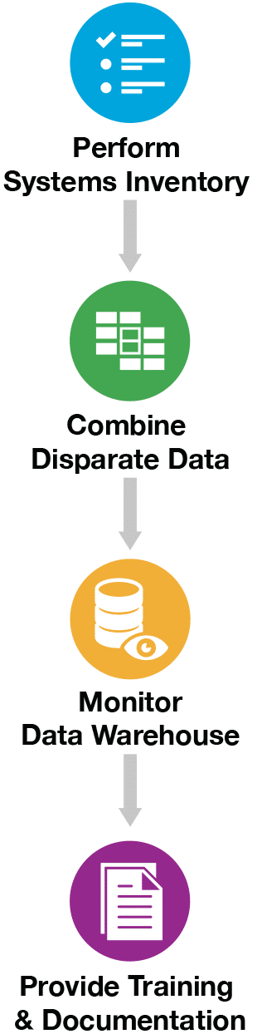

# AS

EVOLVE Through Data Comprehension

No matter how complex or big your data is, we can support and guide you through every step, even the uncomfortable resistance to change that often goes along with growth.

You are likely looking at more data than you can handle, and we can help you separate the wheat from the chaff — to gain competitive advantage — by providing you the right knowledge, at the right time, so you can make the right decisions.

* Understand your customers
* Identify opportunities and threats
* Respond to business needs
* Innovate faster with relevant data
* Gain competitive advantage

Experience combined with the insights derived from the data enables you to evolve your business and create a blueprint for building your company well into the future. So. What’s your mission?

## SIOT Approach

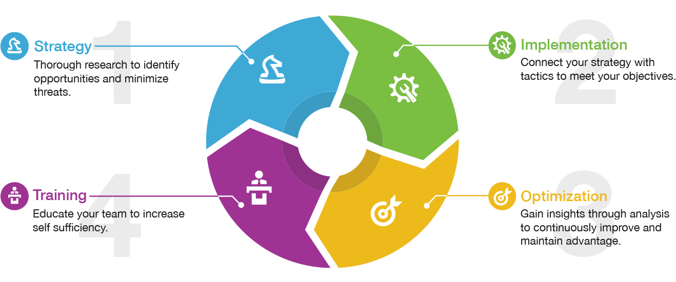

Over the years, we’ve constantly been **evolving** from what we know, iterating from challenge to challenge to continuously improve our results. Our focus is to help you and your organization do the same, by using data to make better decisions, prioritize, take action and achieve sustainable results.

* **Speed.** Structured, fast delivery of knowledge from your data. Constant evolution is the priority.
* **Flexibility.** Change is inevitable, it is constant. Through the understanding of your needs we will adapt solutions to optimize your results.
* **Ingenuity.** As creative problem solvers, we apply our collective know-how to help you evolve and innovate with data.

# CMS

## Change Management Implementation Services

Forward your Change Management Strategy now & start building your organizational ability to change for your Future State.

ProClipse Consulting Change Implementation Services provide you with the opportunity to engage Certified Prosci Change Management Affiliates and gain access to the latest Change Management research, tools and methods available. ProClipse Consulting’s Change Advisors collaborate with your team to apply Change Management methods to deliver sustainable results by proving expert application of Change Management practices and tools to improve adoption of your changes.

**Tailored Change Management implementation engagements improve your performance and accelerate project success.**

Typical ways to leverage our services include:

* ProClipse Consulting executes Change Management with you on your projects varying from an individual practitioner to an [enterprise all-encompassing license](https://proclipseconsulting.com/change-management/#enterpriseChangeManagement), we are here to help you find the solution that best fits your needs and size.
* Our expert ProClipse Consulting change advisors assess and help you manage a portfolio of change projects by placing them - on-site or virtual - on your selected project(s) team and delivering agreed results.
* ProClipse Consulting provides expert support for building out your CMO and enterprise-wide Change Management capability by taking the lead in preparing your in-house change managers and support some of your strategic projects until your team is ready to take over.

# KA

Left Menu

Use cases

Resources

Training

Blog

## Passionate Consultants – Driven to Make Our Mark

Founded in 1999, Blast Analytics & Marketing is a [strategic analytics consulting company](https://www.blastanalytics.com/analytics-consulting) accelerating the complex analytics journey for enterprise and mid-market clients. We solve clients’ data challenges to help optimize marketing campaigns, improve customer experience, increase competitive advantage, and, ultimately, [**EVOLVE**](https://www.blastanalytics.com/evolve) their organizations.

With over 80 teammates sharing a purpose to “[Make Your Mark](https://www.blastanalytics.com/make-your-mark)” — on our company, teammates, clients, industry, and community — Blast has been named one of *Inc.* magazine’s top 5000 fastest-growing private companies and is also a Great Place to Work-Certified company.

# ABOUT

Left menu:

About

The Team

Clients

Contact us

### Why ProClipse Consulting?

**‘The Eclipse’** - one of nature’s most exhilarating phenomena, the true definition of progressive transformation. By seemingly casting darkness with total or partial obscuring, the perfect alignment of elements eventually allows light to be revealed. With this inspiration, ProClipse Consulting came to life driven by the core belief that like an eclipse, though change can be marred with uncertainty, the promise of light always lies on the other side of darkness.

ProClipse Consulting is exclusively focused on Change Management & Corporate Governance. We are proud members of Prosci®’s Global Affiliate Network - the most knowledgeable organization in the Change Management industry, backed by more than 20 years of Change Management research and best practices.

With dedicated & specialized Corporate Governance team of certified GRC Professionals, we proudly follow the Australian Institute of Company Directors [Code of Conduct](https://aicd.companydirectors.com.au/-/media/cd2/global-resources/about/pdf/code-of-conduct-september-2005.ashx).

At ProClipse Consulting, we are all committed to professionally support the way to manage the people side of change continuously better in a structured & repeatable way.

We are a group of professional experts in our respective fields. As members of the Prosci Global Affiliate Network (GAN) we are also the Authorized Training Provider (ATP) for Prosci’s Training & Certification. We can cover all your bases.

From [advising](https://proclipseconsulting.com/solutions/advisory/) you through your organizational change endeavours, [Training & Development](https://proclipseconsulting.com/solutions/training-upskilling/), to [Coaching](https://proclipseconsulting.com/solutions/training-upskilling/leadership-capability-building/#executiveCoachingSkillsForManagers) with genuine passion and savoir-faire.

## Our Goal

We will pave a path that inspires organizations in the region to increase their capability and fully embrace a culture of Change Management that is sharp, structured and genuinely People-Centric by applying all of our values throughout each engagement.

## Our Values

* ProClipse Consulting**People**: We believe that a genuine connection on an emotional level is at the root of any successful partnership. People are the cornerstones of what we do and why we do it. While knowledge is our power, empathy is our fuel.
* ProClipse Consulting**Impact**: We make a difference by creating a significant footprint in the organizations we partner with and the people we cross in our path.
* ProClipse Consulting**Results**: We focus on what's important to our clients, the people, and their transition journey to the future state. We create tailor-made, evidence-based and practical solutions to guarantee successful outcomes.
* ProClipse Consulting**Passion**: We are committed to achieving our goal and embodying our values every step of the way.
* ProClipse Consulting**Integrity**: We vow to always deliver in a trustworthy and reliable manner. Our word is our bond, transparency is our promise.