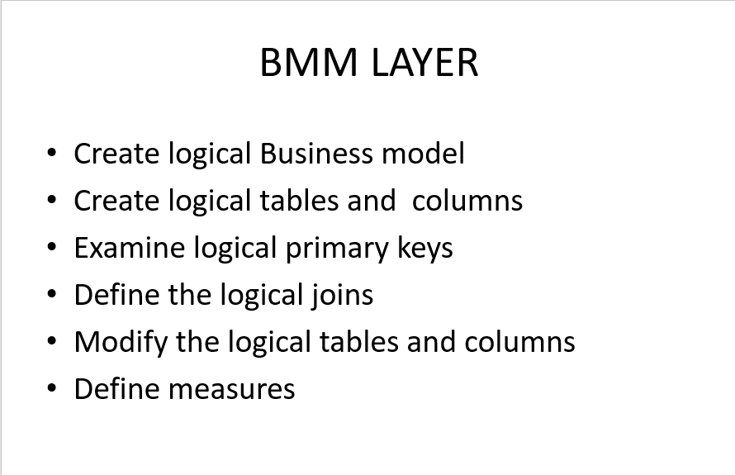

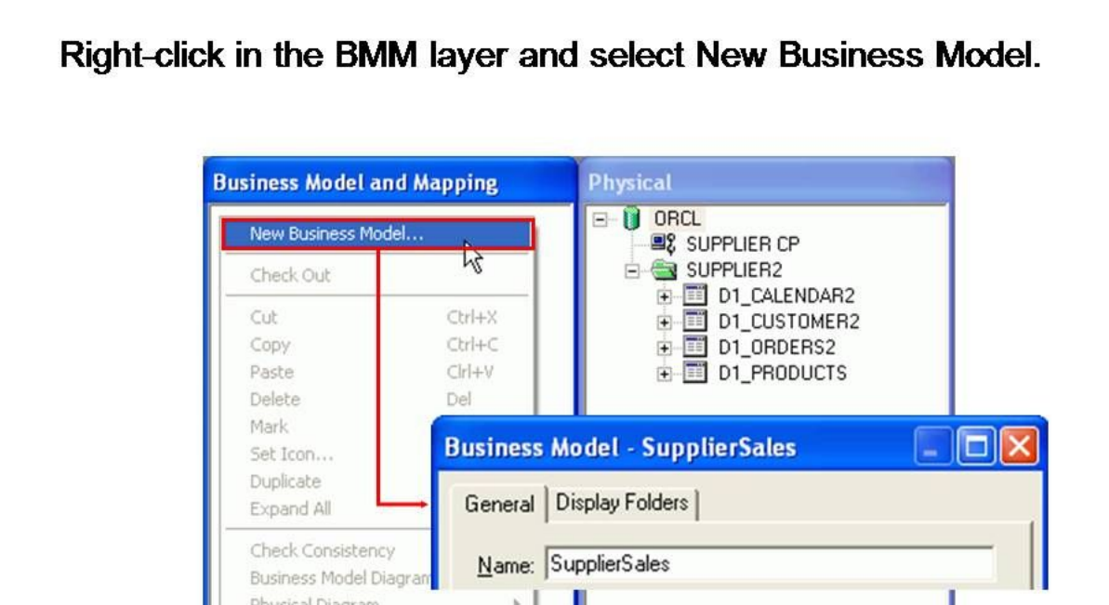

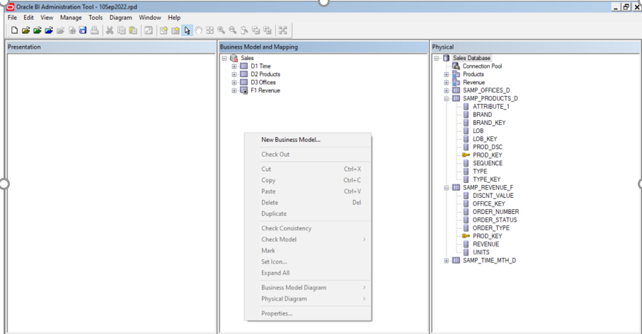

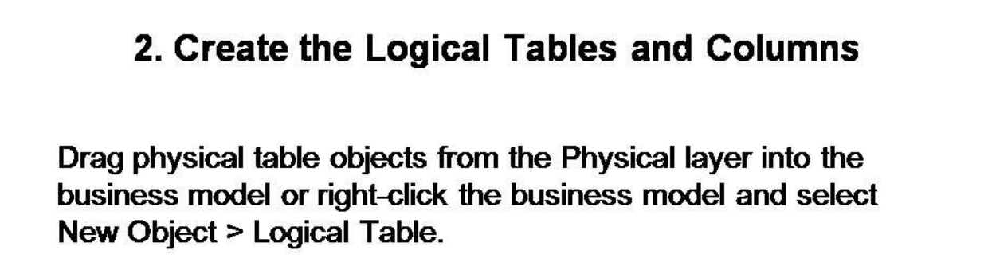

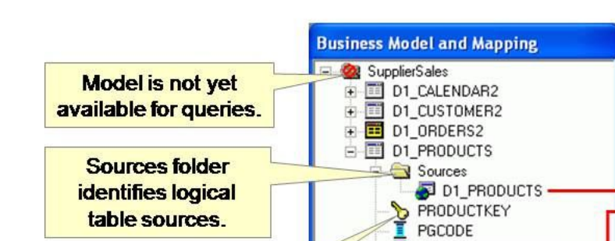

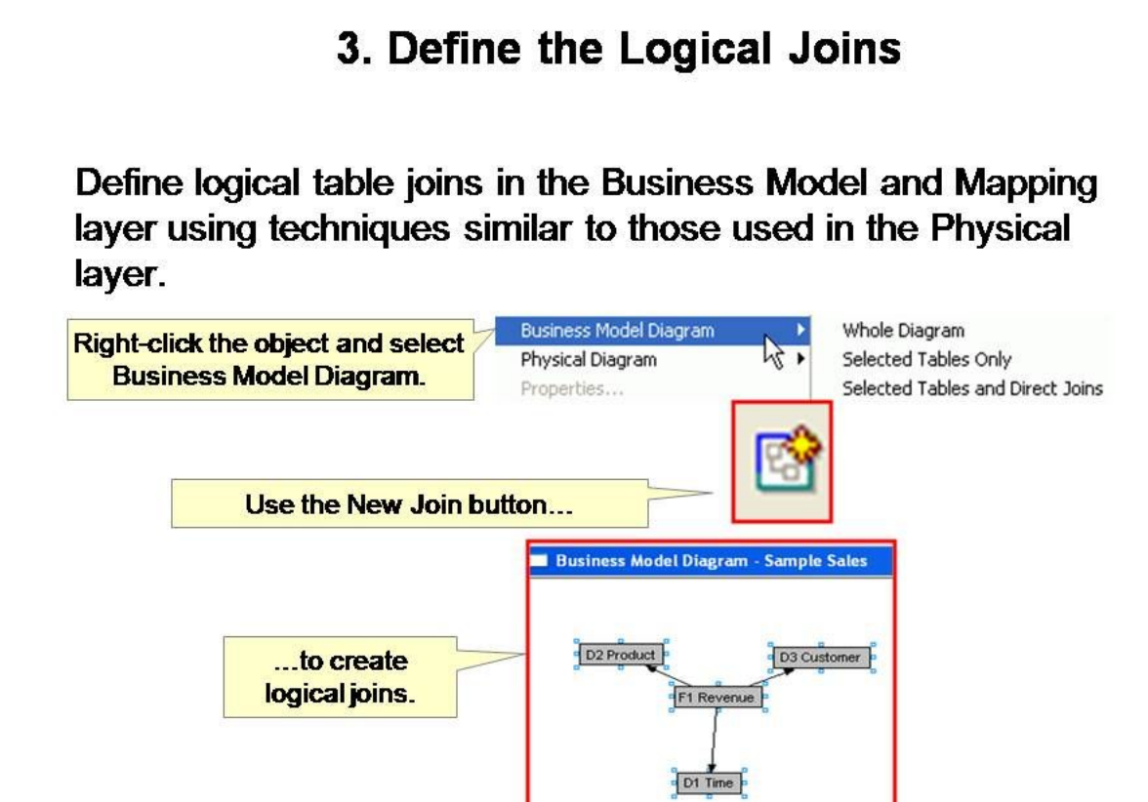

**4. Modify Tables and columns**

**Tools->utilities->Rename wizard**

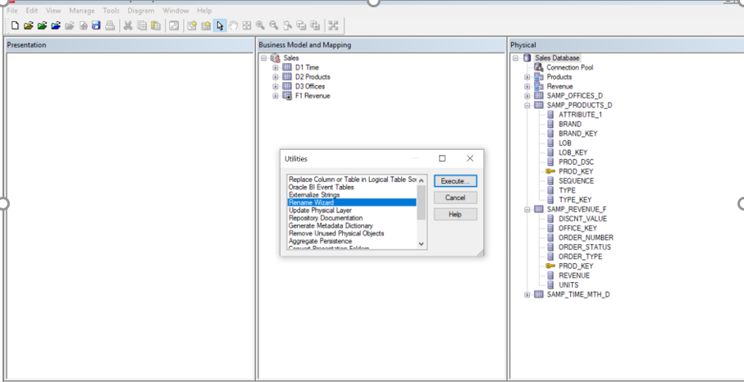

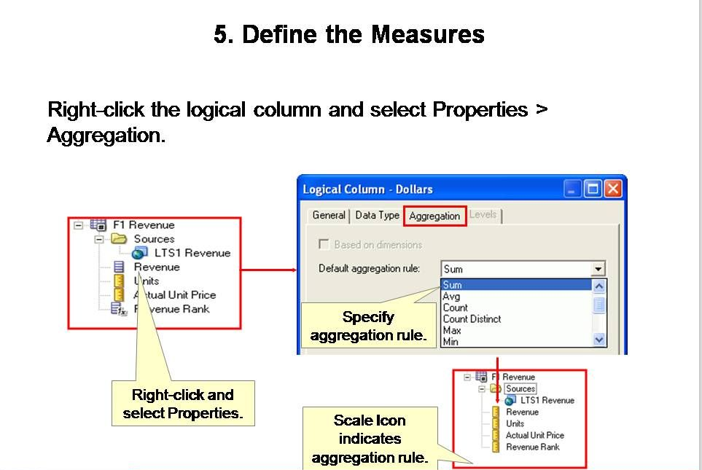

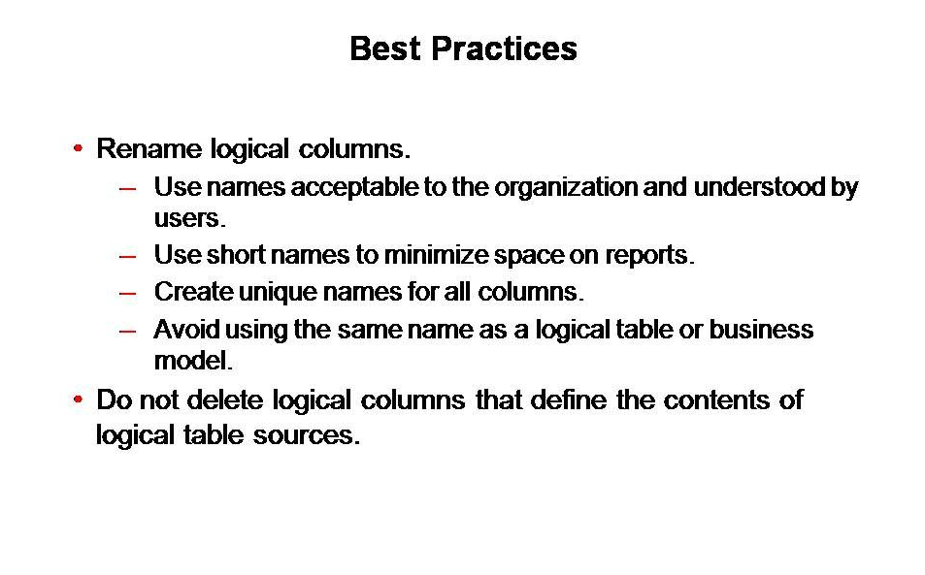

**References:**

[**https://docs.oracle.com/middleware/12211/biee/BIEMG/GUID-30BC87C9-C51D-4C8D-A6B1-09C4D9C234EC.htm#ident_cont_bus_mod**](https://docs.oracle.com/middleware/12211/biee/BIEMG/GUID-30BC87C9-C51D-4C8D-A6B1-09C4D9C234EC.htm#ident_cont_bus_mod)