Working with Enterprise Manager

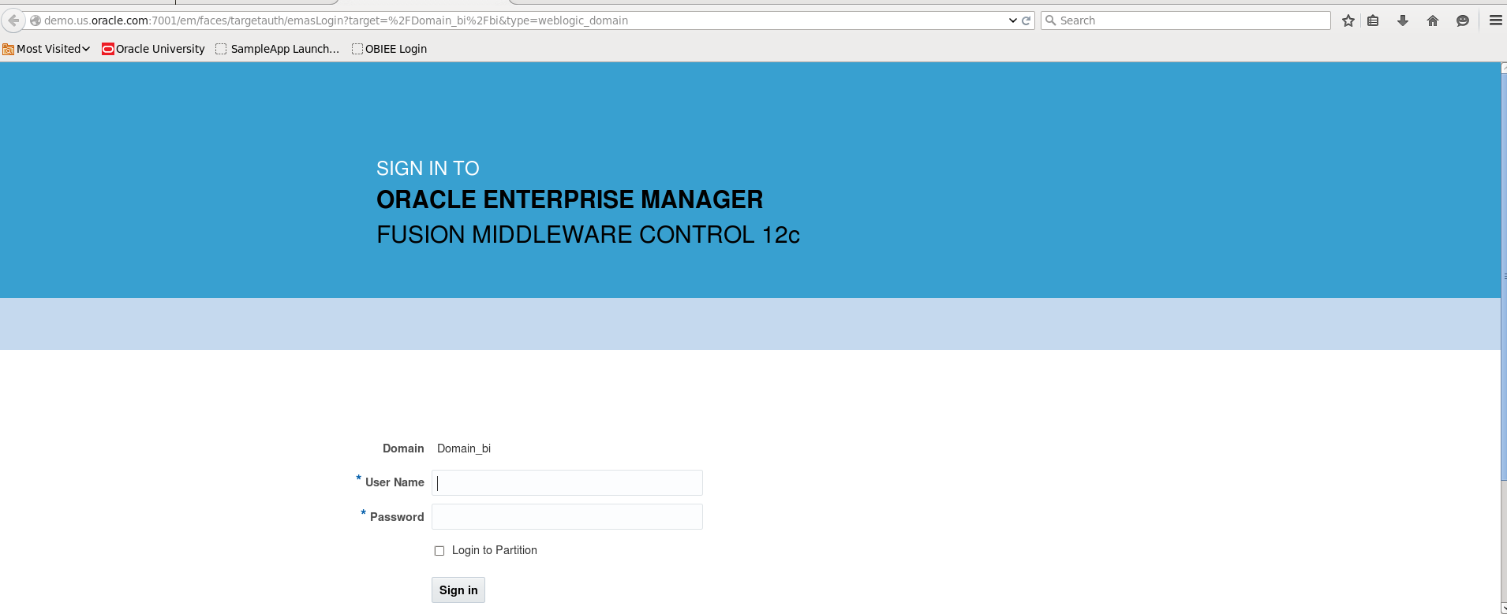

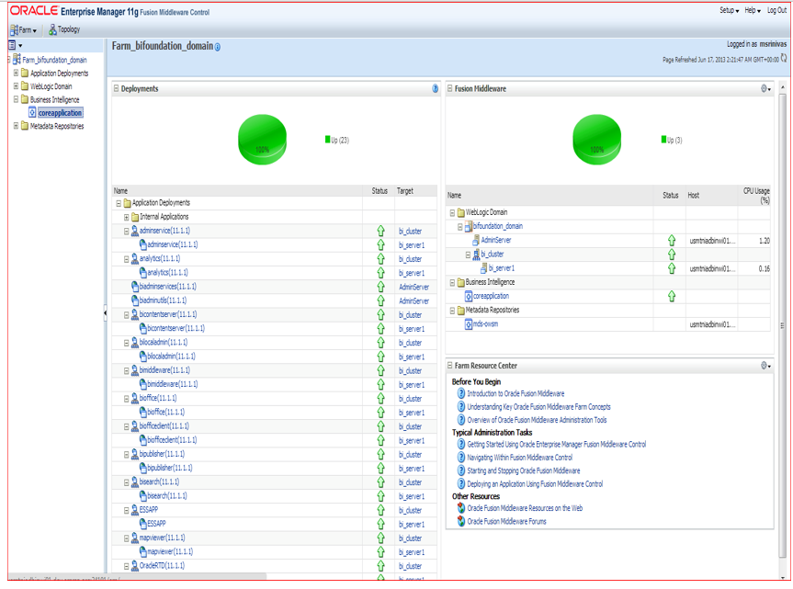

Create Application Roles:

From the left-hand tree-view panel, select **Business Intelligence** -> **coreapplication**

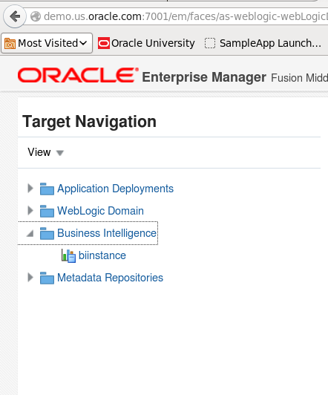

Rightclick on biinstance->security->Application roles

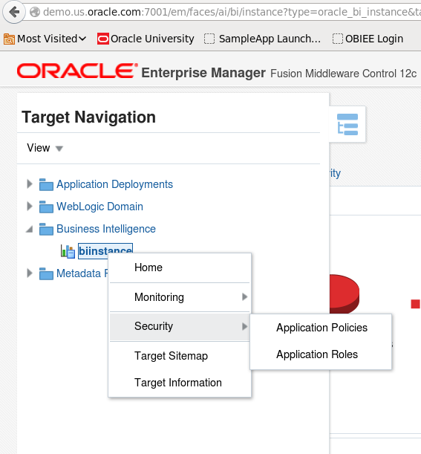

Please Note that **authenticated-role** one of the default memberships discovered above is also a member of the **BIConsumer** role, helping to explain why all new users receive both permissions by default.

At this point you can assign users new application role permissions directly using this screen – this is not however considered best practice. Instead you should be looking to associate users with groups, and groups with application roles.

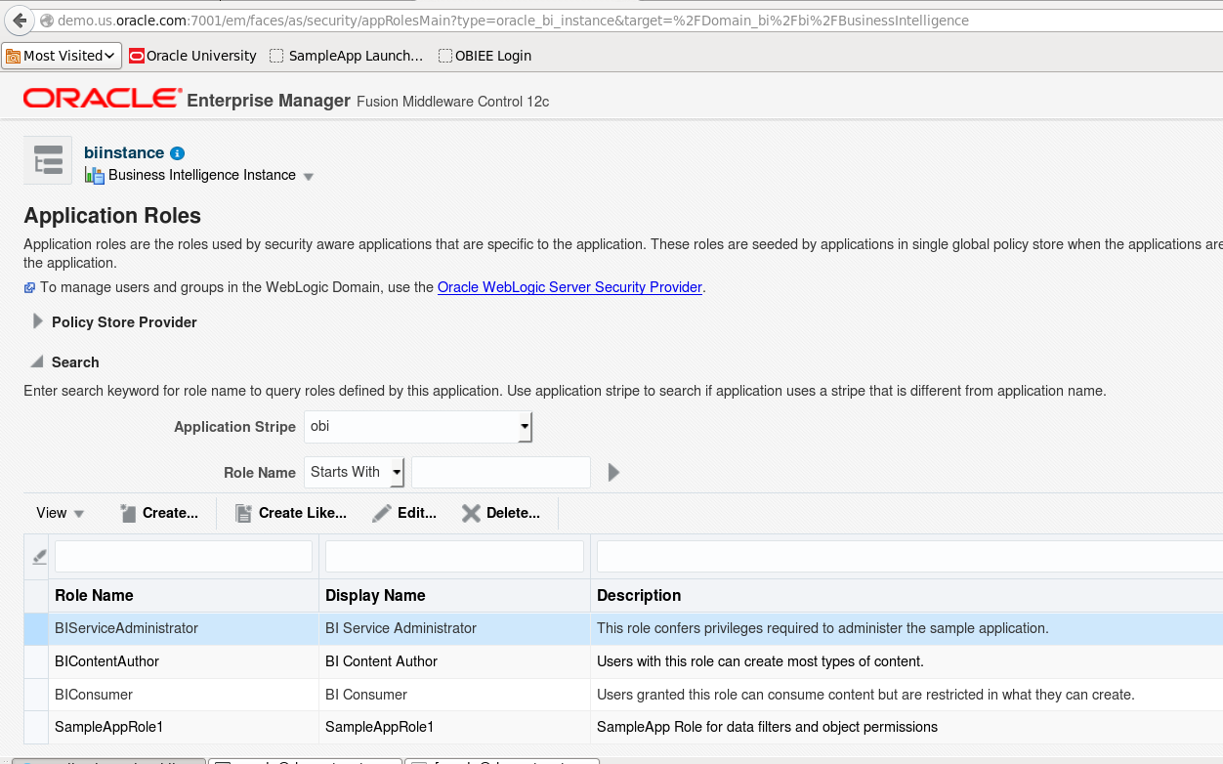

**Assigning permissions to WebLogic users**

Once you understand the difference between security groups and application roles, changing user group memberships is relatively simple.

Login weblogic console:/console

From the **Users and Groups** tab of the **myrealm** security realm click the **Groups** tab:

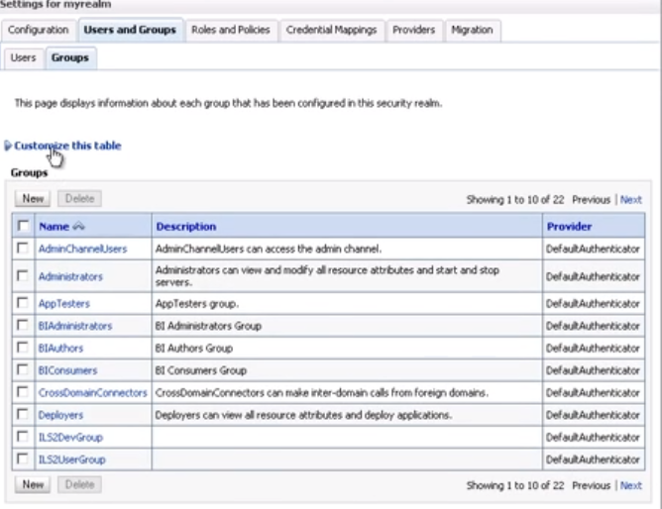

1. Check for the group that you want to add your new user to – for our example we will be working with the group that has already been defined as **BIAuthors**.

As before the system displays just ten groups by default. You can change the number of records displayed by clicking the **Customize this table** link and making the necessary alterations.

1. Click the **Users** sub-tab above the tableand then select the new user’s name from the table displayed.
2. When the Settings screen reloads, click the **Groups** tab:

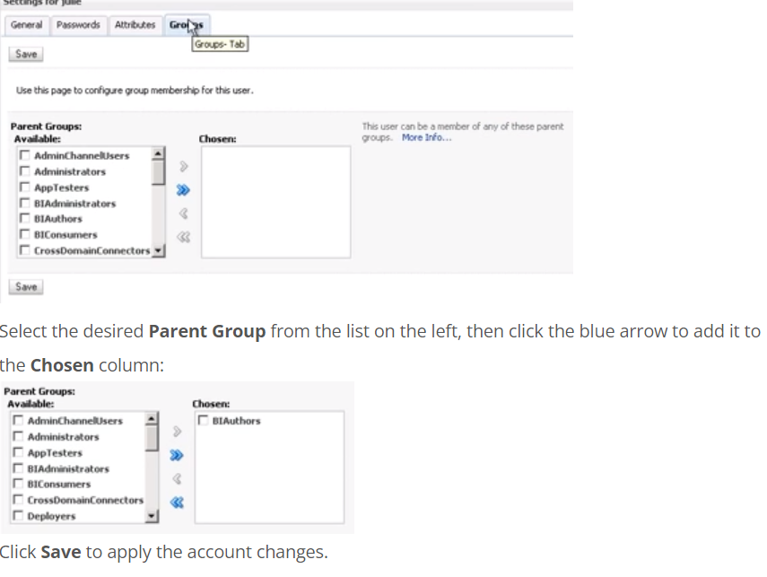

The user will now need to log out of the OBIEE for the new permissions to apply. Upon next login the new Application Role settings will have been added to the account and the user will have access to additional functions as defined in the **Role eg: BiAuthor** application role. You can confirm the new permissions have been applied by checking the **My Account** settings as detailed above.

Monitor Obiee services:

