**Steps to start the Database**:

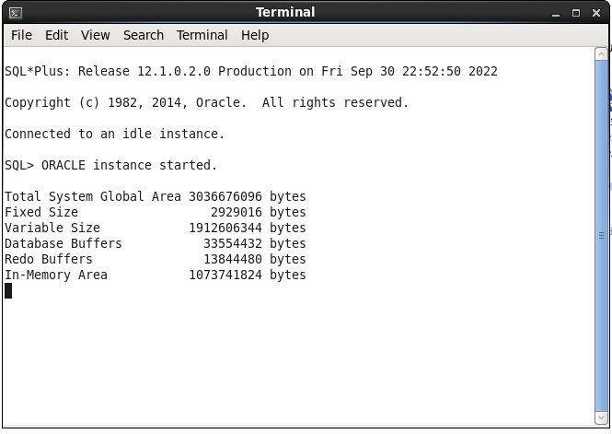

Shows message Database mounted and started Succussfully.

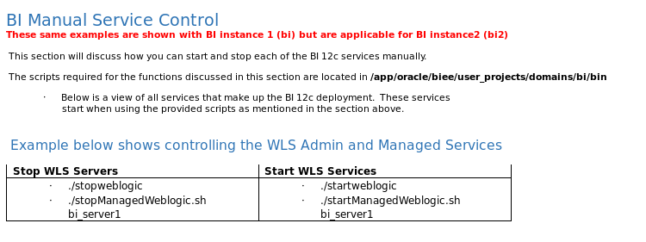

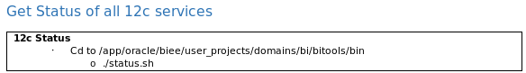

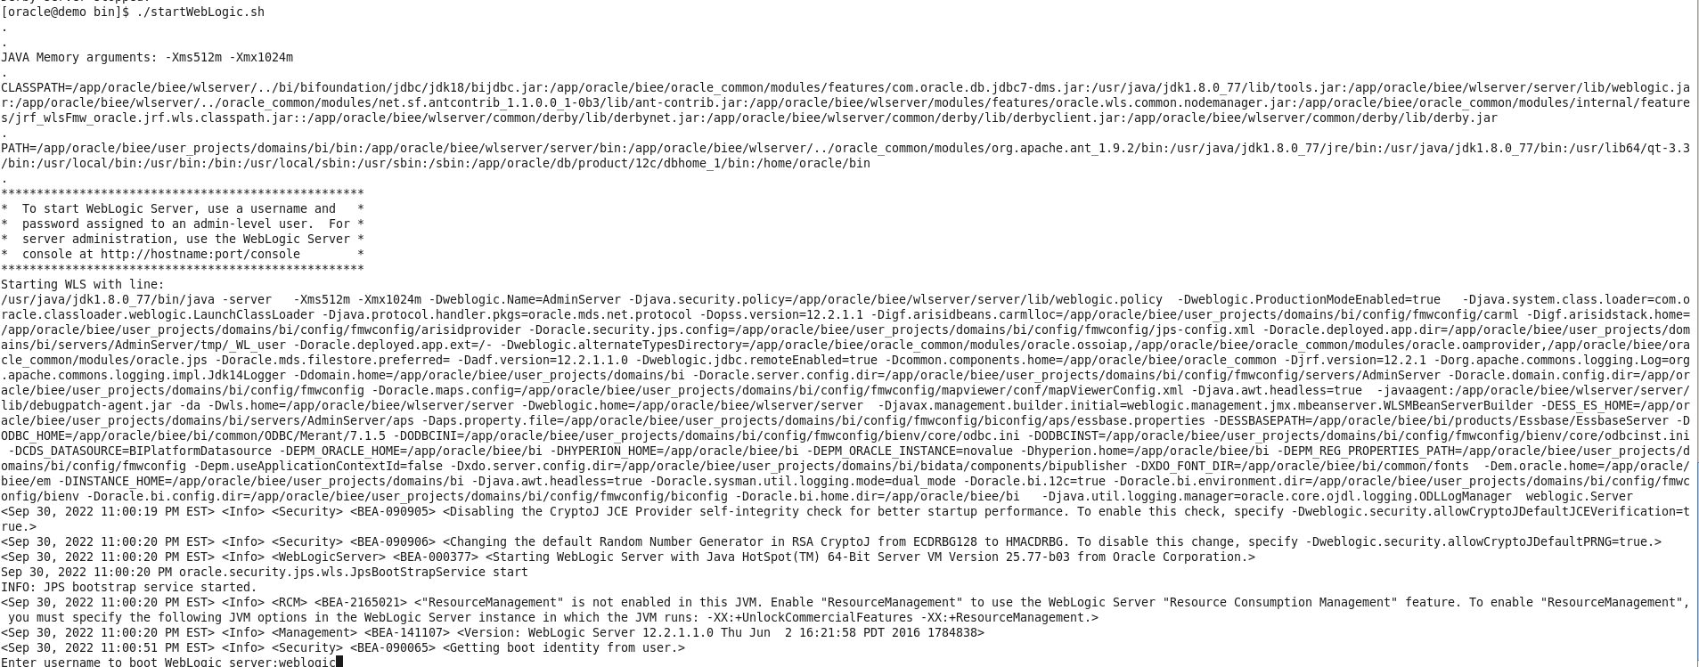

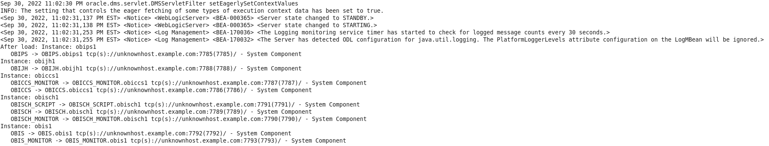

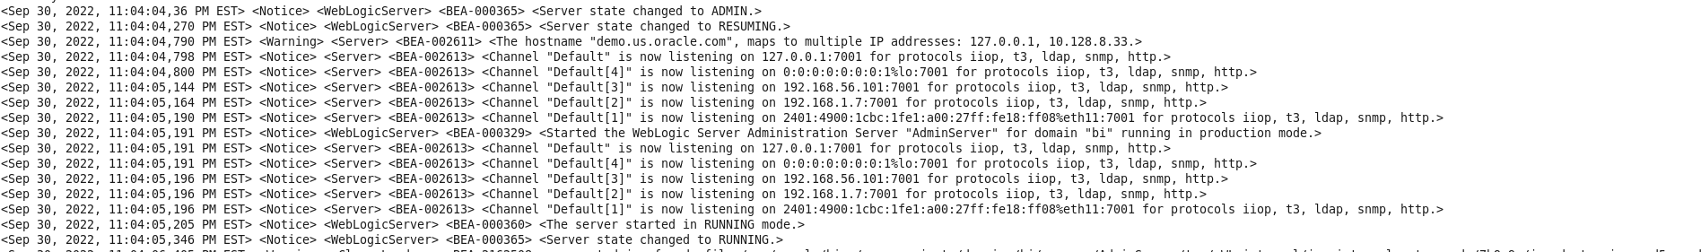

# Using Commands to Start, Stop, and View Status of Oracle BI EE Processes

**Start and Stop OBIEE Services in OBIEE 12c**

The OBIEE 12c start and stop are done through command line. It is a very simple command to just start and stop OBIEE services. OBIEE 11g even give an option to select from the start menu to Start and Stop OBIEE services but this is no more available in OBIEE 12c.  We have total 3 options:

Start.cmd for start services

Stop.cmd for stop servicesEnter an appropriate command to run the start script located in:

*DOMAIN_HOME*/bitools/bin

On UNIX | Windows:

./start.sh | start.cmd

References:

<https://docs.oracle.com/middleware/12212/biee/BIESG/GUID-6543ADEA-8161-4C90-9AEA-A132C292D2EE.htm#BIESG9259>