# **Assignment2**

# Created on March 31 2021

# **Table of Contents**

1.0. Home

2.0. Products

3.0. Find Us

# **1.0. Home**

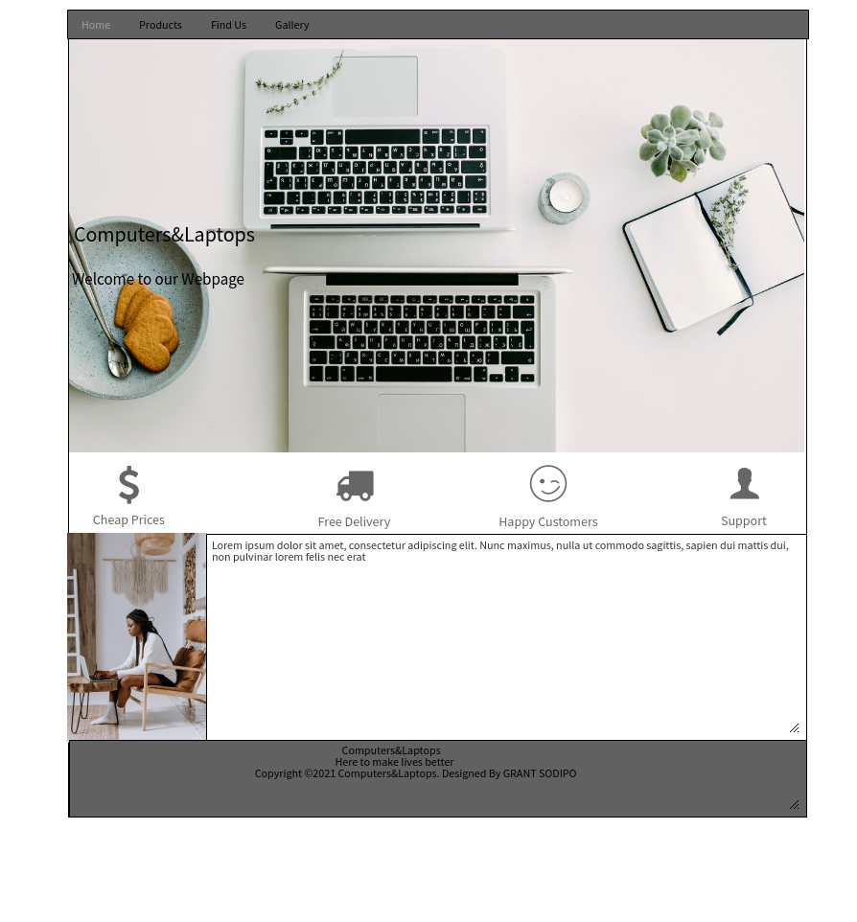

# **2.0. Products**

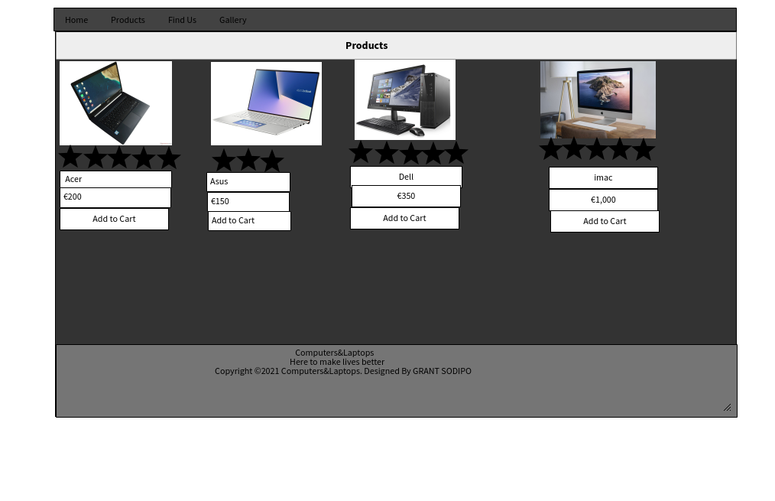

# **3.0. Find Us**

