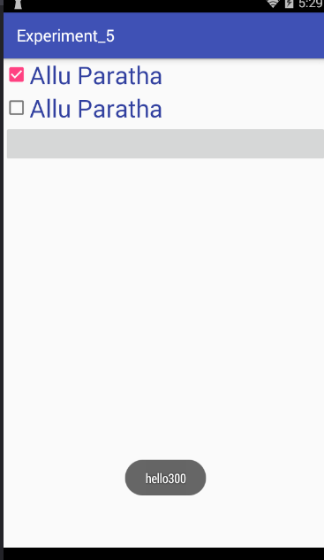

**package** commmm.gps.gauravpratapsingh.experiment_5;  
  
**import** android.support.v7.app.AppCompatActivity;  
**import** android.os.Bundle;  
**import** android.view.View;  
**import** android.widget.Button;  
**import** android.widget.CheckBox;  
**import** android.widget.Toast;  
  
**public class** MainActivity **extends** AppCompatActivity {  
 CheckBox **c1**,**c2**;  
 **int sum**=0;  
 Button **btn1**;  
  
 @Override  
 **protected void** onCreate(Bundle savedInstanceState) {  
 **super**.onCreate(savedInstanceState);  
 setContentView(R.layout.***activity_main***);  
 **c1**=(CheckBox)findViewById(R.id.***alu***);  
 **c2**=(CheckBox)findViewById(R.id.***alu1***);  
 **btn1**=(Button)findViewById(R.id.***btn1***);  
  
 **btn1**.setOnClickListener(**new** View.OnClickListener() {  
  
  
  
 @Override  
 **public void** onClick(View v) {  
 **if**(**c1**.isChecked()) {  
 **sum** = **sum** + 300;  
 }  
 **if**(**c2**.isChecked()) {  
 **sum** = **sum** + 200;  
 }  
 Toast.*makeText*(getApplicationContext(),**"hello"**+**sum** ,Toast.***LENGTH_LONG***).show();  
 **sum**=0;  
 }  
  
 });  
  
 }  
  
}