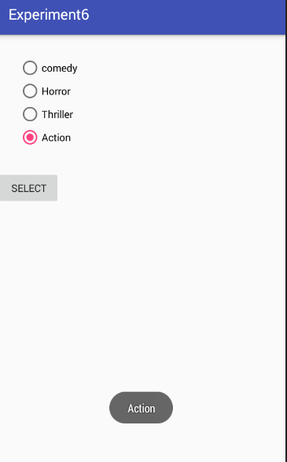

**package** commmm.gps.gauravpratapsingh.experiment6;  
  
**import** android.support.v7.app.AppCompatActivity;  
**import** android.os.Bundle;  
**import** android.view.View;  
**import** android.widget.Button;  
**import** android.widget.RadioButton;  
**import** android.widget.RadioGroup;  
**import** android.widget.Toast;  
  
**public class** MainActivity **extends** AppCompatActivity {  
 **private** RadioGroup **radioGroup**;  
 **private** RadioButton **b1**;  
 **private** Button **btnDisplay**;  
  
 @Override  
 **protected void** onCreate(Bundle savedInstanceState) {  
 **super**.onCreate(savedInstanceState);  
 setContentView(R.layout.***activity_main***);  
 **radioGroup**=(RadioGroup)findViewById(R.id.***radioG***);  
 **btnDisplay**=(Button) findViewById(R.id.***btnDisplay***);  
  
 **btnDisplay**.setOnClickListener(**new** View.OnClickListener() {  
 @Override  
 **public void** onClick(View v) {  
 **int** selectedId = **radioGroup**.getCheckedRadioButtonId();  
 *// find the radiobutton by returned id* **b1** = (RadioButton) findViewById(selectedId);  
  
 Toast.*makeText*(getApplicationContext(), **b1**.getText(), Toast.***LENGTH_SHORT***).show();  
  
 }  
 });  
  
 }  
}