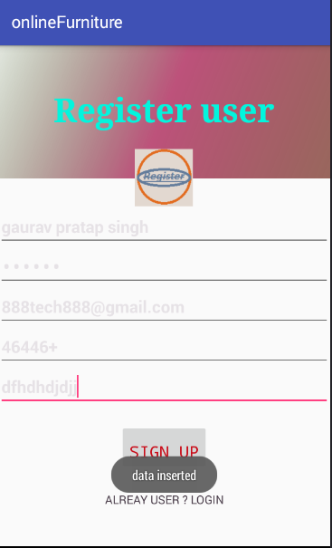

**package** comm.gps.gauravpratapsingh.onlinefurniture;  
  
**import** android.content.Intent;  
**import** android.support.v7.app.AppCompatActivity;  
**import** android.os.Bundle;  
**import** android.view.View;  
**import** android.widget.Button;  
**import** android.widget.EditText;  
**import** android.widget.Toast;  
  
**public class** Register **extends** AppCompatActivity {  
 **private** EditText **uname**,**uemail**,**upassword**,**uphone**,**uadhar**;  
 **private** Button **alreadyuser**,**signup**;  
 DatabaseHelper **mydb**;  
 @Override  
 **protected void** onCreate(Bundle savedInstanceState) {  
 **super**.onCreate(savedInstanceState);  
 setContentView(R.layout.activity_register);  
 mydb=**new** DatabaseHelper(**this**);  
 initializer();  
 alreadyuser.setOnClickListener(**new** View.OnClickListener() {  
 @Override  
 **public void** onClick(View v) {  
 alreadyUserRegister();  
 }  
 });  
 addData();  
 }  
  
  
  
 **private void** alreadyUserRegister()  
 {  
 Intent it =**new** Intent(**this**,MainActivity.**class**);  
 startActivity(it);  
 }  
 **private void** initializer()  
 {  
 uname=(EditText)findViewById(R.id.uname);  
 uemail=(EditText)findViewById(R.id.uemail);  
 upassword=(EditText)findViewById(R.id.upass);  
 uphone=(EditText)findViewById(R.id.uphone);  
 uadhar=(EditText)findViewById(R.id.uadhar);  
 signup=(Button)findViewById(R.id.signup);  
 alreadyuser=(Button)findViewById(R.id.alreadyuser);  
  
 }  
 **public void** addData()  
 {  
 signup.setOnClickListener(**new** View.OnClickListener() {  
 @Override  
 **public void** onClick(View v) {  
 **boolean** result= mydb.dataInsert(uname.getText().toString(),uphone.getText().toString(),uadhar.getText().toString(),upassword.getText().toString(),uemail.getText().toString());  
 **if**(result==**true**)  
 {  
 Toast.makeText(Register.**this**,**"data inserted"**,Toast.LENGTH_LONG).show();  
 }**else** {  
 Toast.makeText(Register.**this**,**"data not inserted"**,Toast.LENGTH_LONG).show();  
 }  
 }  
 });  
 }  
}