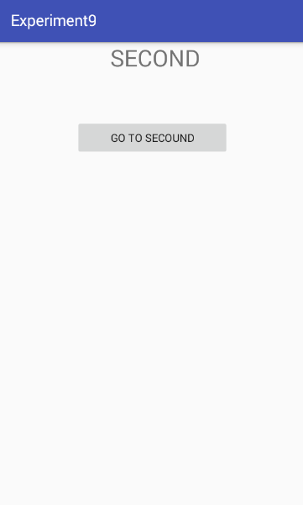 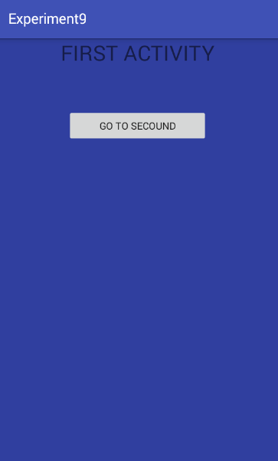

firstAcitivity

*<?***xml version="1.0" encoding="utf-8"***?>*<**RelativeLayout xmlns:android="http://schemas.android.com/apk/res/android"  
 xmlns:app="http://schemas.android.com/apk/res-auto"  
 xmlns:tools="http://schemas.android.com/tools"  
 android:layout_width="match_parent"  
 android:layout_height="match_parent"  
 tools:context=".Main2Activity"**>  
  
 <**TextView  
 android:layout_width="match_parent"  
 android:text=" SECOND"  
 android:gravity="center"  
 android:textSize="30dp"  
 android:layout_height="wrap_content"** />  
 <**Button  
 android:id="@+id/btn1"  
 android:layout_width="match_parent"  
 android:gravity="center"  
 android:layout_margin="100dp"  
 android:text="Go to Secound"  
 android:layout_height="wrap_content"** />  
</**RelativeLayout**>

Second

*<?***xml version="1.0" encoding="utf-8"***?>*<**RelativeLayout xmlns:android="http://schemas.android.com/apk/res/android"  
 xmlns:app="http://schemas.android.com/apk/res-auto"  
 xmlns:tools="http://schemas.android.com/tools"  
 android:layout_width="match_parent"  
 android:layout_height="match_parent"  
 tools:context=".Main2Activity"**>  
  
 <**TextView  
 android:layout_width="match_parent"  
 android:text=" SECOND"  
 android:gravity="center"  
 android:textSize="30dp"  
 android:layout_height="wrap_content"** />  
 <**Button  
 android:id="@+id/btn1"  
 android:layout_width="match_parent"  
 android:gravity="center"  
 android:layout_margin="100dp"  
 android:text="Go to Secound"  
 android:layout_height="wrap_content"** />  
</**RelativeLayout**>

mainActivity.class

**package** commmm.gps.gauravpratapsingh.experiment9;  
  
**import** android.content.Intent;  
**import** android.support.v7.app.AppCompatActivity;  
**import** android.os.Bundle;  
**import** android.view.View;  
**import** android.widget.Button;  
  
**public class** MainActivity **extends** AppCompatActivity {  
**private** Button **button**;  
 @Override  
 **protected void** onCreate(Bundle savedInstanceState) {  
 **super**.onCreate(savedInstanceState);  
 setContentView(R.layout.***activity_main***);  
  
 **button**=(Button)findViewById(R.id.***butn***);  
 **button**.setOnClickListener(**new** View.OnClickListener() {  
 @Override  
 **public void** onClick(View v) {  
 Intent it=**new** Intent(MainActivity.**this**,Main2Activity.**class**);  
 it.putExtra(**"value1"**,**"Cach first by second"**);  
 startActivity(it);  
 }  
 });  
 }  
}

main2Activity

**package** commmm.gps.gauravpratapsingh.experiment9;  
  
**import** android.content.Intent;  
**import** android.support.v7.app.AppCompatActivity;  
**import** android.os.Bundle;  
**import** android.view.View;  
**import** android.widget.Button;  
  
**public class** Main2Activity **extends** AppCompatActivity {  
**private** Button **button**;  
 @Override  
 **protected void** onCreate(Bundle savedInstanceState) {  
 **super**.onCreate(savedInstanceState);  
 setContentView(R.layout.***activity_main2***);  
 **button**=(Button)findViewById(R.id.***btn1***);  
  
 **button**.setOnClickListener(**new** View.OnClickListener() {  
 @Override  
 **public void** onClick(View v) {  
 Intent it= **new** Intent(Main2Activity.**this**,MainActivity.**class**);  
 it.putExtra(**"value1"**,**"Cach second by first"**);  
 startActivity(it);  
 }  
 });  
 }  
}