**布料检测项目设计流程**

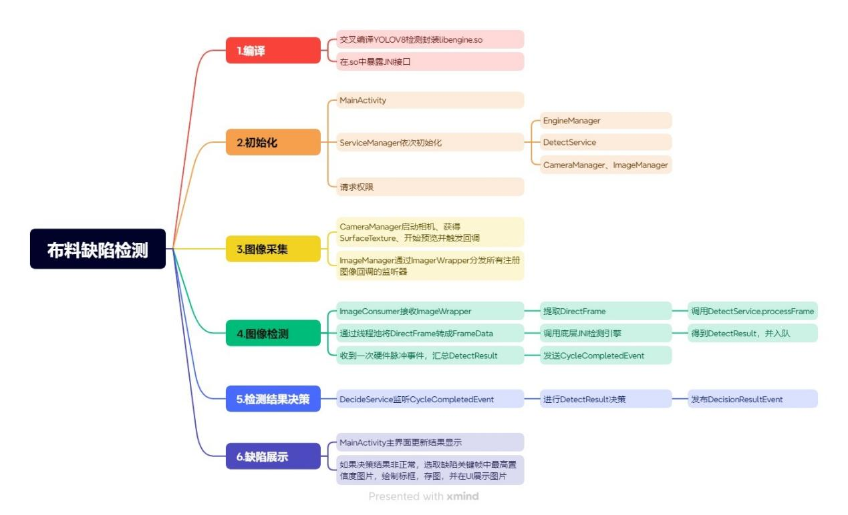

1. **开发与编译阶段**  
    **1.1.** 在 RK3588 平台上交叉编译 YOLOv8 检测引擎，生成 Android ABI 对应的 libengine.so等文件，放入 [arm64-v8a](vscode-file://vscode-app/e:/Software Study/Program software/vscode/Microsoft VS Code/resources/app/out/vs/code/electron-sandbox/workbench/workbench.html" \o ")；  
    **1.2.** 针对 Android 12 （API 31+）调整 NDK 构建脚本（CMake/ndk-build），确保 .so 中 JNI 接口暴露给 Java 层；  
    **1.3.** 在 AndroidStudio 中配置 externalNativeBuild，引入交叉编译输出的 .so。

**2.应用初始化阶段**  
 **2.1.** 启动 [MainActivity](vscode-file://vscode-app/e:/Software Study/Program software/vscode/Microsoft VS Code/resources/app/out/vs/code/electron-sandbox/workbench/workbench.html" \o ")；  
 **2.2.** 通过单例 [ServiceManager](vscode-file://vscode-app/e:/Software Study/Program software/vscode/Microsoft VS Code/resources/app/out/vs/code/electron-sandbox/workbench/workbench.html" \o ") 依次初始化：  
 - [EngineManager](vscode-file://vscode-app/e:/Software Study/Program software/vscode/Microsoft VS Code/resources/app/out/vs/code/electron-sandbox/workbench/workbench.html" \o ")：加载 .so 并构建底层 [DetectionService](vscode-file://vscode-app/e:/Software Study/Program software/vscode/Microsoft VS Code/resources/app/out/vs/code/electron-sandbox/workbench/workbench.html" \o ") （native JNI 封装）；  
 - [DetectService](vscode-file://vscode-app/e:/Software Study/Program software/vscode/Microsoft VS Code/resources/app/out/vs/code/electron-sandbox/workbench/workbench.html" \o ") 与 [DecideService](vscode-file://vscode-app/e:/Software Study/Program software/vscode/Microsoft VS Code/resources/app/out/vs/code/electron-sandbox/workbench/workbench.html" \o ")：Java 层的检测与决策服 务；  
 - [CameraManager](vscode-file://vscode-app/e:/Software Study/Program software/vscode/Microsoft VS Code/resources/app/out/vs/code/electron-sandbox/workbench/workbench.html" \o ")、[ImageManager](vscode-file://vscode-app/e:/Software Study/Program software/vscode/Microsoft VS Code/resources/app/out/vs/code/electron-sandbox/workbench/workbench.html" \o ")：摄像头与帧管理。  
 **2.3.** 请求必要权限（存储、相机、通知等），准备 UI。

**3.摄像头采集与图像流转**  
 **3.1**. 用户点击“开始预览”/[MainActivity.startPreview()](vscode-file://vscode-app/e:/Software Study/Program software/vscode/Microsoft VS Code/resources/app/out/vs/code/electron-sandbox/workbench/workbench.html" \o ") 或切换到 [CameraActivity.java](vscode-file://vscode-app/e:/Software Study/Program software/vscode/Microsoft VS Code/resources/app/out/vs/code/electron-sandbox/workbench/workbench.html" \o ")；  
 **3.2**. [CameraManager](vscode-file://vscode-app/e:/Software Study/Program software/vscode/Microsoft VS Code/resources/app/out/vs/code/electron-sandbox/workbench/workbench.html" \o ") 打开相机、获得 [SurfaceTexture](vscode-file://vscode-app/e:/Software Study/Program software/vscode/Microsoft VS Code/resources/app/out/vs/code/electron-sandbox/workbench/workbench.html" \o ")，开始预览并不断回调 [ImageManager.handleImage(...)](vscode-file://vscode-app/e:/Software Study/Program software/vscode/Microsoft VS Code/resources/app/out/vs/code/electron-sandbox/workbench/workbench.html" \o ")；  
 **3.3**. [ImageManager](vscode-file://vscode-app/e:/Software Study/Program software/vscode/Microsoft VS Code/resources/app/out/vs/code/electron-sandbox/workbench/workbench.html" \o ") 通过 [ImageWrapper](vscode-file://vscode-app/e:/Software Study/Program software/vscode/Microsoft VS Code/resources/app/out/vs/code/electron-sandbox/workbench/workbench.html" \o ") 将帧分发给所有注册的监听器（包括 [MainActivity](vscode-file://vscode-app/e:/Software Study/Program software/vscode/Microsoft VS Code/resources/app/out/vs/code/electron-sandbox/workbench/workbench.html" \o ")、CameraActivity、[ImageConsumer](vscode-file://vscode-app/e:/Software Study/Program software/vscode/Microsoft VS Code/resources/app/out/vs/code/electron-sandbox/workbench/workbench.html" \o ") 等）。

**4.实时检测与队列**  
 **4.1.** [ImageConsumer](vscode-file://vscode-app/e:/Software Study/Program software/vscode/Microsoft VS Code/resources/app/out/vs/code/electron-sandbox/workbench/workbench.html" \o ") 接收 [ImageWrapper](vscode-file://vscode-app/e:/Software Study/Program software/vscode/Microsoft VS Code/resources/app/out/vs/code/electron-sandbox/workbench/workbench.html" \o ") → 提取 [DirectFrame](vscode-file://vscode-app/e:/Software Study/Program software/vscode/Microsoft VS Code/resources/app/out/vs/code/electron-sandbox/workbench/workbench.html" \o ") → 调用 [DetectService.processFrame(DirectFrame)](vscode-file://vscode-app/e:/Software Study/Program software/vscode/Microsoft VS Code/resources/app/out/vs/code/electron-sandbox/workbench/workbench.html" \o ")；  
 **4.2.** [DetectService](vscode-file://vscode-app/e:/Software Study/Program software/vscode/Microsoft VS Code/resources/app/out/vs/code/electron-sandbox/workbench/workbench.html" \o ") 在线程池中将 [DirectFrame](vscode-file://vscode-app/e:/Software Study/Program software/vscode/Microsoft VS Code/resources/app/out/vs/code/electron-sandbox/workbench/workbench.html" \o ") 转成 [FrameData](vscode-file://vscode-app/e:/Software Study/Program software/vscode/Microsoft VS Code/resources/app/out/vs/code/electron-sandbox/workbench/workbench.html" \o ")，调用底层 JNI 引擎 [detectionService.detect(...)](vscode-file://vscode-app/e:/Software Study/Program software/vscode/Microsoft VS Code/resources/app/out/vs/code/electron-sandbox/workbench/workbench.html" \o ") 得到 [DetectResult](vscode-file://vscode-app/e:/Software Study/Program software/vscode/Microsoft VS Code/resources/app/out/vs/code/electron-sandbox/workbench/workbench.html" \o ")，并入队（[resultQueue](vscode-file://vscode-app/e:/Software Study/Program software/vscode/Microsoft VS Code/resources/app/out/vs/code/electron-sandbox/workbench/workbench.html" \o ")）；  
 **4.3**. 每收到一次硬件脉冲事件（[PulseEvent](vscode-file://vscode-app/e:/Software Study/Program software/vscode/Microsoft VS Code/resources/app/out/vs/code/electron-sandbox/workbench/workbench.html" \o ")），汇总当前圈所有 [DetectionWrapper](vscode-file://vscode-app/e:/Software Study/Program software/vscode/Microsoft VS Code/resources/app/out/vs/code/electron-sandbox/workbench/workbench.html" \o ") → 发送 [CycleCompletedEvent](vscode-file://vscode-app/e:/Software Study/Program software/vscode/Microsoft VS Code/resources/app/out/vs/code/electron-sandbox/workbench/workbench.html" \o ")。

**5.决策与展示**  
 **5.1.** [DecideService](vscode-file://vscode-app/e:/Software Study/Program software/vscode/Microsoft VS Code/resources/app/out/vs/code/electron-sandbox/workbench/workbench.html" \o ") 监听 [CycleCompletedEvent](vscode-file://vscode-app/e:/Software Study/Program software/vscode/Microsoft VS Code/resources/app/out/vs/code/electron-sandbox/workbench/workbench.html" \o ")，在线程池中调用 [InnerDetectionService.doDecide(...)](vscode-file://vscode-app/e:/Software Study/Program software/vscode/Microsoft VS Code/resources/app/out/vs/code/electron-sandbox/workbench/workbench.html" \o ") 得出 [DecideResult](vscode-file://vscode-app/e:/Software Study/Program software/vscode/Microsoft VS Code/resources/app/out/vs/code/electron-sandbox/workbench/workbench.html" \o ") → 发布 [DecisionResultEvent](vscode-file://vscode-app/e:/Software Study/Program software/vscode/Microsoft VS Code/resources/app/out/vs/code/electron-sandbox/workbench/workbench.html" \o ")；  
 **5.2.** 主界面 [MainActivity](vscode-file://vscode-app/e:/Software Study/Program software/vscode/Microsoft VS Code/resources/app/out/vs/code/electron-sandbox/workbench/workbench.html" \o ")（@Subscribe(threadMode=MAIN) onDecisionResultEvent）更新结果显示；  
 **5.3.** 如果决策结果非正常，则 [DefectImageSaver](vscode-file://vscode-app/e:/Software Study/Program software/vscode/Microsoft VS Code/resources/app/out/vs/code/electron-sandbox/workbench/workbench.html" \o ")（@Subscribe(threadMode=BACKGROUND) onDecisionResultEvent）选取关键帧最高置信度图像 → 绘制标框 → 存入相册 → 发 [StopDetectionCommand("检测到缺陷")](vscode-file://vscode-app/e:/Software Study/Program software/vscode/Microsoft VS Code/resources/app/out/vs/code/electron-sandbox/workbench/workbench.html" \o ") → 启动 [DefectStopActivity](vscode-file://vscode-app/e:/Software Study/Program software/vscode/Microsoft VS Code/resources/app/out/vs/code/electron-sandbox/workbench/workbench.html" \o ") 展示图片。

**6.其他模块**

**6.**1灵敏度/参数设置：[SensitivitySettingsActivity](vscode-file://vscode-app/e:/Software Study/Program software/vscode/Microsoft VS Code/resources/app/out/vs/code/electron-sandbox/workbench/workbench.html" \o ") 通 过 [ParamsManager](vscode-file://vscode-app/e:/Software Study/Program software/vscode/Microsoft VS Code/resources/app/out/vs/code/electron-sandbox/workbench/workbench.html" \o ") 更新参数；

**6.2**布料切换：[ChangeFabricActivity](vscode-file://vscode-app/e:/Software Study/Program software/vscode/Microsoft VS Code/resources/app/out/vs/code/electron-sandbox/workbench/workbench.html" \o ")，在界面上调整取向、亮度、抽针等 参数，同步到硬件；

**6.3**设备安装：DeviceSetupActivity 中完成标定、灰度测量、硬件控制按 钮等功能。