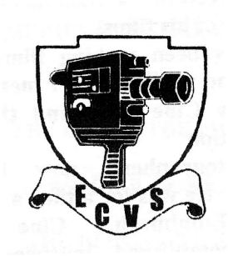 | Edinburgh Cine and Video Society  Members Annual Competition  Entry Form  2011 – 2012 Season
Name of Entrant :……………………………................................................................

Address :…..………………………................................................................................

……………………………….........................................................................................

Tel :……………………………......................................................................................

Email :……………………………..................................................................................

Title of Entry :…………………………….....................................................................

Running Time :………………………..……… (recommended maximum of 20 mins)
Please leave 10 seconds blank, or the ECVS countdown timer at start of each entry.

Please circle as applicable:
Format : MINI DV DVD Blu-ray

Video Aspect : 4x3 16x9 (native) 16x9(letterboxed)

Sound : Mono Stereo Other …………………………

ECVS plans to make copies of any award winning videos, for showing at various events, and publishing on the ECVS website. Any member who does not agree to their video being used in this way should tick this box. | 
The "First Award Competition" is a sub-competition to the main Annual Competition. It is open to any member who has never previously won a film or video competition (either in E.C.V.S. or elsewhere). Members eligible for the First Award Competition should tick this box.

I confirm that any necessary copyright clearance has been obtained for sound and visual elements of this film.

Signed: ………………………….………………. Date: ………………

Closing Date for Entries : TBAth February 2012
Competition Date : TBAth March 2012 Awards Date : TBAth April 2012

One completed form should be enclosed with each entry (maximum of 5 entries per member) and left in box on the table in the Club Rooms or sent to:
Annual Competition Entries, ECVS, 23a Fettes Row, Edinburgh.

ECVS ARE UNABLE TO ACCEPT ENTRIES RECEIVED AFTER THE CLOSING DATE

