**Introduction**

This is the first project of our intern period. So it is mainly focus about learning new technologies. Our project is basically about student enrollment system for university. It has several functions as well. We got our requirement from our mentor and he explained about it, that what we should actually do. And after that we started to design our project based on UML diagrams. We used Microsoft Visio 2013 to draw those designs. After that we decided to draw UI mockups for the whole system by using online tool call “www.moqups.com”. There are three user types those are student, course coordinator and admin. We divided task for particular user type according to the user requirement.

**Student Enrolment system requirements**

These are the requirement for the project. There are few optional requirements in the list. We didn’t design those requirements yet. Because we have to complete this project in 3 weeks of period. If we can finish the project before expected time, we willing to add those requirements as well.

1. student registration for a course
2. system user
3. admin user
   1. view all details and add new users (course coordinators)
4. course coordinator
   1. enroll a student
   2. view student details
   3. view student reports
   4. add grades
   5. view student attendance (optional)
5. student
   1. view course schedule
   2. view grades
   3. comment on course module (forum, and optional)

**Design**

Our project design was started with UML diagrams. After analyzing the requirement we identified three user types and what are the task for each user types. Then we draw the use case diagram

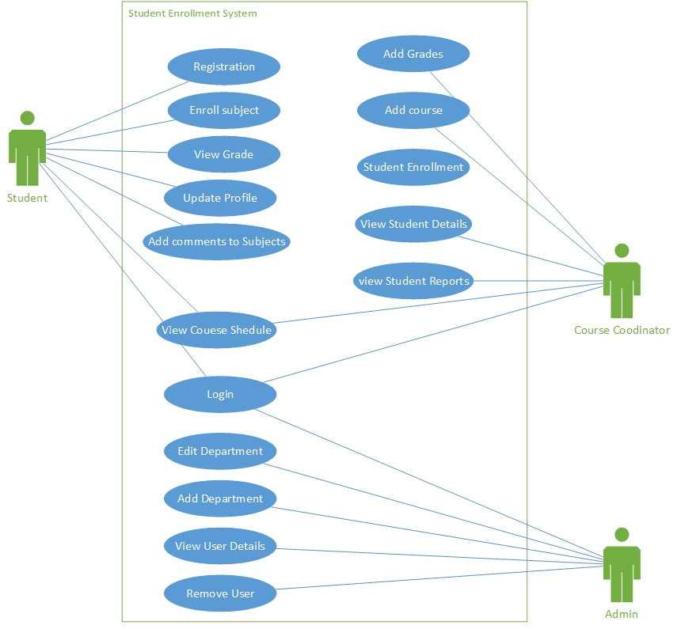

**Use case diagram**

And also we identify the activity work flow of the system. And we drew some activity diagrams for them.

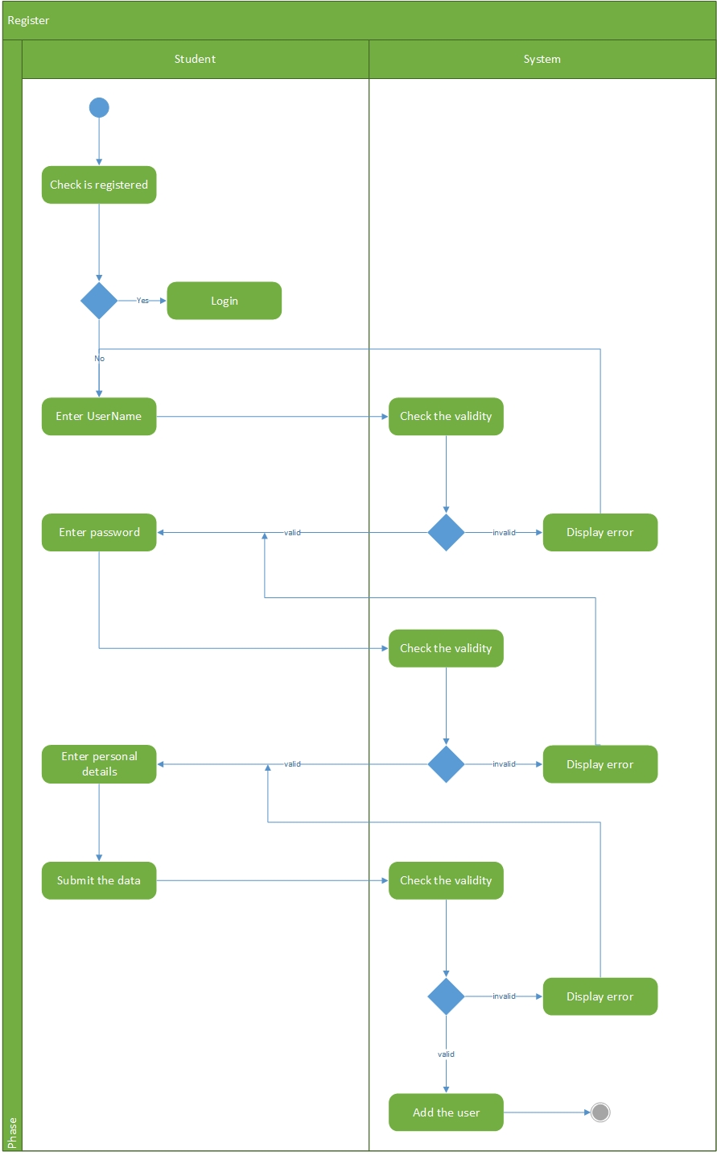

**Register Activity Diagram**

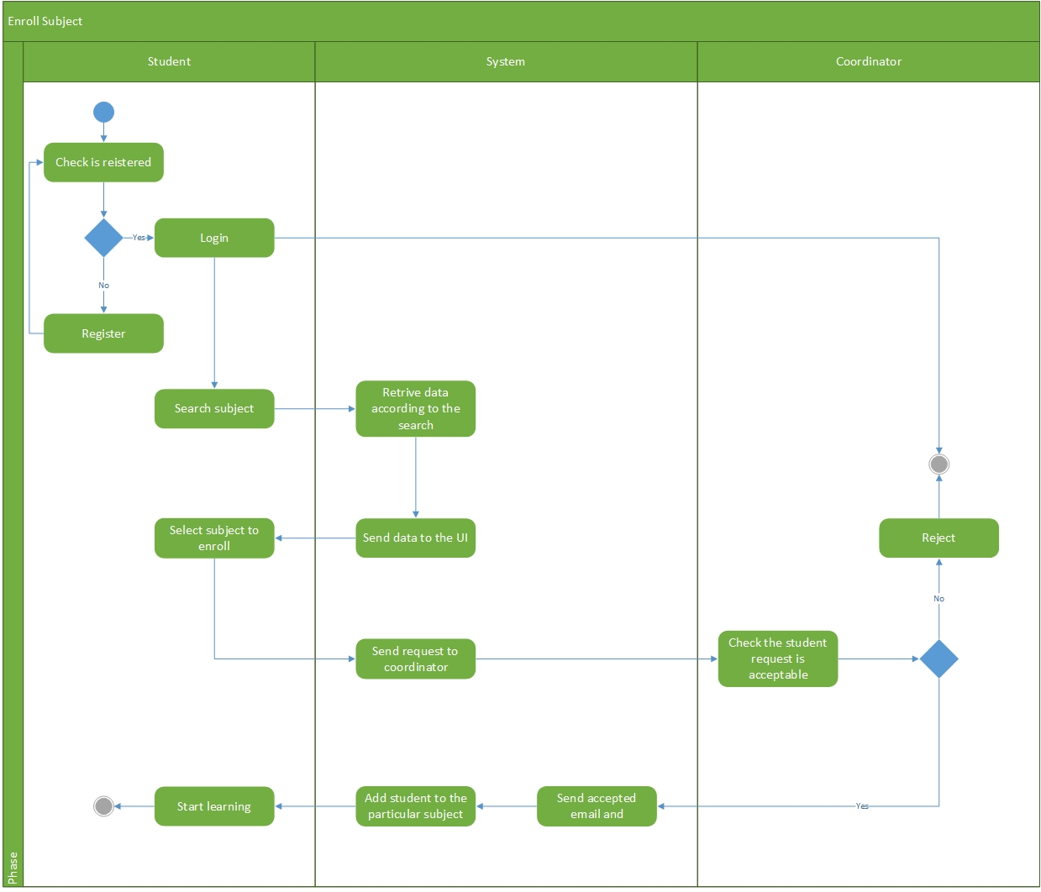

**Enroll subject**

And also we drew the class diagram for the system. Because then we can get clear idea of attributes and functions for relevant user types. And it was really helpful for us to design the database as well.

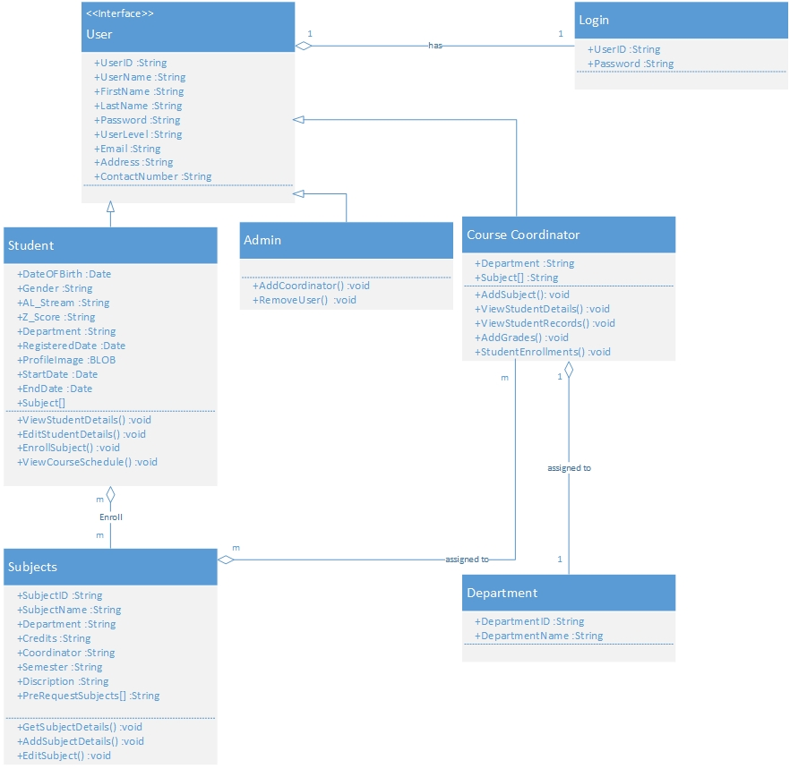

**Class Diagram**

**UI Mockups**

* Used Technologies :- moqups.com

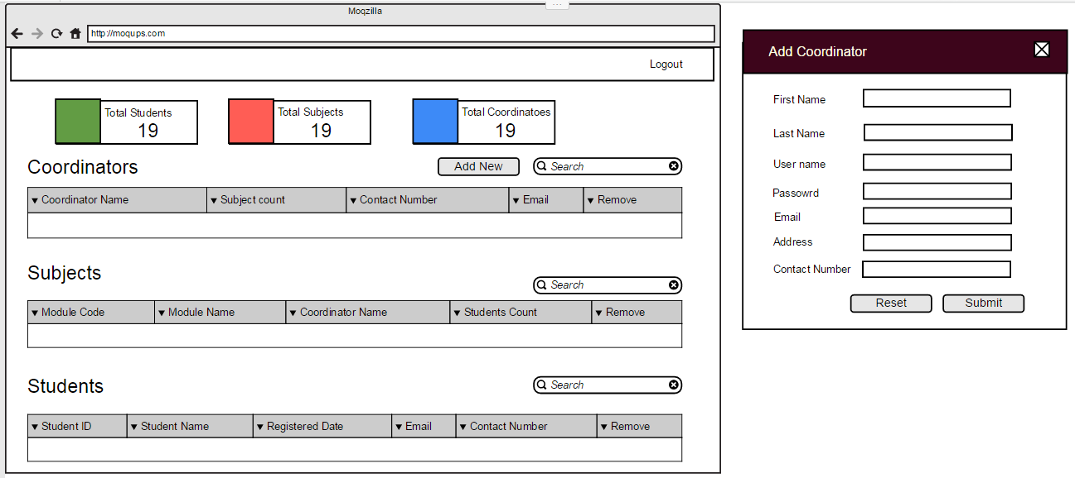**Admin :-**

**Coordinator :-**

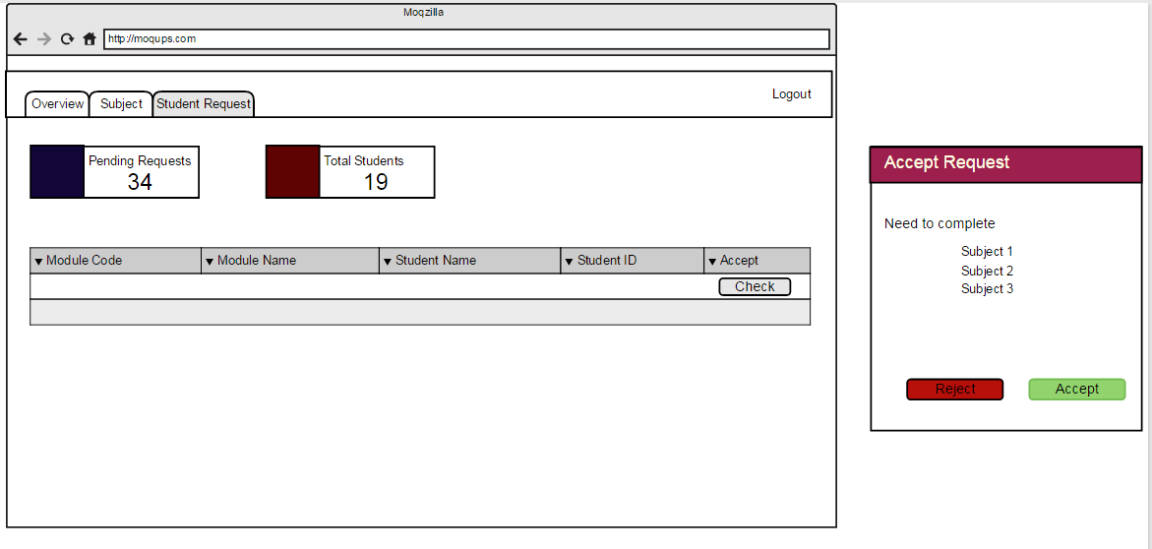

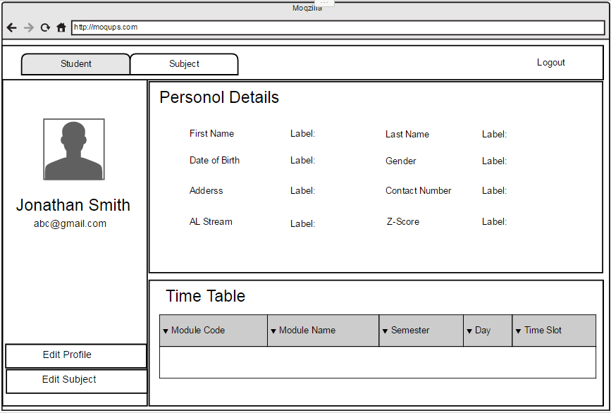

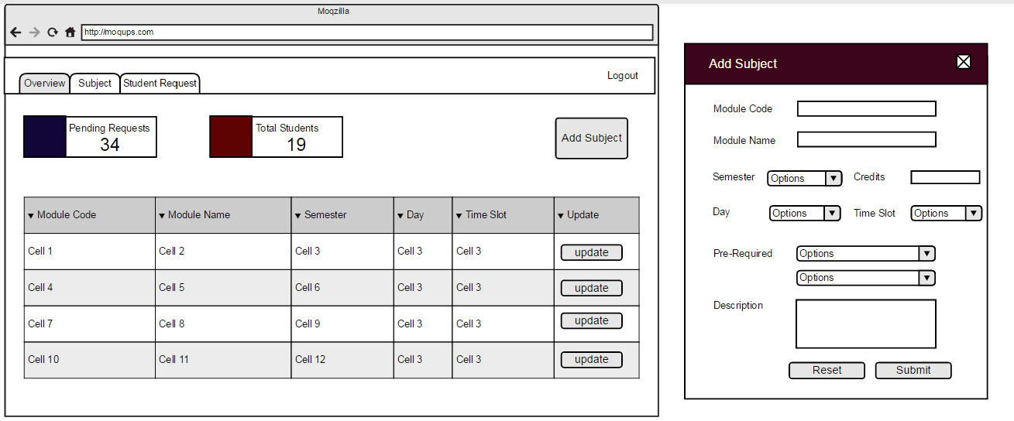

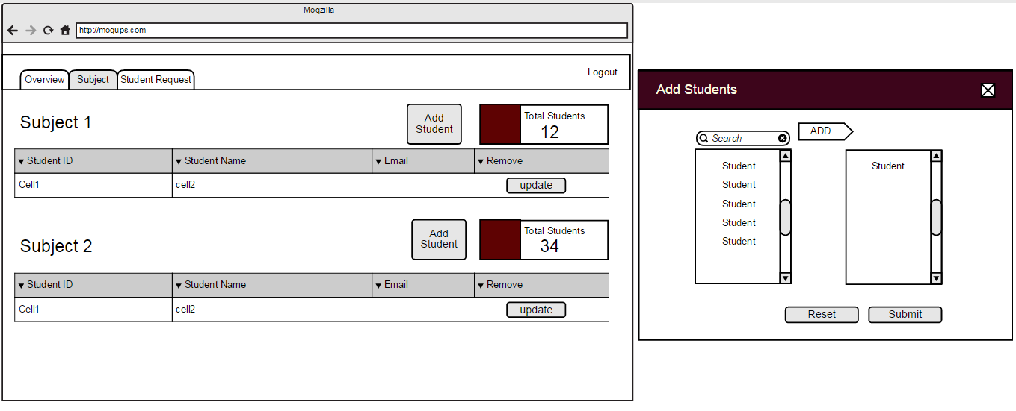

**Student :-**



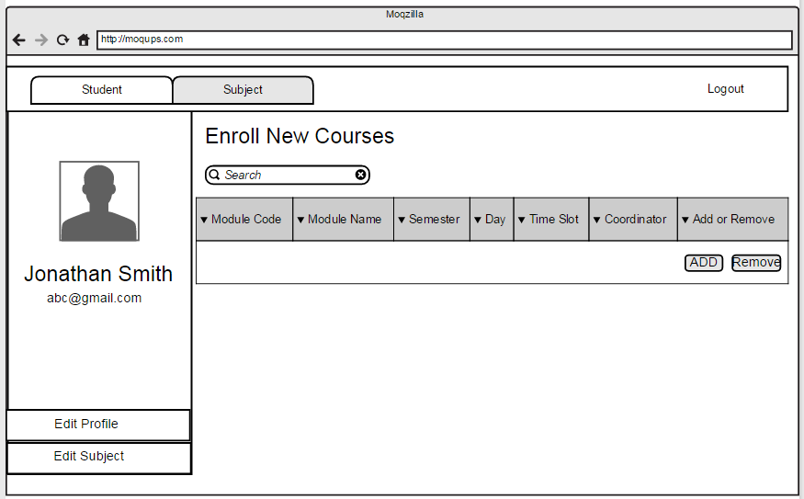

Registration and Login



