Member 4 methodology and results
  - Cao Taihe 24101734d | DataVinci | 2 November 2026
These sections are ready to integrate into the group report using the teacher’s chapter numbers. They document tested Member 4 work. The complete six-model comparison and full team notebook remain dependent on the other members’ implementations in the supplied archive.

3 2 Experimental design
We use the team’s clean_v2 dataset of 1,525 retained tweets. A tweet keeps its original row id; group_id joins duplicate or similar normalized content. We sort by id and take the first split from StratifiedGroupKFold with five splits, shuffle enabled and seed 42 as the reserved holdout. We apply the same algorithm to the remaining development rows to obtain five validation folds. No group occurs in more than one fold or on both sides of the holdout boundary. A random grouped split measures transfer to unseen content groups, rather than performance on a future chronological period.
Partition | Records | Share of all data | Purpose
Development | 1,222 | 80.13% | Five-fold model selection
Test | 303 | 19.87% | Reserved final evaluation
Outer training per run | 975–980 | 63.93–64.26% | Fit embeddings and classifier
Outer validation per run | 242–247 | 15.87–16.20% | OOF comparison

Table 5 Data partitioning. Development is the union of the five validation folds; the last two rows describe each CV iteration and are not additional partitions.
Subset | Neutral | Positive | Negative
Development | 348 | 486 | 388
Test | 85 | 121 | 97
Fold 0 | 66 | 97 | 79
Fold 1 | 72 | 97 | 78
Fold 2 | 70 | 97 | 77
Fold 3 | 71 | 96 | 77
Fold 4 | 69 | 99 | 77

Before saving, check_splits and additional validation verify schema, coverage, legal fold numbers, group consistency and all classes in each training and validation fold. The split manifest records the data and split SHA-256 hashes. Existing folds_v1 cannot be silently overwritten by a different partition. Preprocessing parameters and class weights are learned only from the applicable training rows. The holdout is used for prediction after selection, without computing its scores.

3 4 MLP model and refinement
We pair a separately trained FastText skip-gram embedding model with a randomly initialized PyTorch MLP. FastText uses 100 dimensions, window 5, minimum count 2, subword lengths 3–5, 200,000 hash buckets and 50 epochs. It uses one worker, seed 42 and stable CRC32 hashing. Each outer-fold embedding sees only the other four folds. Word vectors are averaged per tweet and standardized before entering the MLP. The full embedding sees all development text, but no holdout text.
The classifier contains hidden layers of 512 and 256 units, each followed by BatchNorm, ReLU and Dropout, with three output logits. We optimize cross-entropy with AdamW, batch size 64 and gradient clipping at 1.0. Each outer training partition contains a grouped inner split for early stopping: a maximum of 50 epochs, patience 7, selected by inner Macro-F1. The model is then reinitialized and fitted on the full outer training partition for that epoch count. This keeps the outer validation fold out of epoch selection. The final development refit uses the median selected epoch count of 11.
Configuration | Dropout | LR | Weight decay | Weighted | OOF Macro F1
Initial | 0.5 | 0.001 | 0.01 | No | 0.5403
Regularized | 0.3 | 0.0005 | 0.05 | No | 0.5234
Weighted | 0.3 | 0.0005 | 0.05 | Yes | 0.5301
TF IDF LR reference | — | — | — | No | 0.5820

The initial MLP remains the selected configuration. Its OOF accuracy is 0.5401, Macro-Precision 0.5487, Macro-Recall 0.5364 and Macro-F1 0.5403. Class F1 scores are 0.5638 Neutral, 0.5614 Positive and 0.4957 Negative. The independent TF-IDF/LR reference uses the same folds and has Macro-F1 0.5820, a difference of −0.0417 for MLP. It is a reference reproduction, not a replacement for Member 1’s official results. Both attempted refinements decreased Macro-F1. These are selection-set scores after three candidate comparisons and should not be interpreted as unbiased final performance.
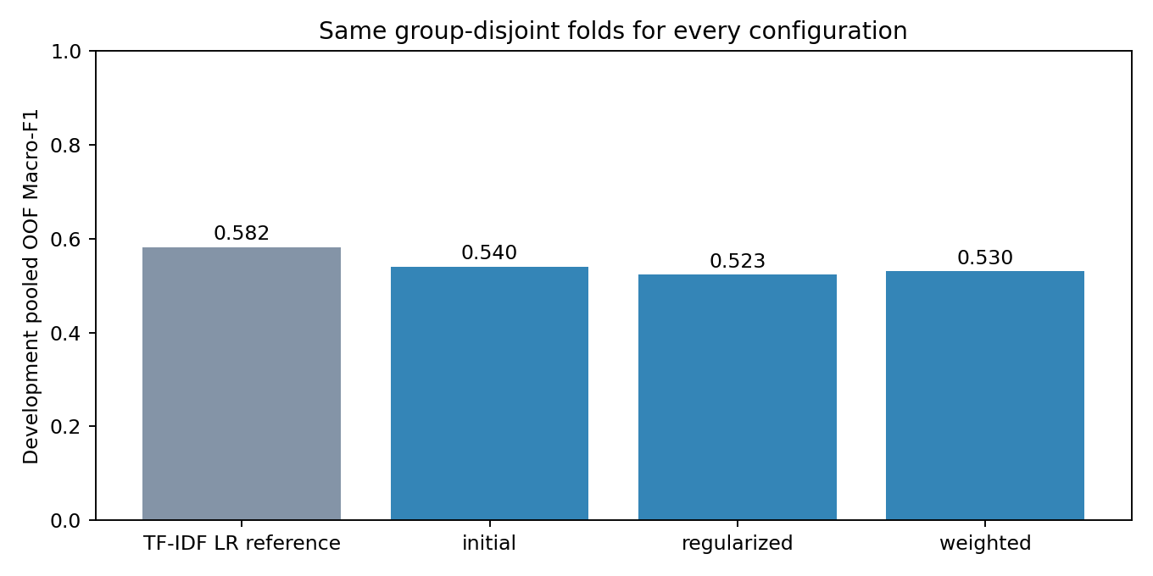
Figure M4 1 Development OOF comparison. Mean pooling discards word order and the supervised sample is small relative to classifier capacity. These are plausible explanations for the MLP result; this experiment does not establish their causal effects.

3 5 Evaluation and computing environment
Macro-F1 is the primary selection measure because it weights Neutral, Positive and Negative equally. We also report accuracy, macro precision and recall, per-class F1 and the OOF confusion matrix. Predictions are aligned by stable id and probability columns are always 0 Neutral, 1 Positive, 2 Negative. Fold scores and their sample standard deviation are supplied for stability assessment; five correlated folds are not independent confidence-interval replicates.
Environment item | Measured value
Operating system | Windows 11 build 26200
Processor | Intel64 Family 6 Model 198; 24 logical CPUs
Memory and accelerator | 15.38 GiB system RAM; CPU execution; CUDA unavailable
Python and PyTorch | 3.13.9 and 2.9.1 CPU; 2 PyTorch threads
Numerical stack | NumPy 2.3.5; SciPy 1.16.3; pandas 2.3.3
Other libraries | scikit-learn 1.7.2; gensim 4.4.0; Matplotlib 3.10.6

We use perf_counter for wall-clock intervals. MLP fit time includes the five inner early-stopping runs and five outer refits, but excludes embedding generation, scaling, prediction and plotting. Embedding and total pipeline times are logged separately. The three MLP configurations took 9.90, 9.98 and 12.00 seconds of fit time respectively. The first complete pipeline run took 65.30 seconds, including 25.08 seconds to produce six FastText versions. Times are measurements from this computer and can vary with load, software and caching. The original team Python 3.11 environment is preserved but was not the environment tested here.

5 4 Scalability and practical feasibility
At the measured scale, the selected MLP has 185,347 trainable parameters, requiring 741,388 bytes for FP32 parameter tensors, excluding optimizer state and framework overhead. The 1,222 × 100 development feature matrix occupies 488,800 bytes. The final 11-epoch refit took 1.25 seconds, while predicting 303 precomputed holdout vectors took 0.00747 seconds. The latter excludes text processing, embedding and feature standardization and is not an end-to-end service latency benchmark. System RAM capacity is recorded, but peak process memory was not measured.
For fixed dimensions and architecture, MLP training cost grows approximately with epochs and sample count. Frozen vector inference can be batched. FastText subword tables, training corpora and cached fold representations add storage that is absent from the classifier parameter count. Increasing text volume needs fresh measurements of ingestion, embedding latency, peak memory and sustained throughput. This small dataset cannot support an operational claim about large-scale real-time monitoring. A production service also needs drift monitoring and human review; noisy labels limit the meaning of higher classification scores.

Appendix A Reproducibility
Item | Record
Author | Cao Taihe, 24101734d
Single notebook | DSAI4205_DataVinci_Final.ipynb — executable Member 4 integration snapshot
Data | Embedded immutable clean_v2.csv; 1,525 records
Partitions | folds_v1.csv; seed 42; five development folds; 303-row test
Execution | Install requirements-member4-tested.txt; Restart Kernel and Run All
Source entry | python -m src.member4; source included in notebook
Evidence | Member4_file/evidence/summary.json, fold_metrics.csv, training_history.csv
Predictions | data/preds/<selected_prediction_run>.npz, classes [0,1,2]
Test policy | Holdout probabilities saved; no holdout performance computed

The notebook includes the runtime source and compressed clean data, so it can run without importing local project source files or downloading a language model. It writes to member4_notebook_run. The package also provides separate 02_splits and 23_m4_mlp notebooks, the shared training template, regression tests, split provenance and a rebuilding utility. Prediction files, embeddings and weights stay in local artifacts and are excluded from the Git upload package.
The tested contribution is complete for the available Member 4 model and infrastructure. The full team final notebook cannot be certified from the supplied ZIP: EDA, multilingual SBERT/token extraction, SVM, XGBoost, TextCNN, BiLSTM, ensemble and imbalance notebooks are still skeletons. integration_status.json lists these dependencies. The builder’s strict-final gate rejects this state. The group must supply these stages and run complete integration acceptance before final submission; a successful Member 4 Run All does not certify those stages.

References
Bojanowski, P., Grave, E., Joulin, A., and Mikolov, T. (2017). Enriching Word Vectors with Subword Information. Transactions of the ACL, 5, 135–146. https://aclanthology.org/Q17-1010/
scikit-learn. StratifiedGroupKFold API documentation. https://scikit-learn.org/stable/modules/generated/sklearn.model_selection.StratifiedGroupKFold.html
PyTorch. Reproducibility. https://docs.pytorch.org/docs/stable/notes/randomness.html
PyTorch. AdamW API documentation. https://docs.pytorch.org/docs/stable/generated/torch.optim.AdamW.html
Team source archive. README, clean_v2 cleaning log, project description and final report template. Supplied 2 November 2026.

