The Hong Kong Polytechnic University
Department of Data Science and Artificial Intelligence

DSAI4205 Big Data Analytics
Group Project Interim Report
Text Classification Decision Support System for 2022 Stock-Market-Crash Tweets

Group: DataVinci
Dataset 3: Huge crash in the Stock market

Group member | Student ID
FENG Dingran | 24128996D
GU Kailei | 24102618D
CHOI CHUN MAN | 24133223D
YANG Qitian | 24128112D
CAO Taihe | 24101734D
YU Guanlin | 24107216D

Submission date: 6 November 2026

Summary
This interim report covers the work up to week 9 on Dataset 3: 1,698 tweets posted under #stockmarketcrash during the 2022 market crash, each labelled Negative, Neutral or Positive. We explored and cleaned the data, fixed one data split for all experiments, and trained the required baseline (TF-IDF with logistic regression) and a first neural model (FastText with an MLP). Three findings shape the rest of the project. First, the given labels are highly consistent with the VADER sentiment lexicon, which reproduces 93.0% of them, although the original labelling process is unknown. Second, Neutral tweets are much shorter than the others (a median of 13 whitespace tokens against 25 and 26). Third, on the 1,525 tweets with English text used in the current experiments, the baseline reaches a cross-validated macro-F1 of 0.582 and the first FastText + MLP model 0.540 (0.526–0.535 when rerun in the team environment); the words the baseline relies on for Positive and Negative are almost all VADER lexicon words. The six embedding-and-classifier models of the next phase will be compared with the baseline on the same folds.

1. Introduction and Dataset

1.1 Decision problem and objectives
Social media reacts to market events within minutes. An investor or analyst following a falling market cannot read thousands of tweets, but a classifier can sort them into Negative, Neutral and Positive and show how the mood changes. Our decision-support system aims to provide this signal for crash-related discussion. The task is three-class sentiment classification of single tweets. The main measure of success is macro-F1, the average of the three per-class F1 scores, so that the smaller classes count as much as the largest; the final models should beat the baseline on the same cross-validation folds.

1.2 Dataset description
According to its description, the dataset was gathered from Twitter under #stockmarketcrash during the 2022 crash, and each tweet has one of three sentiment labels. The file has 1,698 rows and two columns, the tweet text and its label. Besides #stockmarketcrash (1,009 tweets), many tweets also carry #bearmarket (720). The file has no timestamp or user fields, although a few tweets mention dates in their text; the content fits 2022: 56 tweets use hashtags that contain “2022” (for example #BearMarket2022), 92 mention Russia or Ukraine and 26 mention the LUNA/Terra cryptocurrency, which collapsed in May 2022. The description does not say how the labels were assigned; Section 2.4 examines this question.
Table 1 Dataset overview
Attribute | Description
Dataset and version | Dataset 3 “Huge crash in the Stock market”, stock_market_crash_2022.csv as provided by the course; cleaned version clean_v2
Source and time coverage | Tweets collected from Twitter under #stockmarketcrash during the 2022 crash; no timestamp field
Unit of analysis | One tweet
Size and language | 1,698 tweets; 1,525 with English text are used in the current experiments; 123 tweets (7.2%) are in other languages or unreadable
Target labels | text_sentiment: 0 Neutral (575), 1 Positive (627), 2 Negative (496); labelling method not stated
Usage conditions | Provided by the course for this assignment; no licence is stated. The tweets are public but contain user names, which we replace with @user

Table 2 Data dictionary of the cleaned data
Field | Type | Description
text → text_raw | Text | Original tweet, unchanged; used for EDA and error analysis
text_sentiment → label | Integer 0/1/2 | Target: 0 Neutral, 1 Positive, 2 Negative (label_name holds the name)
id | Integer | Row number in the raw file; links the data, the split, embeddings and predictions
group_id | Integer | Duplicate and near-duplicate tweets share one value, so the split keeps them together
text_clean | Text | Repaired tweet with case and punctuation kept; input for Sentence-BERT
text_norm | Text | Lower-cased, lemmatised tweet without stopwords (negations kept); input for TF-IDF and FastText
emoji_lost | Integer 0/1 | 1 if the source file destroyed characters in the tweet, usually emoji
13 feature columns | Number | Length, counts of hashtags, mentions, cashtags, ! and ?, upper-case ratio, hashtag ratio and flags, market flags (crypto, India, US)

2. Exploratory Data Analysis
We examined 1,698 supplied tweets and the 1,525 records retained in clean_v2. The retained data show modest class imbalance and shorter Neutral tweets. Hashtag and market comparisons describe this sample and require cautious interpretation because the collection is topic filtered and the label source remains uncertain.

2.1 Data quality and descriptive statistics
The unit of analysis is one tweet, not one investor or one trading day. The source CSV contains text and text_sentiment, coded as 0 Neutral, 1 Positive and 2 Negative. We checked missing and blank values, label validity, duplicate text and the retained IDs against the original records. No text or label values were missing, and all source labels were valid. There were nine exact duplicate copies beyond their first occurrence.
The supplied cleaning pipeline retained 1,525 records (89.8%) and excluded 173 (10.2%). The exclusions were 102 non-English records, 39 records without lexical content, 21 records with unreadable encoding and 11 duplicate copies (nine exact and two content duplicates). These counts were reproduced from keep and drop_reason in clean_v2_all.csv; this EDA did not rerun or change the cleaning rules.
Table 3 Data quality summary
Measure | Raw | clean_v2 | Interpretation
Unit of analysis | One tweet | One tweet | Counts describe records, not unique people
Records | 1698 | 1525 | 173 excluded (10.2%)
Missing or blank text or missing label | 0 | 0 | Logical OR across required fields
Invalid sentiment labels | 0 | 0 | Valid codes are 0, 1, 2
Exact duplicate extra rows | 9 | 0 | Copies beyond the first occurrence
Median characters | 139.0 | 135.0 | Raw text versus text_clean; cleaning also changes the retained population
Median whitespace tokens | 21.0 | 21.0 | Whitespace tokens, not transformer tokens
Unique related-text groups | Not assigned | 1513 | Groups are supplied by the cleaning pipeline
Records in non-singleton groups | Not assigned | 20 | Keep related records in the same split and fold
Non-singleton groups | Not assigned | 8 | Near-duplicates remain grouped rather than all being deleted

Raw text has a median length of 139 characters, compared with 135 characters for text_clean in the retained set. This is not a paired estimate of the cleaning effect because both the text representation and the retained population change. The retained data contain 1,513 related-text groups; 20 records belong to 8 non-singleton groups. Related records should stay in the same partition and validation fold.
The supplied flag emoji_lost is set for 397 retained records. It indicates lost source characters, rather than recoverable emoji counts. The team cleaning and label-analysis notes suggest that the given labels may have been produced with VADER. This remains a provenance hypothesis; no independent human-label audit was conducted here, and agreement with supplied labels should not be equated with financial sentiment validity.

2.2 Class distribution
Table 4 Class distribution
Sentiment | Raw | Clean v2 | Clean share
Neutral | 575 | 433 | 28.4%
Positive | 627 | 607 | 39.8%
Negative | 496 | 485 | 31.8%

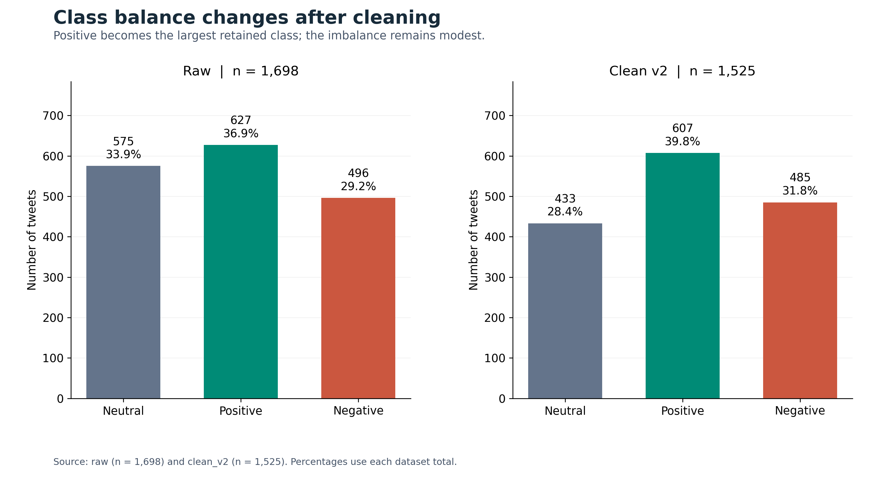
Figure 1 Class distribution in the raw and retained datasets
Positive accounts for 607 retained tweets (39.8%), Negative for 485 (31.8%) and Neutral for 433 (28.4%). The largest-to-smallest class ratio is 1.40. This is modest imbalance. Accuracy alone may conceal differences between classes, so subsequent comparisons should include Macro F1 and per-class precision and recall. EDA does not establish that weighting or oversampling will improve performance.
The Neutral share falls from 33.9% to 28.4%, a decrease of 5.5 percentage points. This is a change in dataset composition caused by exclusions, rather than evidence of changing market sentiment over time.

2.3 Text characteristics
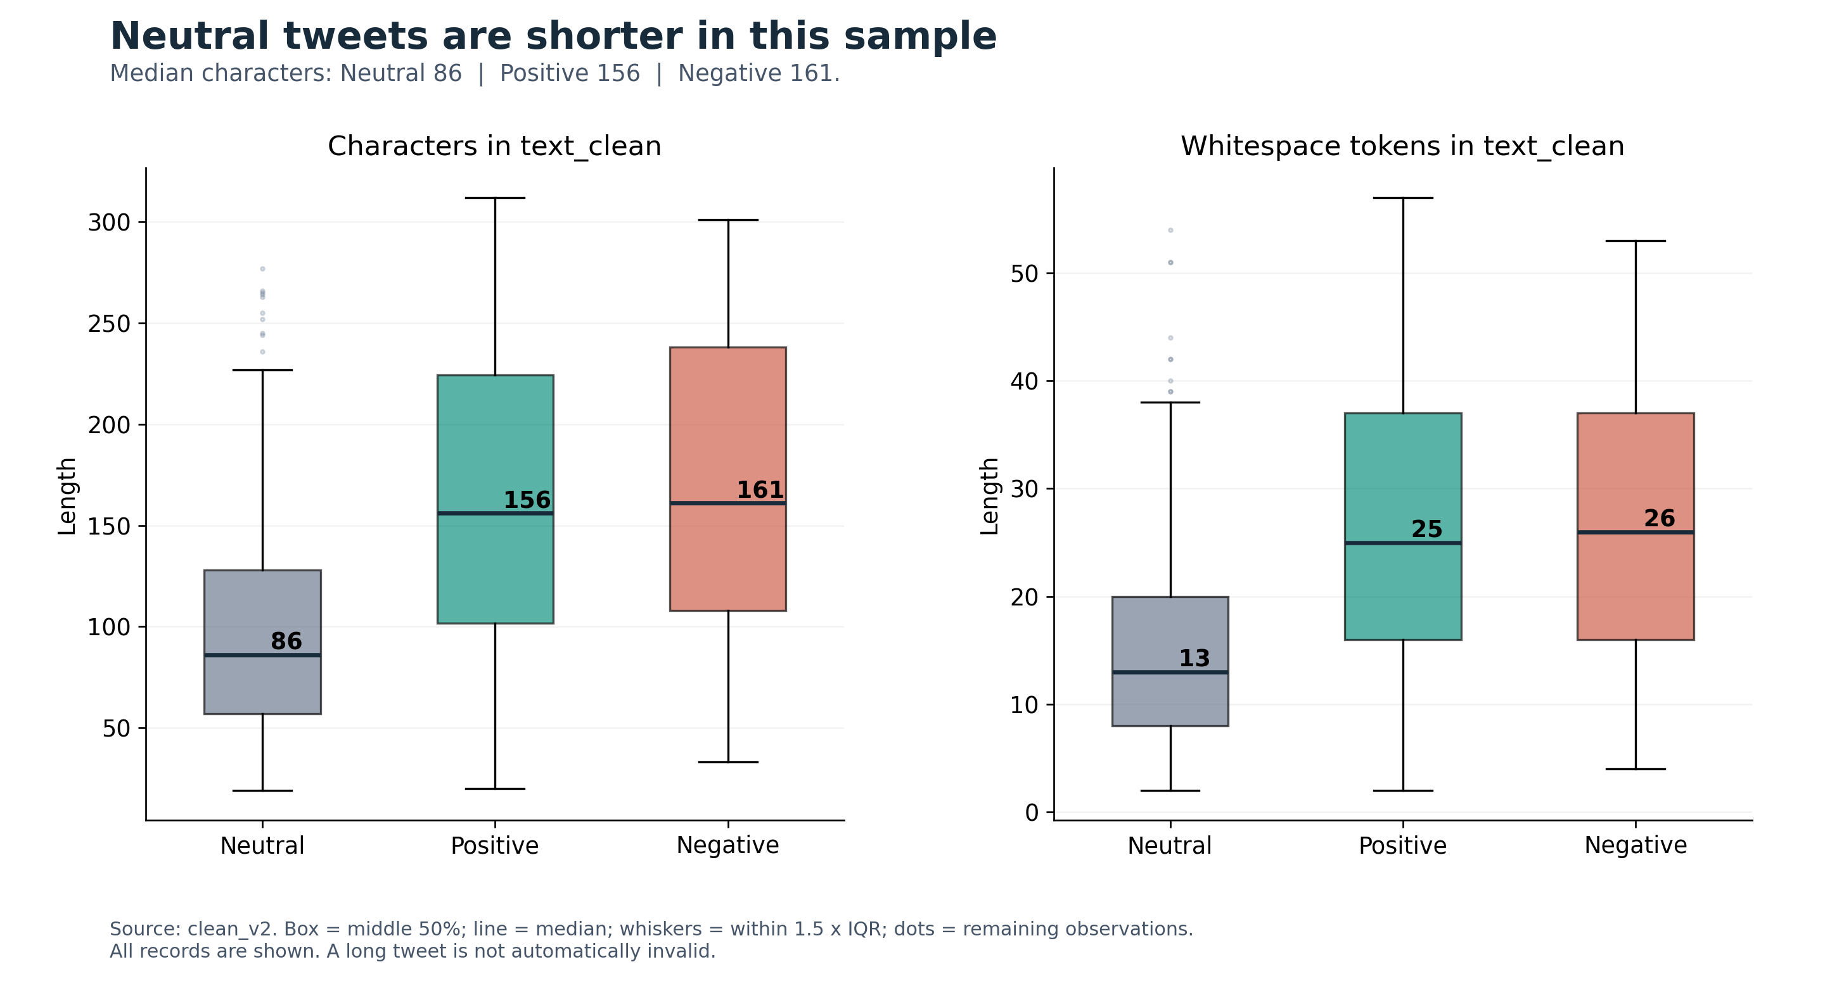
Figure 2 Character and whitespace token lengths by sentiment
Neutral tweets have a median of 86 characters and 13 whitespace tokens, compared with 156 characters and 25 tokens for Positive and 161 characters and 26 tokens for Negative. This descriptive separation suggests that length may be useful as an auxiliary feature, although it could also reflect annotation and topic differences. The boxplots retain all observations. Points outside the whiskers are distributional outliers and are not automatically errors. Transformer sequence limits should be selected from tokenizer lengths in the development data; whitespace tokens are not a substitute.
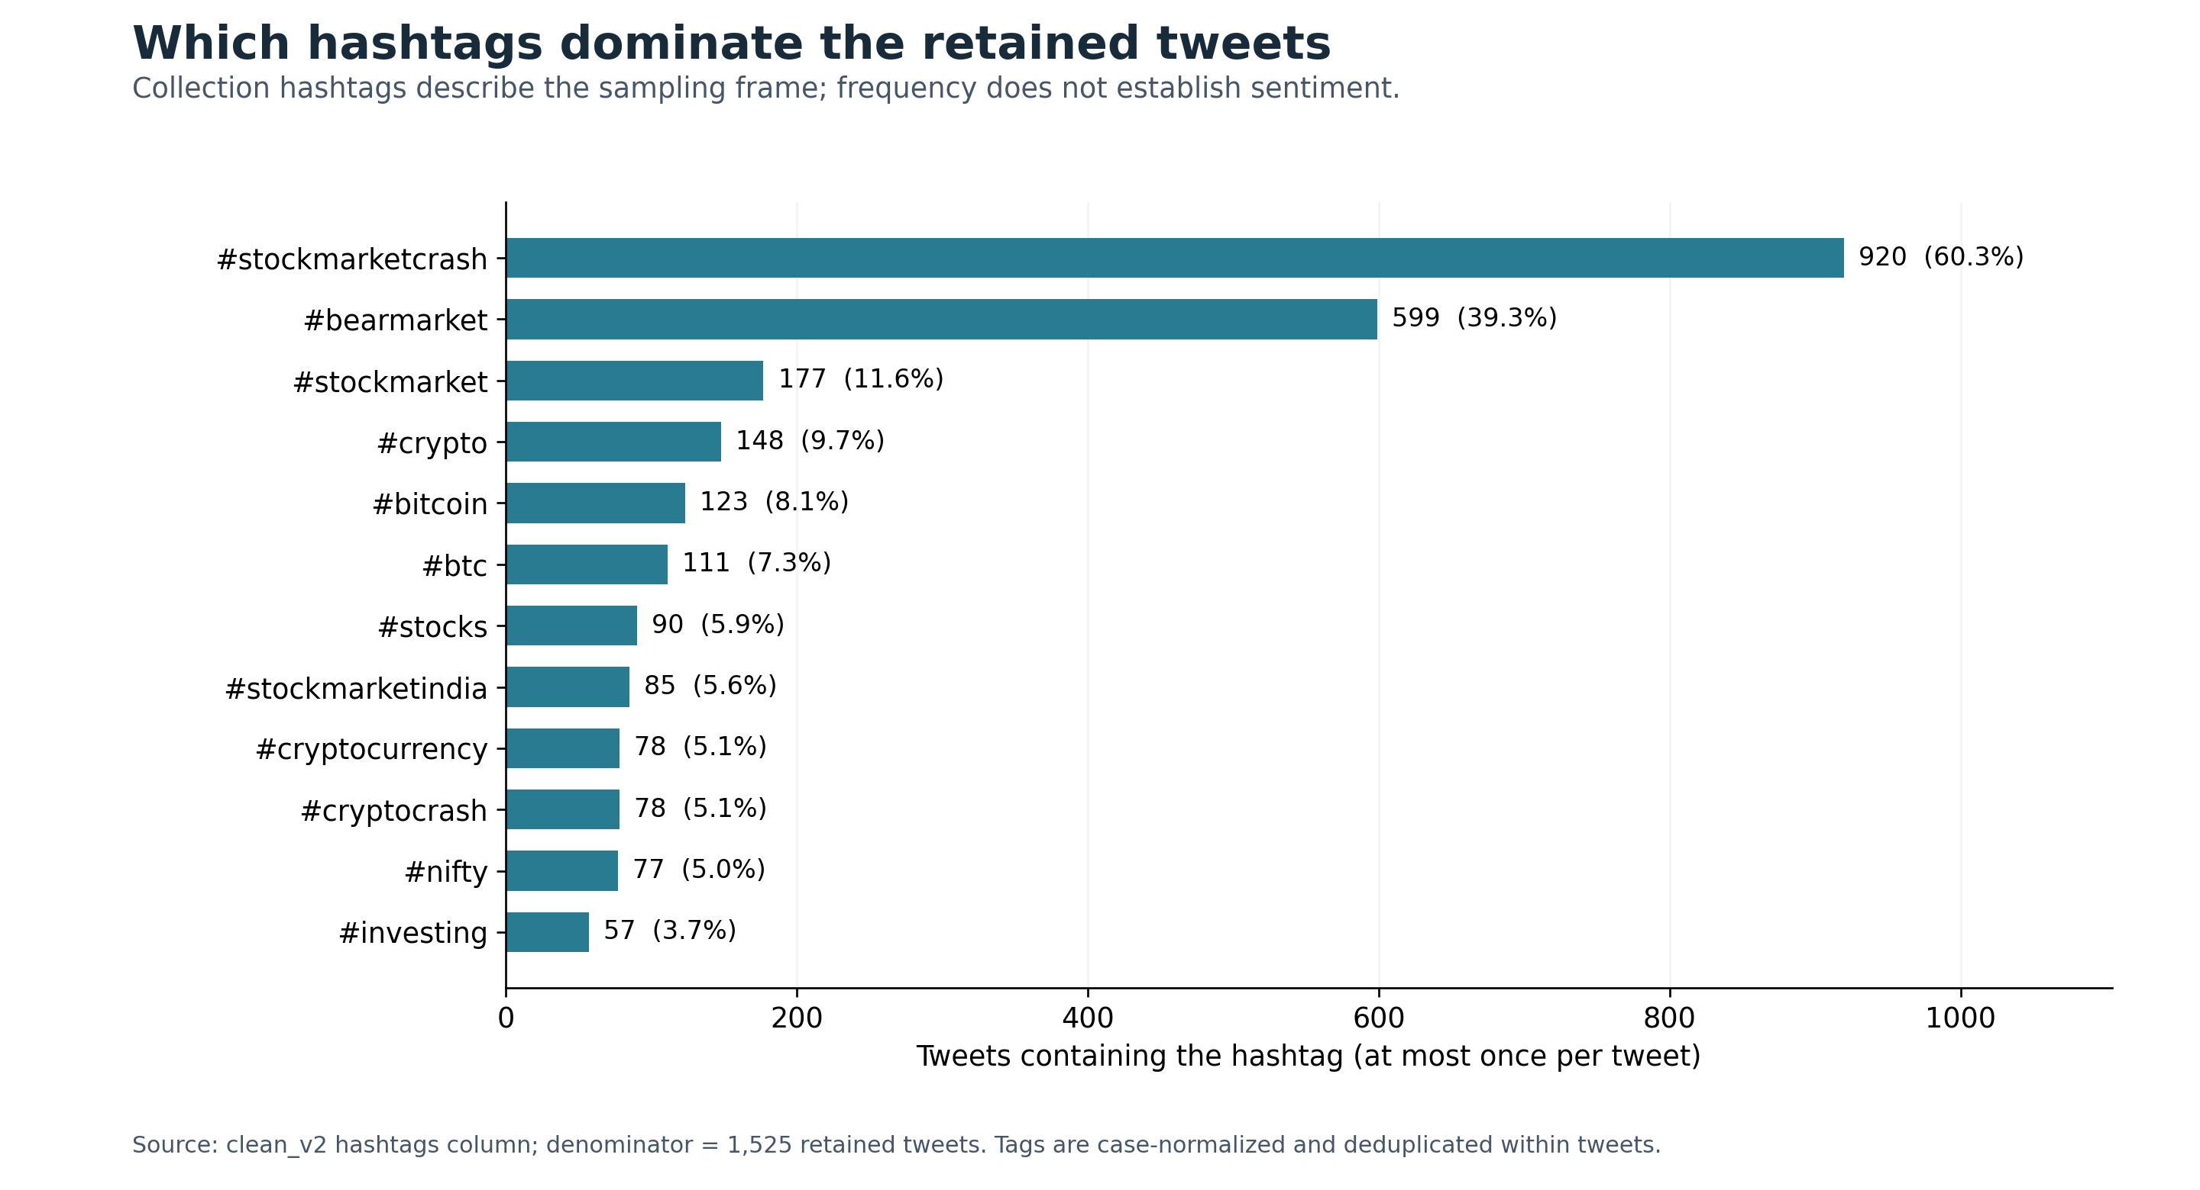
Figure 3 Most frequent hashtags measured by tweet document frequency
Each hashtag is counted at most once per tweet and divided by all 1,525 retained tweets. Topic collection tags dominate the ranking, so their frequency largely reflects how the data were collected. It should not be interpreted as a measure of market-wide attention or emotional intensity.
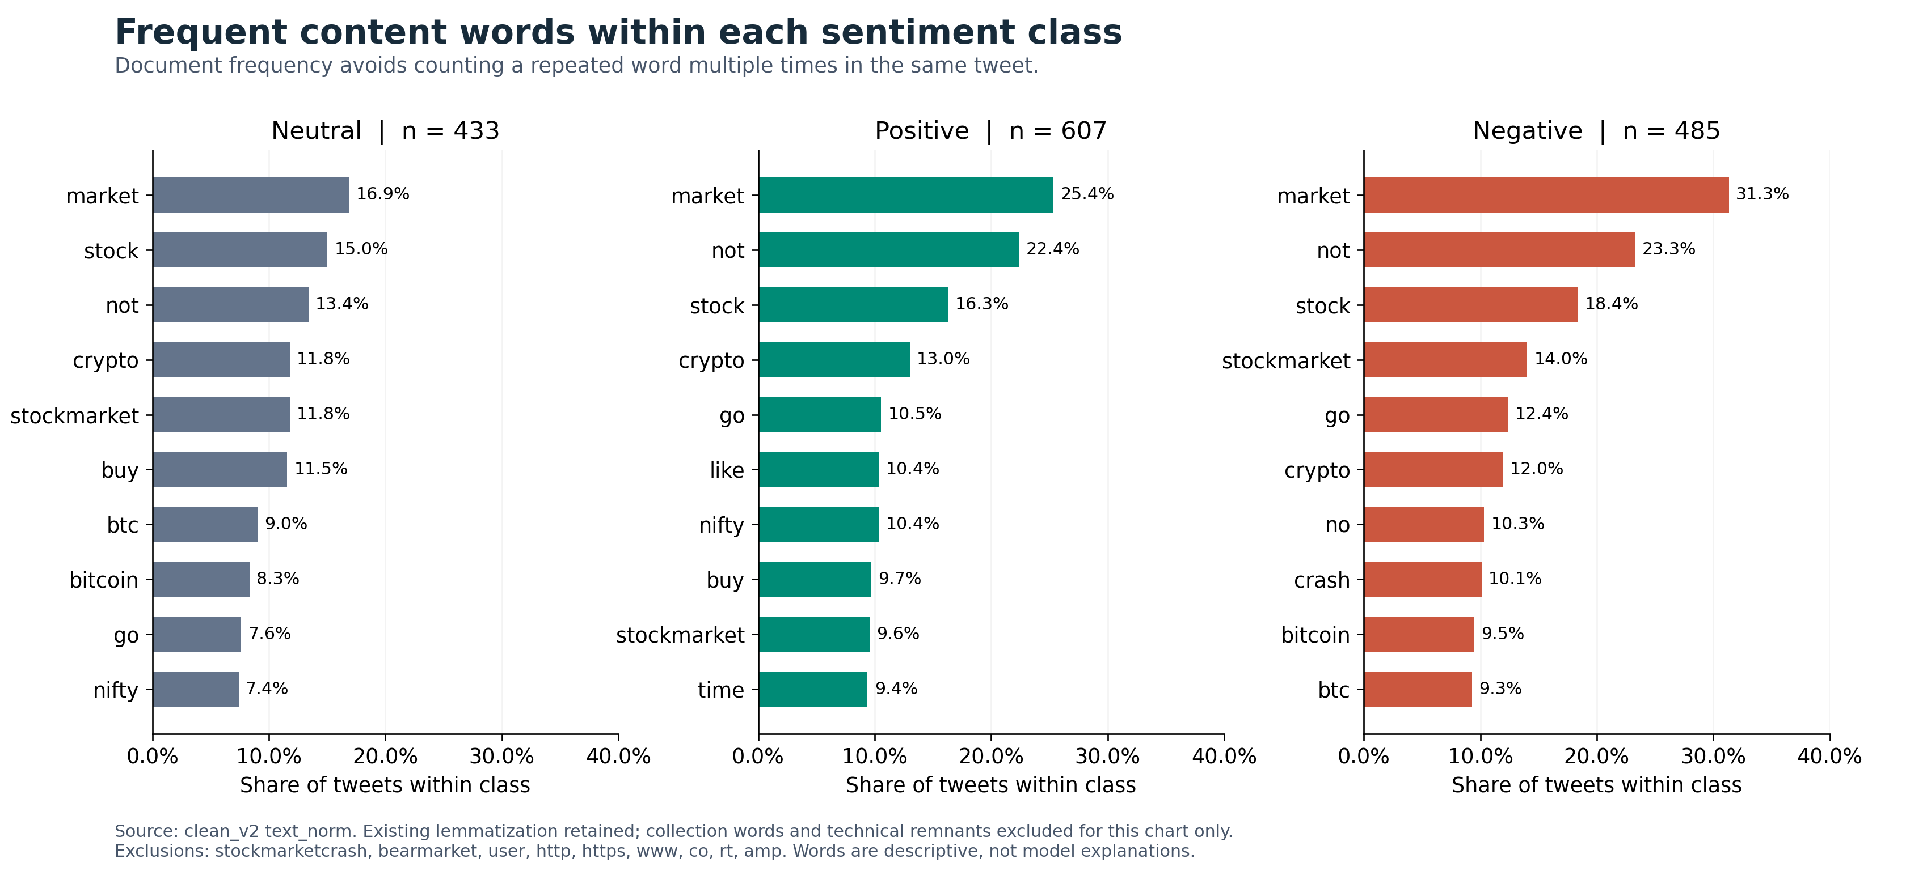
Figure 4 Frequent normalized content words within each sentiment class
For each class, we count tweets containing a word and divide by the number of tweets in that class. This provides comparable within-class rates despite unequal class sizes. The analysis uses the supplied lemmatized text_norm. We remove the collection terms stockmarketcrash and bearmarket and the technical terms user, http, https, www, co, rt and amp for this chart only. The underlying CSV and future model inputs are unchanged. A frequent word need not distinguish its class; these rankings are descriptive and are not explanations of a trained classifier.
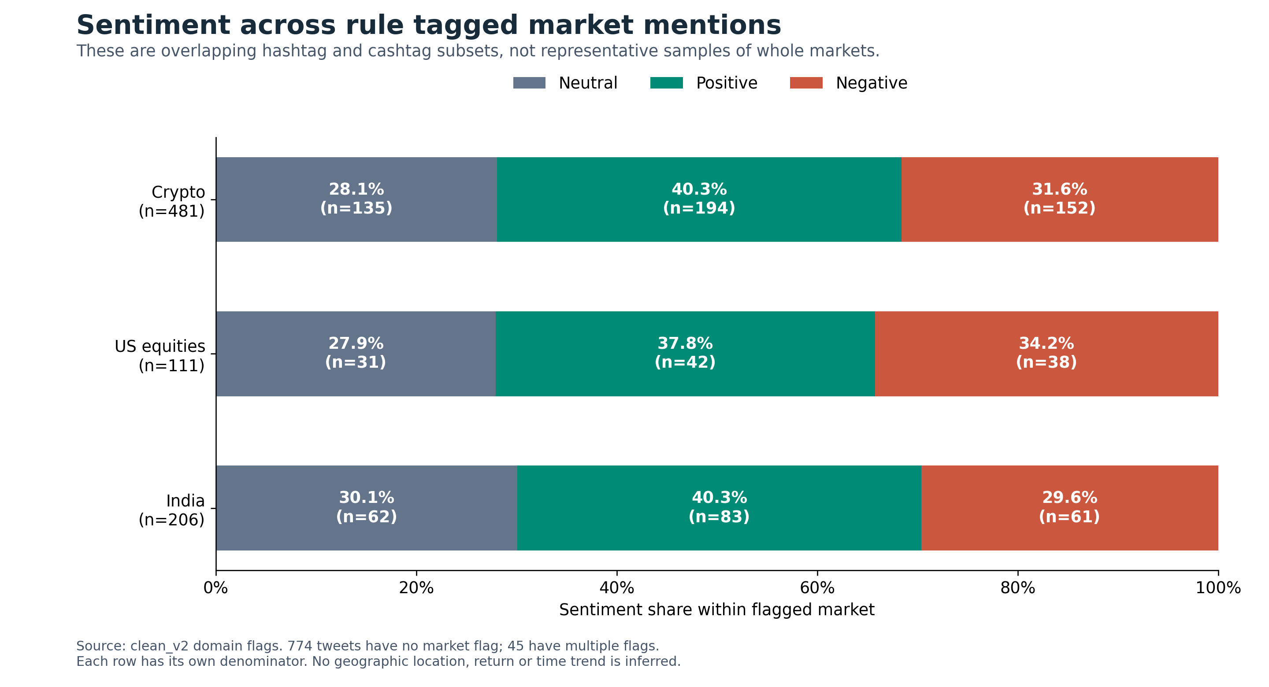
Figure 5 Sentiment proportions in overlapping rule tagged market subsets
The supplied domain flags identify 481 Crypto mentions, 111 US equity mentions and 206 India mentions. Crypto: 194/481 Positive (40.3%); US equities: 42/111 Positive (37.8%); India: 83/206 Positive (40.3%). Positive shares are similar across these subsets, at approximately 38 to 40 percent; the plot does not establish a meaningful market difference. The subsets can overlap, and 774 retained tweets have none of the three flags. These flags are based on hashtag and cashtag rules; they do not identify author location, complete market coverage or representative investor populations. Observed differences are sample descriptions rather than causal comparisons or return forecasts.
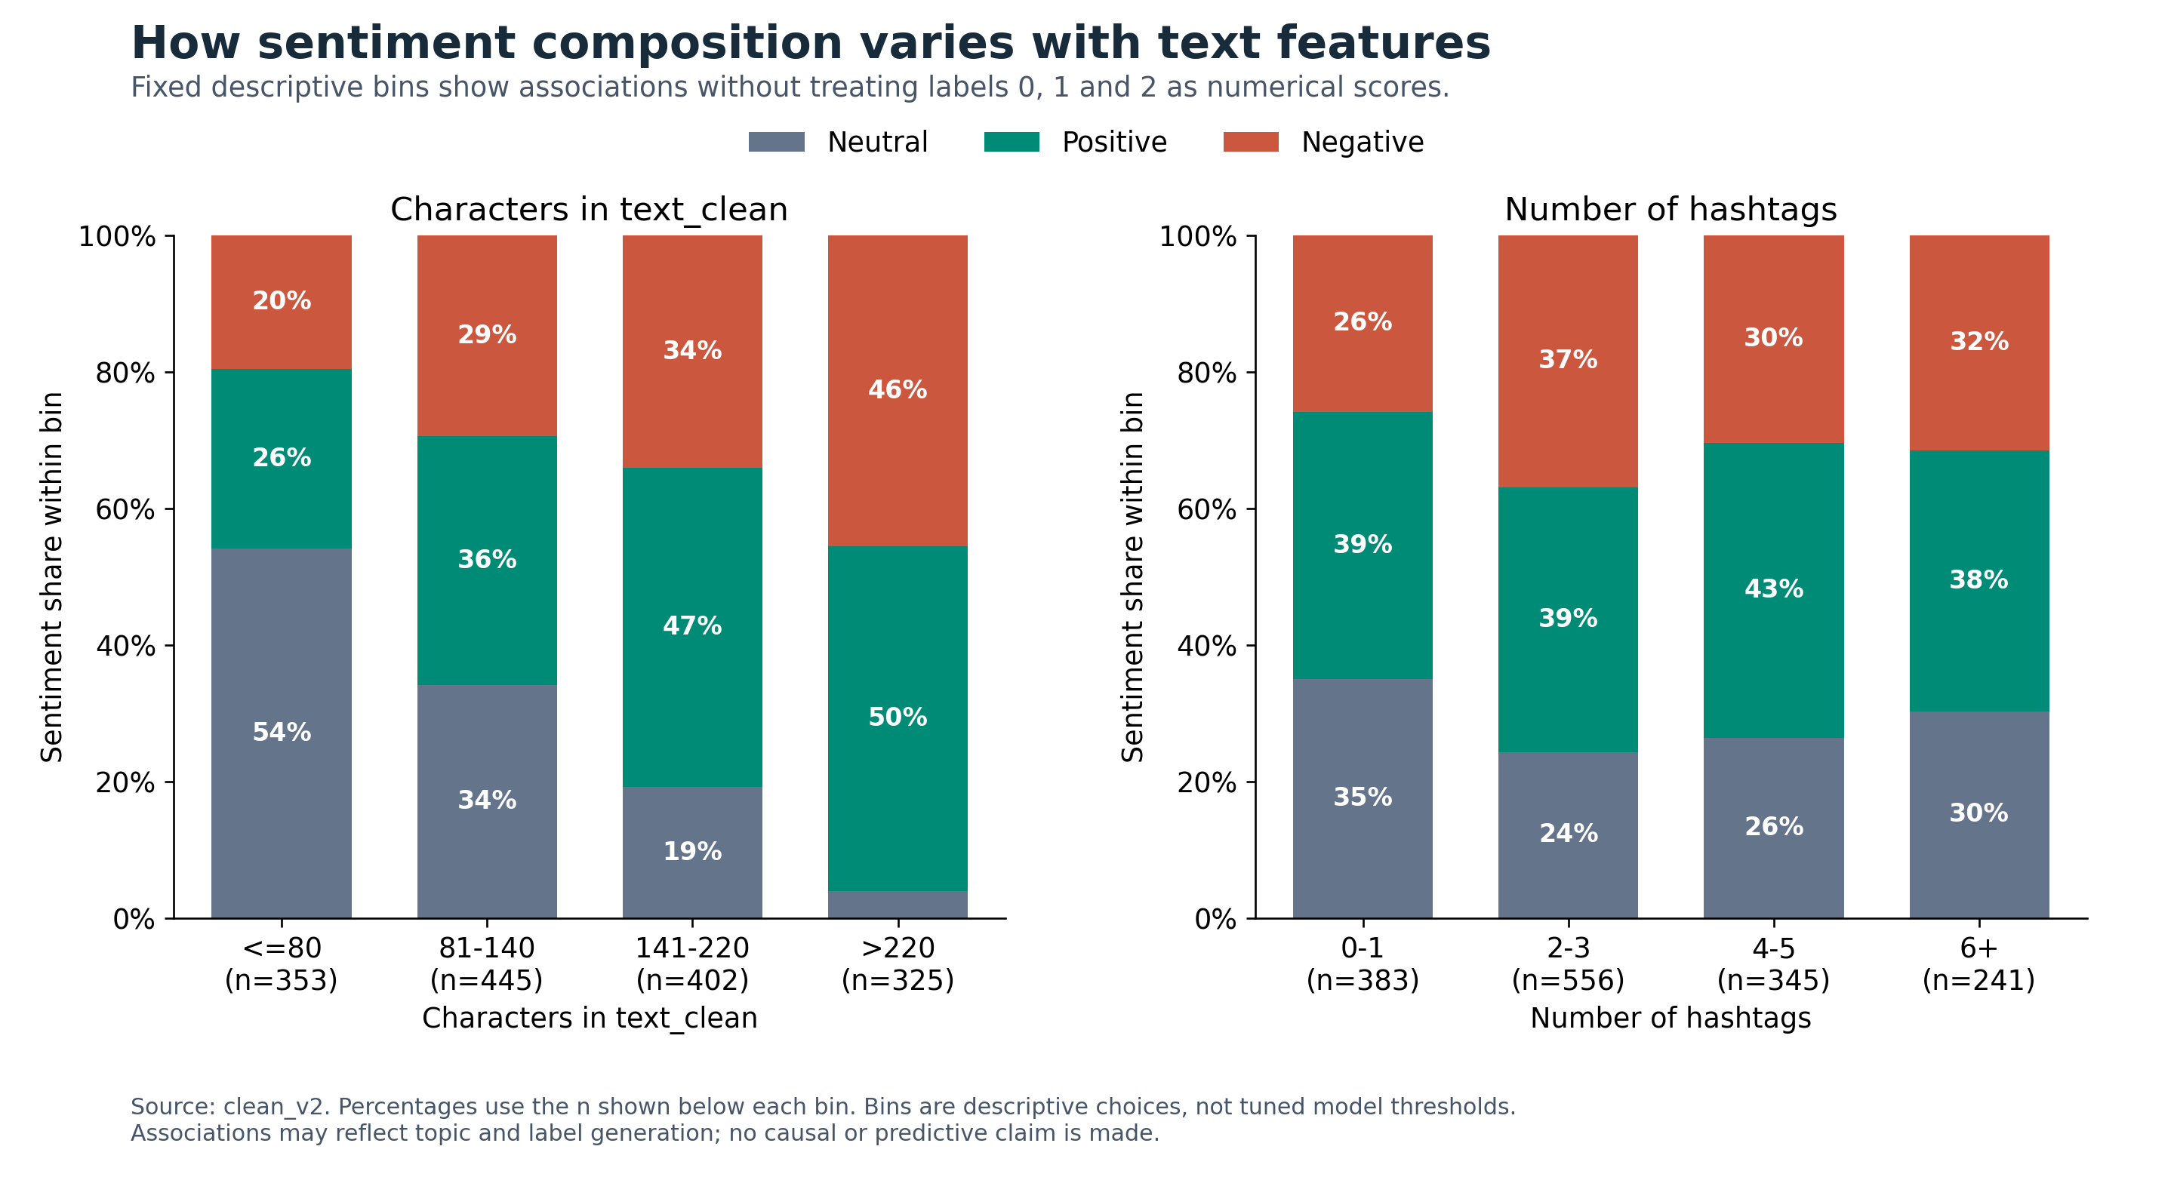
Figure 6 Conditional sentiment proportions by text length and hashtag count
We use fixed bins to compare categorical sentiment composition. Neutral comprises 54.1% of tweets with at most 80 characters (n=353) and 4.0% of tweets longer than 220 characters (n=325). The hashtag panel provides the corresponding conditional proportions for counts 0 to 1, 2 to 3, 4 to 5 and 6 or more. These descriptive cut points are not optimized model thresholds. We do not compute a numerical correlation with labels 0, 1 and 2, because the codes have no numerical ordering.

2.4 Where do the labels come from?
If the labels were produced by a sentiment tool rather than by people, our models would learn to imitate that tool, and its score could not be used as a feature. We therefore tested whether VADER (Hutto & Gilbert, 2014), a widely used rule-based sentiment lexicon, reproduces the labels with its recommended ±0.05 threshold on the compound score. The test uses the 1,666 readable tweets: the 1,525 tweets with English text plus the 141 non-English and word-less tweets, which are part of the evidence.
Table 5 Agreement between automatic sentiment tools and the given labels (1,666 tweets)
Labeller | Agreement | Cohen’s κ
VADER on the raw text, ±0.05 threshold | 93.0% | 0.89
VADER on the raw text, any non-zero score | 94.4% | 0.91
VADER on our cleaned text, ±0.05 threshold | 92.1% | 0.88
TextBlob on the raw text, any non-zero score | 60.2% | 0.40
Always predict the majority class (Positive) | 37.5% | 0.00

VADER reproduces 93.0% of the labels, with a Cohen’s κ (Cohen, 1960) of 0.89, which counts as almost perfect agreement (Landis & Koch, 1977); TextBlob, a different lexicon, reproduces only 60.2%. Agreement is slightly lower on our cleaned text, which is consistent with labels computed on the original text. The pattern among non-English tweets is also consistent with this hypothesis (Figure 7): VADER scores words it does not know as 0, and 73% of these tweets are labelled Neutral, against 25% of the English tweets. Almost all of the 28 non-English tweets labelled Positive or Negative contain words that VADER reads as English, such as Spanish sin (“without”) or German die (“the”).
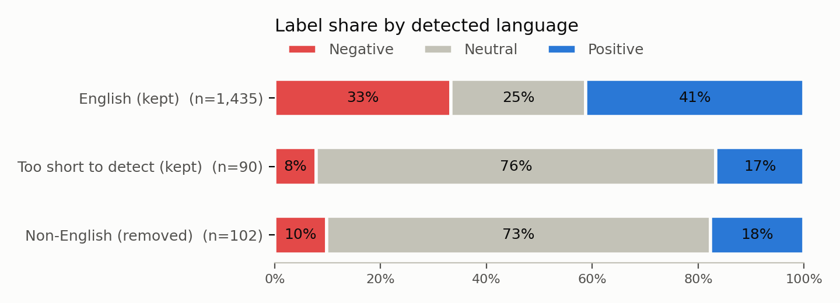
Figure 7 Label share by detected language
The results are therefore highly consistent with labels produced by VADER-style rule-based scoring, but the original labelling process is unknown, so we treat label origin as a working hypothesis rather than a fact. It guides four decisions. VADER scores are never used as a model input, because they could leak the label. The current experiments are limited to tweets with English text (Section 3.1). The 112 tweets with English text where VADER disagrees with the given label (7.3%) are treated as uncertain labels in the error analysis. Finally, a high score means high agreement with these labels, which may differ from human judgement.

2.5 Implications for subsequent modelling
Candidate models can combine independent text embeddings with the supplied length, punctuation, hashtag and market flags. The value of these features must be tested on shared development folds, rather than inferred from EDA. PCA and any other learned transformations should be fitted inside the training fold. Near-duplicate group IDs must remain within one fold, and VADER scores should not be supplied as features because the labels may originate from the same tool. The official split and embedding caches are not required for these descriptive plots.
This EDA covers the full supplied snapshot as requested for the course exploration stage. It neither trains classifiers nor inspects held-out model scores. Because label-conditioned descriptive summaries have been seen, this snapshot should not subsequently be described as completely unseen. The final test protocol should be agreed before tuning, and feature choices should be assessed on development data.

3. Preprocessing and Methodology

3.1 Data cleaning
Table 6 lists the cleaning steps in the order in which they run. Every step is recorded with its rule, the number of rows it affected and a before-and-after example in the cleaning log (data/clean_v2/clean_v2_log.md). Removed and set-aside rows are not deleted from the data: clean_v2_all.csv keeps all 1,698 tweets with a keep flag and the reason, so every decision can be checked or reversed.
Table 6 Data cleaning operations
Operation | Rationale | Records affected
Check missing values | Neither column has missing or empty values, so nothing is imputed | 0
Remove exact duplicates | The same text appears more than once; all copies have the same label, the first is kept | 9 removed
Repair encoding and HTML entities | Double-encoded text such as estÃ©s is repaired with ftfy; &amp; is unescaped | 155 modified
Remove unreadable tweets | Non-Latin text whose characters were lost cannot be repaired or read | 21 removed
Replace user mentions with @user | User names are personal data and are not needed for sentiment | 273 modified
Restore verified contractions | The file turned the apostrophe and the next letter into __ (it__ → it’s); only patterns checked by hand are restored | 166 modified
Remove lost characters | Remaining __ runs (emoji or symbols) cannot be recovered; they are deleted and the tweet is flagged in emoji_lost | 453 modified
Set aside non-English tweets | The current experiments cover English text, and an English lexicon cannot check these labels (mostly Neutral); detected by script, stopword counts and a language detector, with hard cases checked by hand | 102 set aside
Set aside tweets without words | Only hashtags or mentions, all labelled Neutral; keeping them could teach a “no text means Neutral” shortcut | 39 set aside
Normalise hashtags | The # is removed but hashtags are not split into words, because VADER treats each hashtag as one unknown word | all tweets
Remove content duplicates | Tweets identical after removing mentions, punctuation and lost characters | 2 removed
Group related tweets | Near-duplicates (word overlap of 70% or more) and tweets with identical normalised text share a group_id | 20 tweets in 8 groups
Used in the current experiments | English, readable, non-duplicate tweets that contain words | 1,525 of 1,698

The order matters: unreadable tweets are detected before lost characters are deleted, because the damaged characters are the evidence; and the language is detected before the # symbols are removed, because hashtag words such as stockmarketcrash confuse the detector. Hashtags are kept whole because of the label analysis: VADER agrees with the labels on 91.9% of the 1,525 tweets when hashtags stay whole, but only on 71.1% when stockmarketcrash is split into stock market crash, since the split adds the word crash, which VADER would not score in the raw text. No exact or content duplicate had conflicting labels. No tweet was removed for its length or as an outlier, because short and long tweets are both legitimate.
The project brief does not require removing the 141 non-English and word-less tweets, and the fact that VADER cannot read a tweet does not mean that its given label is wrong. We set them aside only to keep the current experiments to English text. A planned comparison run will train the baseline with these tweets included and report how the results change.
Table 7 Examples of cleaned text
Raw tweet | text_clean | text_norm
I don__ see it. #stockmarketcrash | I don’t see it. stockmarketcrash | not see stockmarketcrash
It__ finally here! #StockMarketcrash | It’s finally here! StockMarketcrash | finally stockmarketcrash
#ETH is gone_¦ð_#Ethereum #cryptocurrencies #bearmarket | ETH is gone Ethereum cryptocurrencies bearmarket | eth go ethereum cryptocurrencies bearmarket

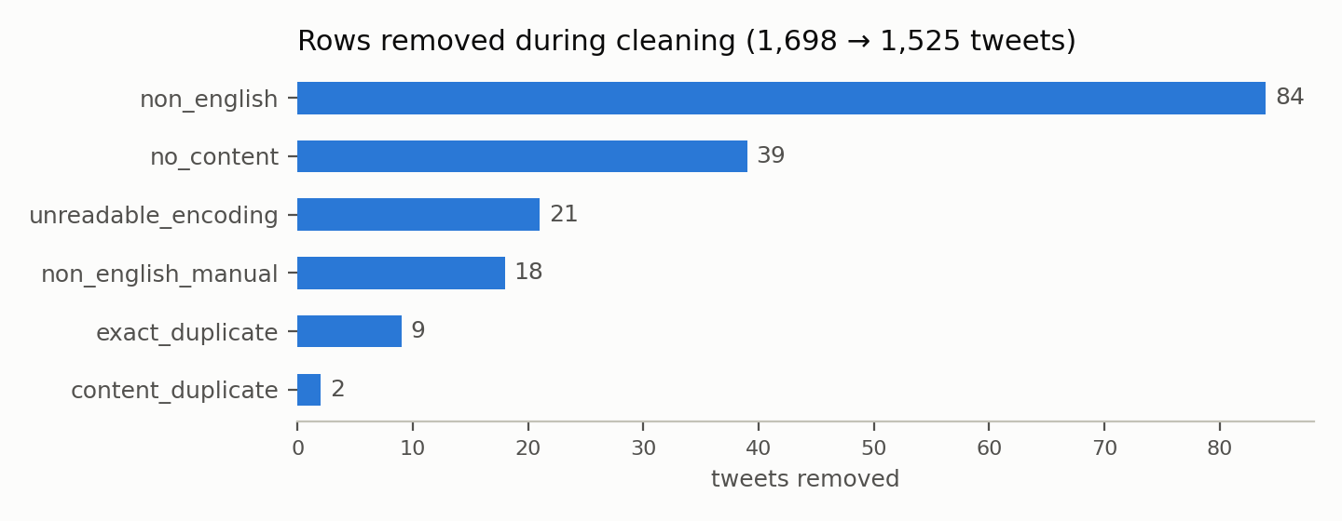
Figure 8 Tweets left out during cleaning, by reason (removed or set aside)

3.2 Experimental design
We use the team’s clean_v2 dataset of 1,525 retained tweets. A tweet keeps its original row id; group_id joins duplicate or similar normalized content. We sort by id and take the first split from StratifiedGroupKFold (scikit-learn, n.d.) with five splits, shuffle enabled and seed 42 as the reserved holdout. We apply the same algorithm to the remaining development rows to obtain five validation folds. No group occurs in more than one fold or on both sides of the holdout boundary. A random grouped split measures transfer to unseen content groups, rather than performance on a future chronological period.
Table 8 Data partitioning
Partition | Records | Share of all data | Purpose
Development | 1,222 | 80.13% | Five-fold model selection
Test | 303 | 19.87% | Reserved final evaluation
Outer training per run | 975–980 | 63.93–64.26% | Fit embeddings and classifier
Outer validation per run | 242–247 | 15.87–16.20% | OOF comparison
Development is the union of the five validation folds; the last two rows describe each CV iteration and are not additional partitions.
Table 9 Class counts in each partition and fold
Subset | Neutral | Positive | Negative
Development | 348 | 486 | 388
Test | 85 | 121 | 97
Fold 0 | 66 | 97 | 79
Fold 1 | 72 | 97 | 78
Fold 2 | 70 | 97 | 77
Fold 3 | 71 | 96 | 77
Fold 4 | 69 | 99 | 77

Before saving, check_splits and additional validation verify schema, coverage, legal fold numbers, group consistency and all classes in each training and validation fold. The split manifest records the data and split SHA-256 hashes. Existing folds_v1 cannot be silently overwritten by a different partition. Preprocessing parameters and class weights are learned only from the applicable training rows. The holdout is used for prediction after selection, without computing its scores.

3.3 Text representation
Cleaning produces two versions of each tweet. text_clean keeps case and punctuation for pre-trained Transformer models such as Sentence-BERT (Reimers & Gurevych, 2019). text_norm is fully normalised for the bag-of-words baseline and our self-trained embedding: contractions are expanded, the text is lower-cased, only letters are kept, words are lemmatised with WordNet according to their part of speech (selling → sell), and NLTK English stopwords (Bird et al., 2009) are removed except negations and direction words. A standard stopword list would delete not (in 307 tweets), down (102), up (84) and below (23) and turn “not bullish” into “bullish”. A normalised tweet has 14.3 words on average.
The baseline represents each tweet with TF-IDF weights over single words of text_norm, computed with scikit-learn (Pedregosa et al., 2011). As the brief requires, TF-IDF is used only in the baseline. The MLP uses FastText word vectors trained from scratch on text_norm (Bojanowski et al., 2017), and the other models of the next phase will use Sentence-BERT or FastText embeddings (Section 5).

3.4 Baseline and candidate models
Baseline. The baseline combines TF-IDF with logistic regression for three-class sentiment classification: Neutral (0), Positive (1), and Negative (2). It uses text_norm from clean_v2, retaining the preprocessing decisions made by the data-cleaning pipeline. TF-IDF uses unigram features with min_df=1, default smoothed inverse document frequency and L2 normalization. Logistic regression uses L2 regularization, C=1.0, the lbfgs solver, max_iter=2000, and no class weighting. The random seed is 42. These parameters define the initial baseline before refinement.
The pipeline fits both TF-IDF and logistic regression separately within each training fold. Neither the vocabulary nor the inverse-document-frequency weights are learned from the validation fold. The shared split file is checked against the clean data by ID and group ID before training. Related tweets must remain in the same partition and fold.
Performance is measured using accuracy, macro-precision, macro-recall and macro-F1. The team comparison record uses pooled out-of-fold predictions, while the mean and sample standard deviation across the five validation folds are reported separately. The confusion matrix and per-class metrics also use out-of-fold predictions. Macro-F1 is the primary model selection metric. The test set is not used during baseline development or hyperparameter tuning.
For interpretation, the pipeline is refitted on the full development set, and the highest positive logistic regression coefficients are displayed for each class. This refit is used only for interpretation, not to calculate the reported cross-validation metrics. Coefficients indicate model associations rather than word frequency or causality.
MLP. We pair a separately trained FastText skip-gram embedding model with a randomly initialized PyTorch MLP. FastText uses 100 dimensions, window 5, minimum count 2, subword lengths 3–5, 200,000 hash buckets and 50 epochs. It uses one worker, seed 42 and stable CRC32 hashing. Each outer-fold embedding sees only the other four folds. Word vectors are averaged per tweet and standardized before entering the MLP. The full embedding sees all development text, but no holdout text.
The classifier contains hidden layers of 512 and 256 units, each followed by BatchNorm, ReLU and Dropout, with three output logits. We optimize cross-entropy with AdamW (PyTorch, n.d.-a), batch size 64 and gradient clipping at 1.0. Each outer training partition contains a grouped inner split for early stopping: a maximum of 50 epochs, patience 7, selected by inner Macro-F1. The model is then reinitialized and fitted on the full outer training partition for that epoch count. This keeps the outer validation fold out of epoch selection. The final development refit uses the median selected epoch count of 11.

3.5 Evaluation and computing environment
Macro-F1 is the primary selection measure because it weights Neutral, Positive and Negative equally. We also report accuracy, macro precision and recall, per-class F1 and the OOF confusion matrix. Predictions are aligned by stable id and probability columns are always 0 Neutral, 1 Positive, 2 Negative. Fold scores and their sample standard deviation are supplied for stability assessment; five correlated folds are not independent confidence-interval replicates.
The cleaning, the split, the label analysis and the baseline run in the team’s pinned conda environment (Python 3.11.17, scikit-learn 1.5.2, pandas 2.2.3, NumPy 1.26.4, NLTK 3.9.1); fitting the baseline on all five folds takes 0.26 seconds. The MLP results in Section 4.3 were produced in CAO Taihe’s environment (Table 10).
Table 10 Computing environment of the MLP experiment
Environment item | Measured value
Operating system | Windows 11 build 26200
Processor | Intel64 Family 6 Model 198; 24 logical CPUs
Memory and accelerator | 15.38 GiB system RAM; CPU execution; CUDA unavailable
Python and PyTorch | 3.13.9 and 2.9.1 CPU; 2 PyTorch threads
Numerical stack | NumPy 2.3.5; SciPy 1.16.3; pandas 2.3.3
Other libraries | scikit-learn 1.7.2; gensim 4.4.0; Matplotlib 3.10.6

We use perf_counter for wall-clock intervals. MLP fit time includes the five inner early-stopping runs and five outer refits, but excludes embedding generation, scaling, prediction and plotting. Embedding and total pipeline times are logged separately. The three MLP configurations took 9.90, 9.98 and 12.00 seconds of fit time respectively. The first complete pipeline run took 65.30 seconds, including 25.08 seconds to produce six FastText versions. Times are measurements from this computer and can vary with load, software and caching.

4. Results

4.1 Baseline performance
Table 11 Baseline performance on the five validation folds (1,222 tweets)
Metric | Pooled out-of-fold | Mean ± standard deviation over folds
Accuracy | 0.592 | 0.593 ± 0.042
Macro precision | 0.605 | 0.608 ± 0.044
Macro recall | 0.577 | 0.577 ± 0.041
Macro-F1 | 0.582 | 0.582 ± 0.042

Table 12 Baseline performance by class (pooled out-of-fold predictions)
Class | Precision | Recall | F1 | Support
Neutral | 0.656 | 0.483 | 0.556 | 348
Positive | 0.566 | 0.735 | 0.639 | 486
Negative | 0.594 | 0.513 | 0.550 | 388
Macro average | 0.605 | 0.577 | 0.582 | 1,222

The baseline reaches a macro-F1 of 0.582. Always predicting the largest class would reach an accuracy of 0.398 but a macro-F1 of only 0.19 on the same tweets. The score varies between folds, from 0.512 to 0.621, so differences of a few points between models will need care. Positive is the easiest class (F1 0.639); Neutral and Negative are harder, mainly because of low recall. CAO Taihe’s independent reproduction of the baseline on the same folds gives the same macro-F1 (0.582).

4.2 Errors and what the baseline learned
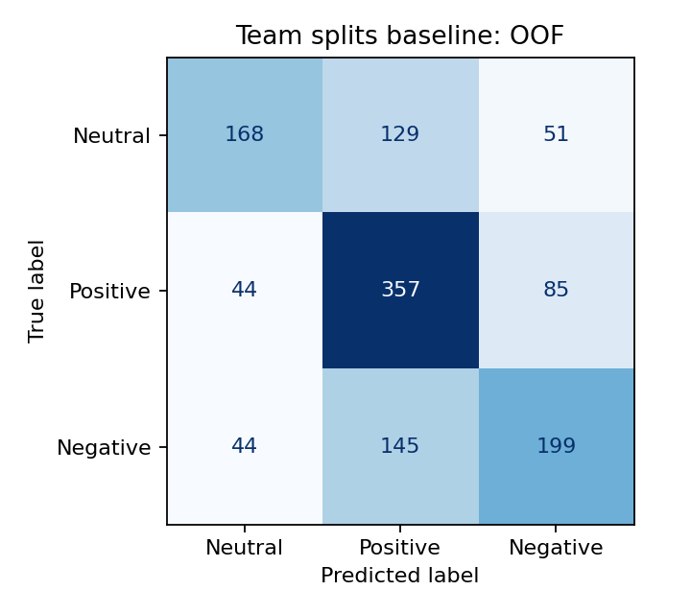
Figure 9 Confusion matrix of the baseline (out-of-fold predictions on the development set)
The model over-predicts the largest class: 129 Neutral and 145 Negative tweets are predicted as Positive. This contributes to the low recall of the two smaller classes and is one reason to compare class weights in the refinement phase.
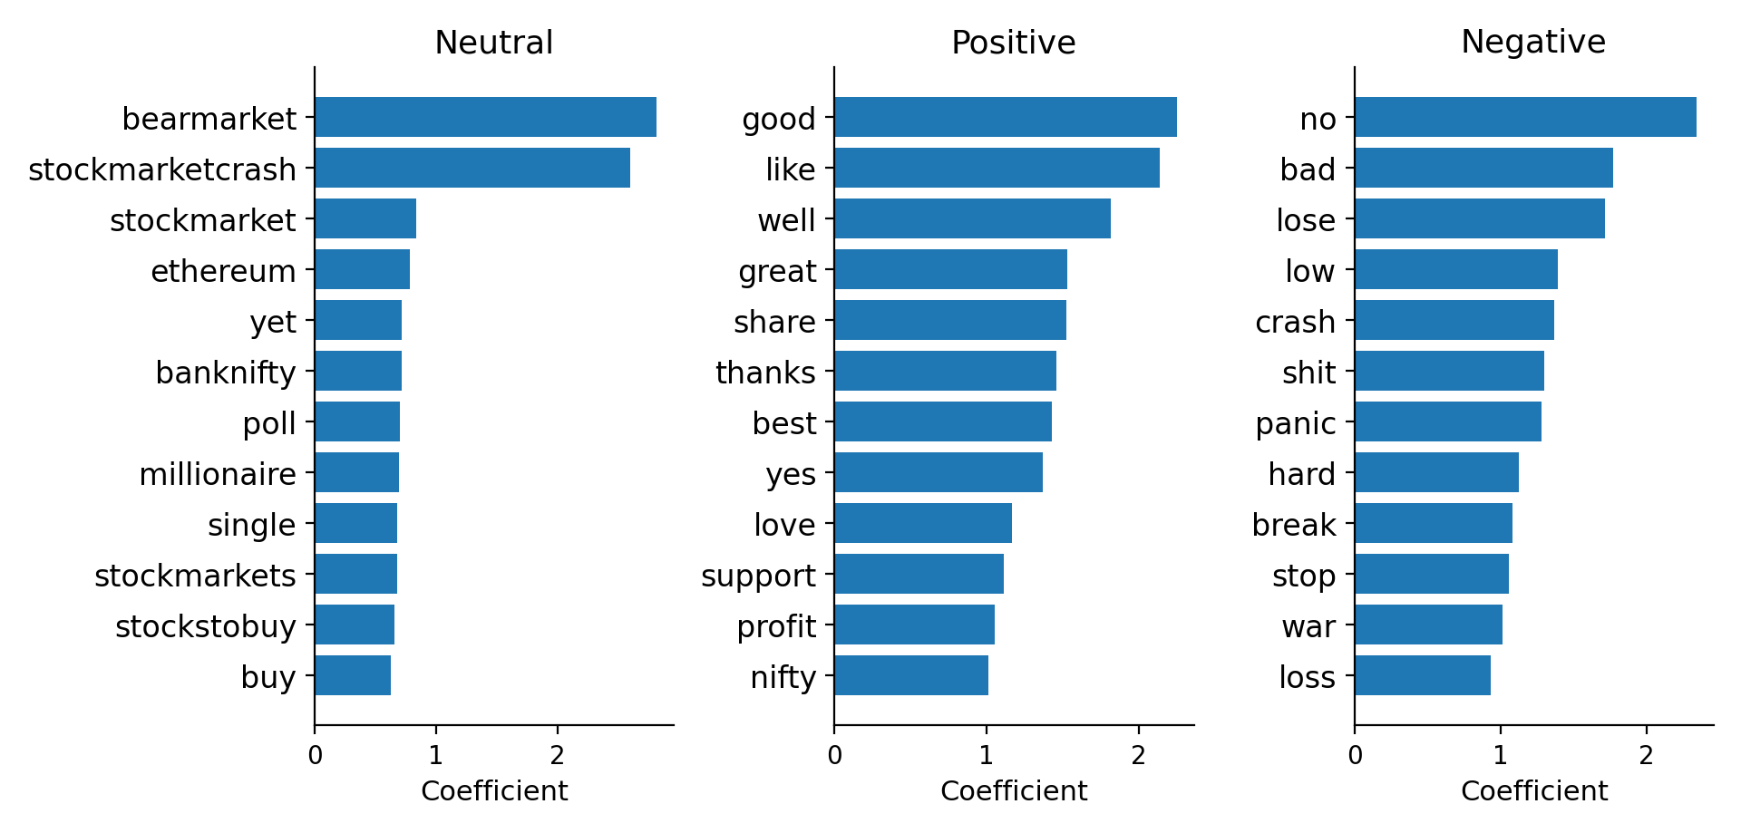
Figure 10 Words with the largest positive coefficients for each class
The words the model relies on are consistent with Section 2.4. All twelve strongest Positive words (good, like, well, great, thanks …) and eleven of the twelve strongest Negative words (no, bad, lose, panic, crash …) are entries of the VADER lexicon, while none of the strongest Neutral words are: Neutral is recognised mainly by the collection hashtags, which fits tweets that contain no sentiment words. The list also suggests how a general lexicon can misread financial language. Nifty, the name of the Indian stock index, is among the strongest Positive words for the model. VADER scores nifty as an English adjective (+1.7). Of the 127 tweets whose normalised text contains the token nifty, 50% are labelled Positive, and of the 99 tweets that contain the whole word nifty in the raw text, 54% are, against 40% of all tweets.

4.3 First neural model: FastText and MLP
Table 13 and the discussion below report the original run in CAO Taihe’s environment (Table 10); Section 4.4 compares it with a rerun in the team environment.
Table 13 MLP configurations (development OOF macro-F1)
Configuration | Dropout | LR | Weight decay | Weighted | OOF Macro F1
Initial | 0.5 | 0.001 | 0.01 | No | 0.5403
Regularized | 0.3 | 0.0005 | 0.05 | No | 0.5234
Weighted | 0.3 | 0.0005 | 0.05 | Yes | 0.5301
TF IDF LR reference | — | — | — | No | 0.5820

The initial MLP remains the selected configuration. Its OOF accuracy is 0.5401, Macro-Precision 0.5487, Macro-Recall 0.5364 and Macro-F1 0.5403. Class F1 scores are 0.5638 Neutral, 0.5614 Positive and 0.4957 Negative. The independent TF-IDF/LR reference uses the same folds and has Macro-F1 0.5820, a difference of −0.0417 for MLP. It is a reference reproduction, not a replacement for FENG Dingran’s official results. Both attempted refinements decreased Macro-F1. These are selection-set scores after three candidate comparisons and should not be interpreted as unbiased final performance.
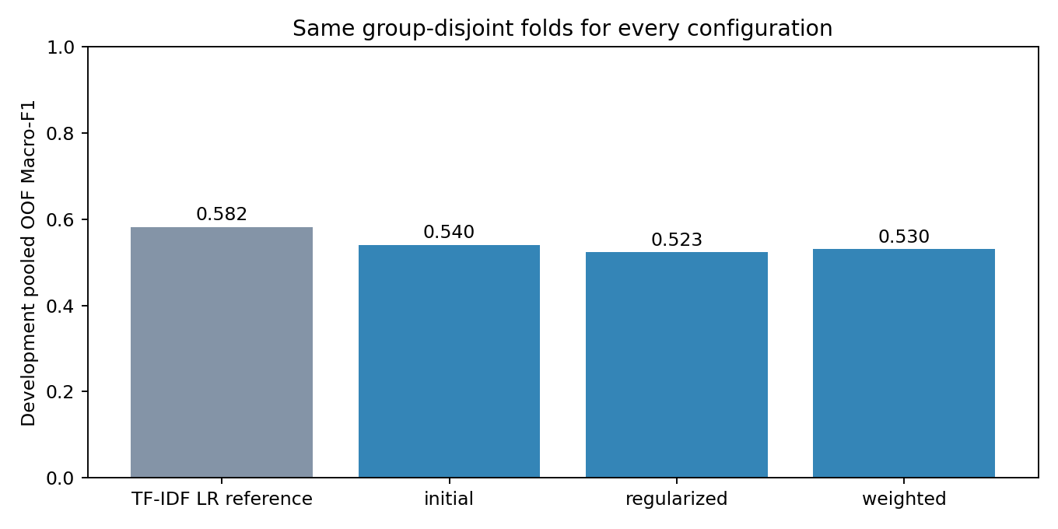
Figure 11 Development OOF comparison
Mean pooling discards word order and the supervised sample is small relative to classifier capacity. These are plausible explanations for the MLP result; this experiment does not establish their causal effects.

4.4 Limitations of the current analysis
- Label origin. The labels agree closely with VADER, but the original labelling process is unknown. Our scores measure agreement with these labels, which may differ from how people or investors would judge the tweets.
- Sample size. The 1,525 tweets leave fewer than 1,000 for training in each fold, and the baseline’s macro-F1 varies from 0.512 to 0.621 between folds. With only 303 test tweets, small differences in test accuracy will be uncertain; intervals will be reported when the test set is scored at the end of the project.
- Scope. The current experiments cover tweets with English text only; the 141 non-English and word-less tweets are set aside, so the results do not apply to them until the planned comparison run.
- No timestamp field. A few tweets mention dates in their text, but the file has no dedicated timestamp field, so we did not conduct a reliable time-series analysis or relate the sentiment to market events.
- Software environments. The MLP results come from CAO Taihe’s environment (Table 10). Rerunning the same design in the team environment, where the FastText vectors differ slightly, gives macro-F1 of 0.526 (initial), 0.535 (regularized) and 0.534 (weighted), all below the baseline. In that rerun the regularized configuration scores highest, so the finding in Section 4.3 that both refinements lowered macro-F1 holds only for the original run; in both runs the three configurations differ by less than 0.02.
- Information lost in cleaning. Lemmatisation turns Fed into feed in 12 of the 38 tweets that contain the word Fed. text_norm keeps letters only, so prices and percentages are dropped in the 578 tweets (38%) that contain numbers; they remain in text_clean. you__e is restored as you’re or you’ve from the following word, which can be wrong (24 raw tweets). Emoji lost in the source file (28% of the raw tweets) cannot be recovered.

5. Next Steps

5.1 Plan to the final report
Each member will pair one word-embedding model with an independent classifier. The embedding models will be a frozen pre-trained Sentence-BERT model (Reimers & Gurevych, 2019; paraphrase-multilingual-mpnet-base-v2), which only produces vectors and is not fine-tuned, and our own FastText trained per fold. All models will use the same folds and be compared with the baseline on macro-F1.
Table 14 Planned models
Member | Embedding | Classifier | Trained from scratch
FENG Dingran | Sentence-BERT and FastText sentence vectors | SVM (linear and RBF kernels) | Classifier
GU Kailei | Sentence-BERT and FastText sentence vectors | kNN (cosine distance) | Embedding (FastText)
CHOI CHUN MAN, YANG Qitian | Sentence vectors plus hand-made features | XGBoost, explained with SHAP | Classifier
CAO Taihe | Sentence-BERT and FastText sentence vectors | MLP (PyTorch) | Classifier and embedding (FastText)
YU Guanlin | Sentence-BERT and FastText token sequences | TextCNN | Classifier
CHOI CHUN MAN, YANG Qitian | Sentence-BERT and FastText token sequences | BiLSTM with attention | Classifier

After the first versions (13 November), the models will be tuned, the imbalance strategies compared, and the models combined by stacking on their out-of-fold probabilities. A comparison run will also include the 141 set-aside tweets. Experiments are planned to be frozen on 18 November; only then will the test set be used, once, for the selected model. An error analysis of the tweets that every model gets wrong will check how many of them are VADER disagreements or misread financial terms.

5.2 Scalability and practical feasibility
At the measured scale, the selected MLP has 185,347 trainable parameters, requiring 741,388 bytes for FP32 parameter tensors, excluding optimizer state and framework overhead. The 1,222 × 100 development feature matrix occupies 488,800 bytes. The final 11-epoch refit took 1.25 seconds, while predicting 303 precomputed holdout vectors took 0.00747 seconds. The latter excludes text processing, embedding and feature standardization and is not an end-to-end service latency benchmark. System RAM capacity is recorded, but peak process memory was not measured.
For fixed dimensions and architecture, MLP training cost grows approximately with epochs and sample count. Frozen vector inference can be batched. FastText subword tables, training corpora and cached fold representations add storage that is absent from the classifier parameter count. Increasing text volume needs fresh measurements of ingestion, embedding latency, peak memory and sustained throughput. This small dataset cannot support an operational claim about large-scale real-time monitoring. A production service also needs drift monitoring and human review; noisy labels limit the meaning of higher classification scores.

5.3 Questions for the consultation
- The labels match VADER on 93% of the tweets, although the original labelling process is unknown. May we report results against these labels and discuss the label noise, or should we also relabel a sample by hand?
- We use Sentence-BERT only to extract vectors, without fine-tuning, and train separate classifiers on them. Does this meet the requirement that the embedding and the classifier are separate models?
- Three of our six models (MLP, TextCNN, BiLSTM) are neural networks. Is this enough variety between models?
- The current experiments set aside 102 non-English tweets (mostly labelled Neutral) and keep them for a comparison run. Is this acceptable, or should they stay in the main experiments?

References
Bird, S., Klein, E., & Loper, E. (2009). Natural language processing with Python. O’Reilly Media.
Bojanowski, P., Grave, E., Joulin, A., & Mikolov, T. (2017). Enriching word vectors with subword information. Transactions of the Association for Computational Linguistics, 5, 135–146. https://aclanthology.org/Q17-1010/
Cohen, J. (1960). A coefficient of agreement for nominal scales. Educational and Psychological Measurement, 20(1), 37–46.
Hutto, C. J., & Gilbert, E. (2014). VADER: A parsimonious rule-based model for sentiment analysis of social media text. In Proceedings of the Eighth International AAAI Conference on Weblogs and Social Media (pp. 216–225).
Landis, J. R., & Koch, G. G. (1977). The measurement of observer agreement for categorical data. Biometrics, 33(1), 159–174.
Pedregosa, F., Varoquaux, G., Gramfort, A., Michel, V., Thirion, B., Grisel, O., et al. (2011). Scikit-learn: Machine learning in Python. Journal of Machine Learning Research, 12, 2825–2830.
PyTorch. (n.d.-a). AdamW. https://docs.pytorch.org/docs/stable/generated/torch.optim.AdamW.html
PyTorch. (n.d.-b). Reproducibility. https://docs.pytorch.org/docs/stable/notes/randomness.html
Reimers, N., & Gurevych, I. (2019). Sentence-BERT: Sentence embeddings using Siamese BERT-networks. In Proceedings of the 2019 Conference on Empirical Methods in Natural Language Processing and the 9th International Joint Conference on Natural Language Processing (EMNLP-IJCNLP) (pp. 3982–3992). https://aclanthology.org/D19-1410/
scikit-learn. (n.d.). StratifiedGroupKFold. https://scikit-learn.org/stable/modules/generated/sklearn.model_selection.StratifiedGroupKFold.html

Appendix A Reproducibility
Table A1 Reproducibility record
Item | Details
Code repository | GitHub Gu-kai-lei/PolyU_DSAI4205_Group_Project (private), branch m2
Data and cleaning | clean_v2: 1,525 tweets used, all 1,698 kept in clean_v2_all.csv; produced by data/clean_v2/clean_v2.py (notebook 01_cleaning); label analysis in 31_label_noise_errors
EDA | Member3_file/00_eda.ipynb and eda_analysis.py; eda_manifest.json records the source hashes
Split | splits/folds_v1.csv from notebook 02_splits (src/splitting.py); seed 42; 303 test tweets, five folds
Baseline | FENG Dingran’s code (Member1_file/member1/baseline.py), run baseline__tfidf__20261102-181839-3628; scores in results/baseline.csv
MLP | Reported results: Member4_file/summary.json and candidate_metrics.csv. The design is rerun in the team environment by notebook 23_m4_mlp (src/member4.py, src/training.py); scores in results/m4_mlp.csv
Environment | environment.yml: Python 3.11.17, scikit-learn 1.5.2, pandas 2.2.3, NumPy 1.26.4, NLTK 3.9.1, PyTorch 2.5.1; the reported MLP environment is in Table 10; src/training.py fixes the random seeds and enables PyTorch deterministic algorithms (PyTorch, n.d.-b)

Appendix B Contributions to this interim report
Table B1 Who produced each part
Member | Work in this report | Next phase
FENG Dingran | Baseline implementation with tests; baseline method text (Section 3.4) | SVM, stacking, final comparison
GU Kailei | Repository and shared code; data cleaning and label analysis (Sections 1, 2.4, 3.1, 3.3); official baseline run with FENG Dingran’s code; source modules completed from CAO Taihe’s guide and tests; report assembly | kNN, error analysis, coordination
CHOI CHUN MAN | – | XGBoost with SHAP, BiLSTM with attention, imbalance handling, report editing (shared)
YANG Qitian | EDA (Sections 2.1–2.3 and 2.5): notebook, script, figures and tables | XGBoost with SHAP, BiLSTM with attention, imbalance handling, report editing (shared)
CAO Taihe | Data split design, PyTorch training template, FastText + MLP experiments; Sections 3.2, 3.4 (MLP), 3.5, 4.3 and 5.2 | MLP with Sentence-BERT, final notebook
YU Guanlin | – | Sentence-BERT vectors and token sequences, TextCNN, slide design

