Question One:

A patient takes a lab test and the result is positive. The test returns a correct positive result in 98% of the cases in which the disease is actually present, and a correct negative result in 97% of the cases in which the disease is not present. Furthermore, 0.8% of the entire population have this cancer disease. Does the patient have cancer?

Question Two:

The minimum squared error procedure is used for binary classification. There are training samples 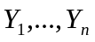 ( are all row vectors) and the linear equations are 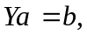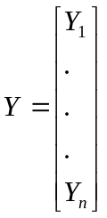. have entries and denotes the class label of the -th training sample. The class label of the training sample is set as follows: if the -th training sample is from the first class, then its class label is set to 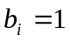; otherwise, the class label is set to 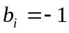. Suppose that each sample is a three-dimensional row vector and the solution to the linear equations is 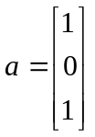. Now, there is a testing sample 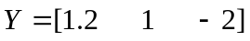. Please use the classification rule of the minimum squared error procedure to classify this testing sample.

Question Three:

What are basic ideas of the maximum likehood estimation method and Bayesian estimation method. When do these two methods have similar results ?

Question Four:

Please describe the nature and possible advantage of Fisher discriminant analysis.

Question Five:

What is the difference between supervised and unsupervised learning methods? Please show two examples of supervised and unsupervised learning methods.

Question Six:

Please use No Free Lunch Theorem to present possible generalized performance of a method.

Question Seven:

What’s the difference in the ideas of the minimum error Bayesian decision and minimum risk Bayesian decision? What’s the condition that makes the minimum error Bayesian decision identical to the minimum risk Bayesian decision?

Question Eight:

What is the K nearest neighbor classifier ? Is it reasonable ?

Question Nine:

Usually a more complex learning algorithm can obtain a higher accuracy in the training stage. So, should a more complex learning algorithm be favored ?

Question Ten:

What is the naïve Bayes rule ?

