Question Three

Answer:

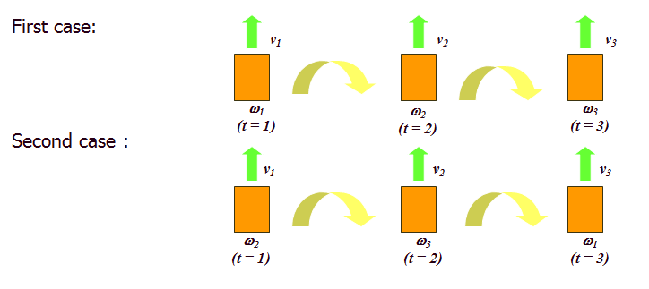



Question Four

Answer:



 (if  is singular, otherwise  ),

where  is a small positive constant and  is the identity matrix.

We exploit construction residual of each class to classify the test sample. After representation coefficient  is obtained, we use training samples of each class to represent the test sample as

,

where  denotes all training samples of th class and  is their corresponding representation coefficients.

Then the construction residual of each class is calculated as follows .

If , then the test sample will be classified to the th class.

Question Five

Answer:

, .

, ,

 , ,









, ,

Thus, , and .