EE6310

Problem Set 17

In this problem set, you will work on your homework in a python notebook.

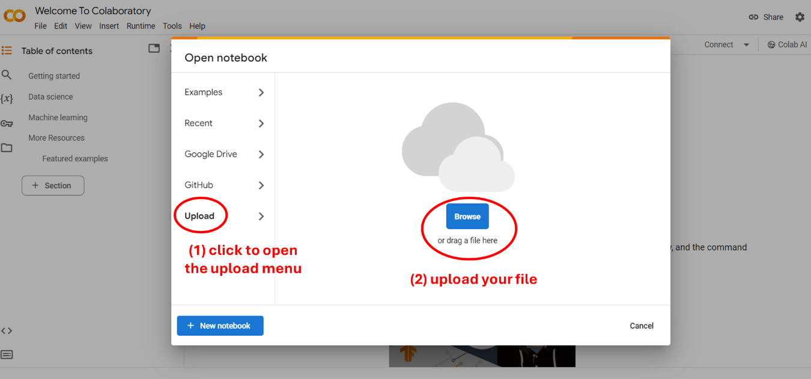

Upload "HW17.ipynb" to the Google Colab via the instruction above and follow the steps to answer questions.

Also download "HW17_data.zip" and decompress it, and upload the data folder to the Google Colab. The "data" folder should be at the same level as the HW17.ipynb.