EE6310

Problem Set 18

In this problem set, you will work on your homework in a python notebook.

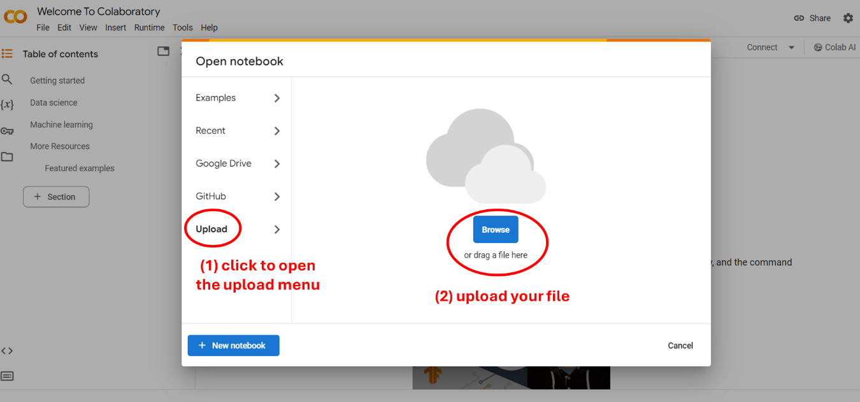

Upload "HW18.ipynb" to the Google Colab via the instruction above and follow the steps to answer questions.

Also download "HW18_data.zip" and decompress it, and upload the data folder to the Google Colab. The "HW18_SmilesAndG.json" file should be at the same folder as the HW18.ipynb.