EE6310

Problem Set 20

In this problem set, you will work on your homework in a python notebook.

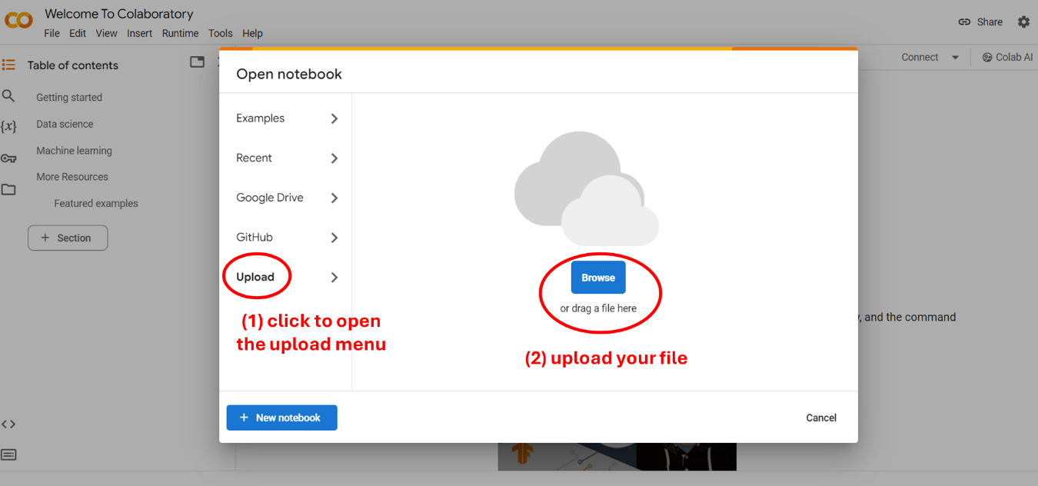

Upload "HW20.ipynb" to the Google Colab via the instruction above and follow the steps to answer questions.

Also download "HW20_data.csv" and upload it to the Google Colab.